Unit 1 Lesson 1: What are Scaled Copies?

1 Printing Portraits (Warm up)

Student Task Statement
Here is a portrait of a student.
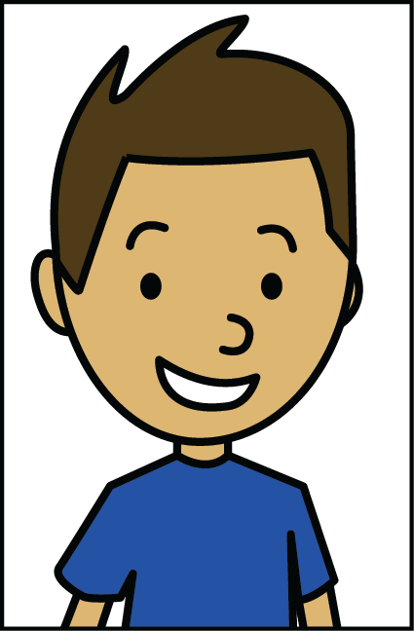
- Look at Portraits A–E. How is each one the same as or different from the original portrait of the student?
- 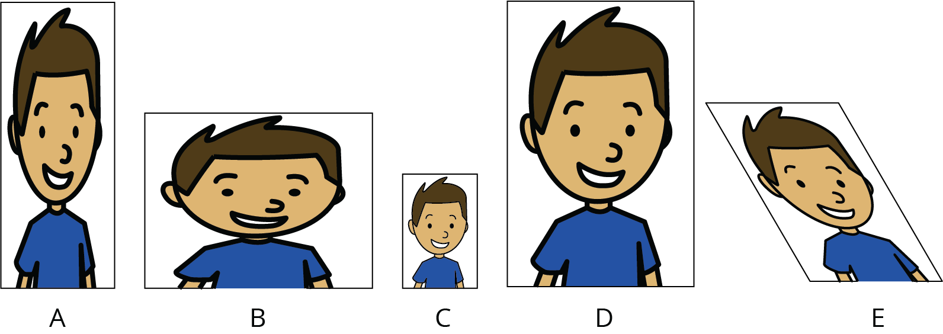
- Some of the Portraits A–E are scaled copies of the original portrait. Which ones do you think are scaled copies? Explain your reasoning.
- What do you think “scaled copy” means?

2 Scaling F

Student Task Statement
Here is an original drawing of the letter F and some other drawings.
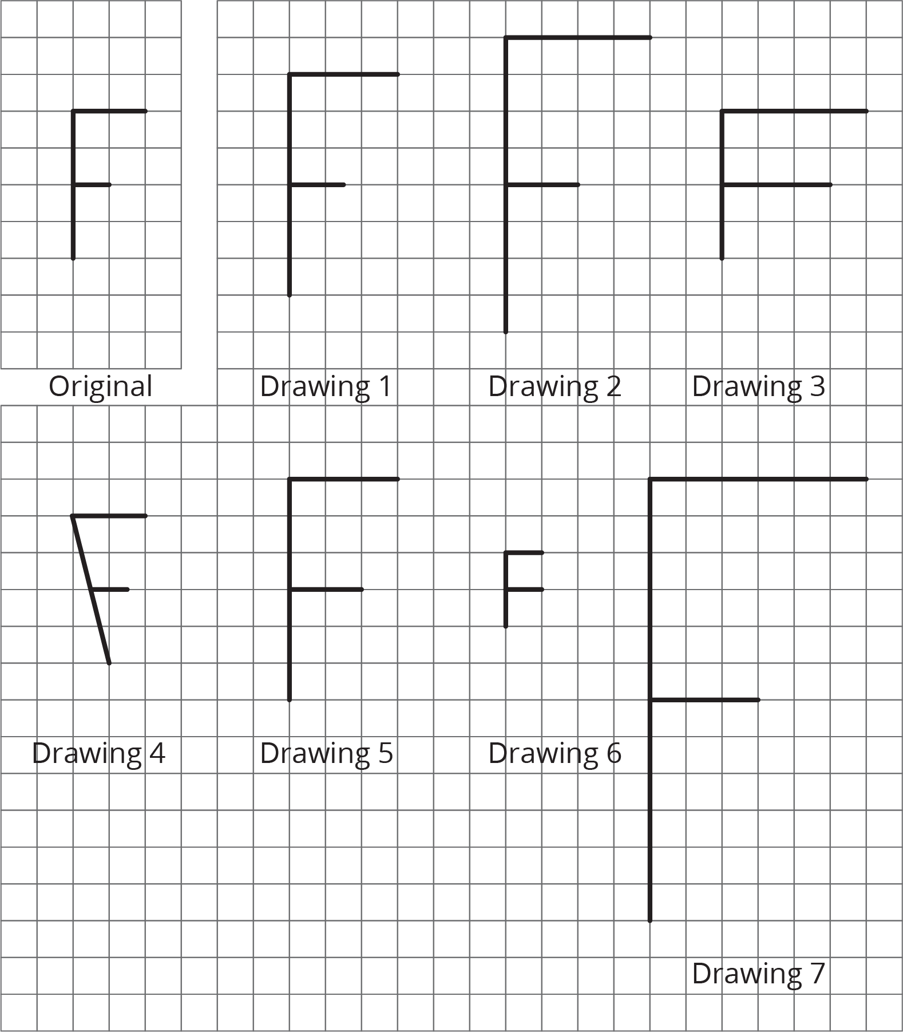
- Identify all the drawings that are scaled copies of the original letter F. Explain how you know.
- Examine all the scaled copies more closely, specifically the lengths of each part of the letter F. How do they compare to the original? What do you notice?
- On the grid, draw a different scaled copy of the original letter F.

3 Pairs of Scaled Polygons

Images for Launch
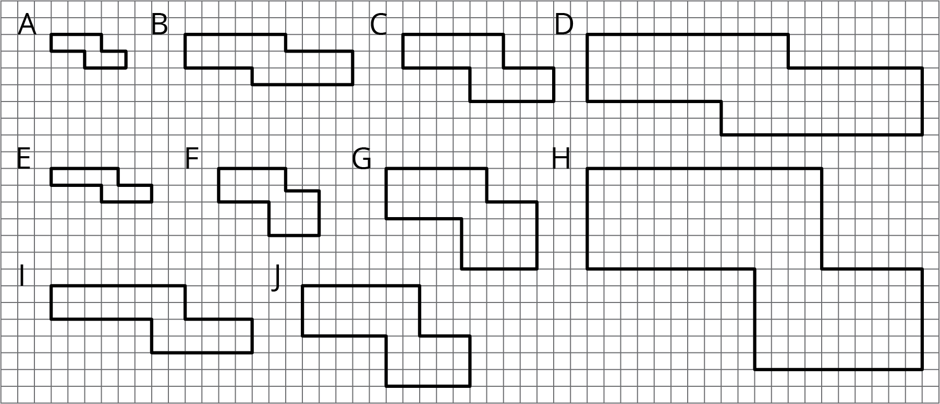

Student Task Statement
Your teacher will give you a set of cards that have polygons drawn on a grid. Mix up the cards and place them all face up.
- Take turns with your partner to match a pair of polygons that are scaled copies of one another.
  - For each match you find, explain to your partner how you know it’s a match.
  - For each match your partner finds, listen carefully to their explanation, and if you disagree, explain your thinking.
- When you agree on all of the matches, check your answers with the answer key. If there are any errors, discuss why and revise your matches.
- Select one pair of polygons to examine further. Draw both polygons on the grid. Explain or show how you know that one polygon is a scaled copy of the other.
© CC BY Open Up Resources. Adaptations CC BY IM.

