Unit 1 Lesson 3: Making Scaled Copies

1 More or Less? (Warm up)

Student Task Statement
For each problem, select the answer from the two choices.
- The value of $25⋅\left(8.5\right)$ is:
  - More than 205
  - Less than 205
- The value of $\left(9.93\right)⋅\left(0.984\right)$ is:
  - More than 10
  - Less than 10
- The value of $\left(0.24\right)⋅\left(0.67\right)$ is:
  - More than 0.2
  - Less than 0.2

2 Drawing Scaled Copies (Optional)

Student Task Statement
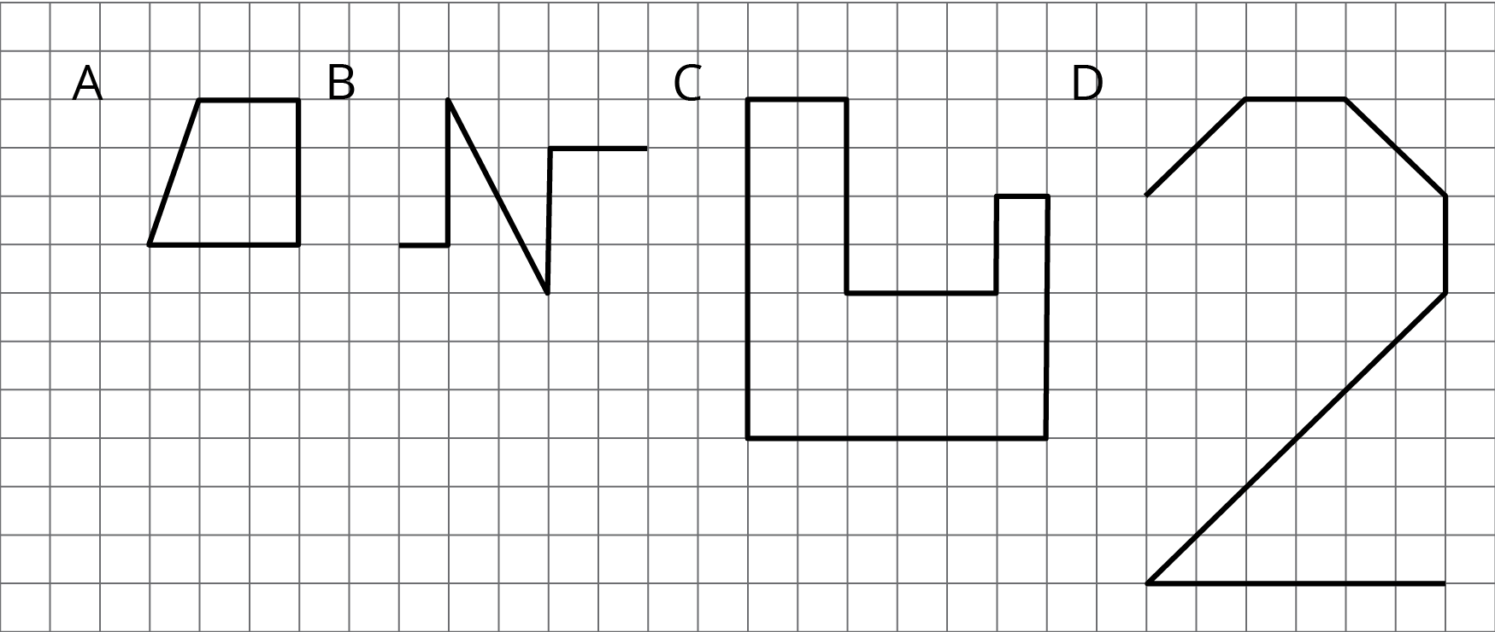
- Draw a scaled copy of either Figure A or B using a scale factor of 3.
- Draw a scaled copy of either Figure C or D using a scale factor of $\frac{1}{2}$.

3 Which Operations? (Part 1)

Student Task Statement
Diego and Jada want to scale this polygon so the side that corresponds to 15 units in the original is 5 units in the scaled copy.
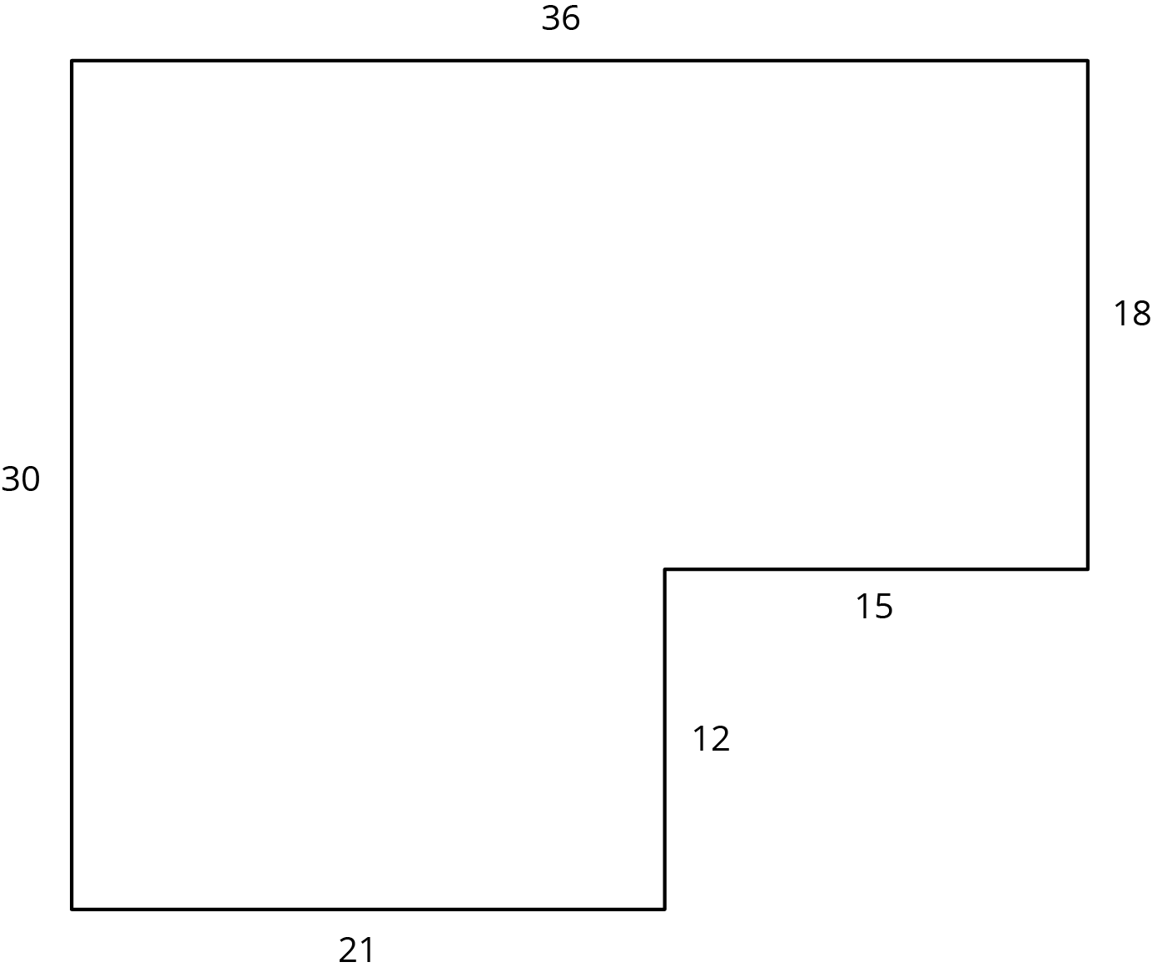
Diego and Jada each use a different operation to find the new side lengths. Here are their finished drawings.
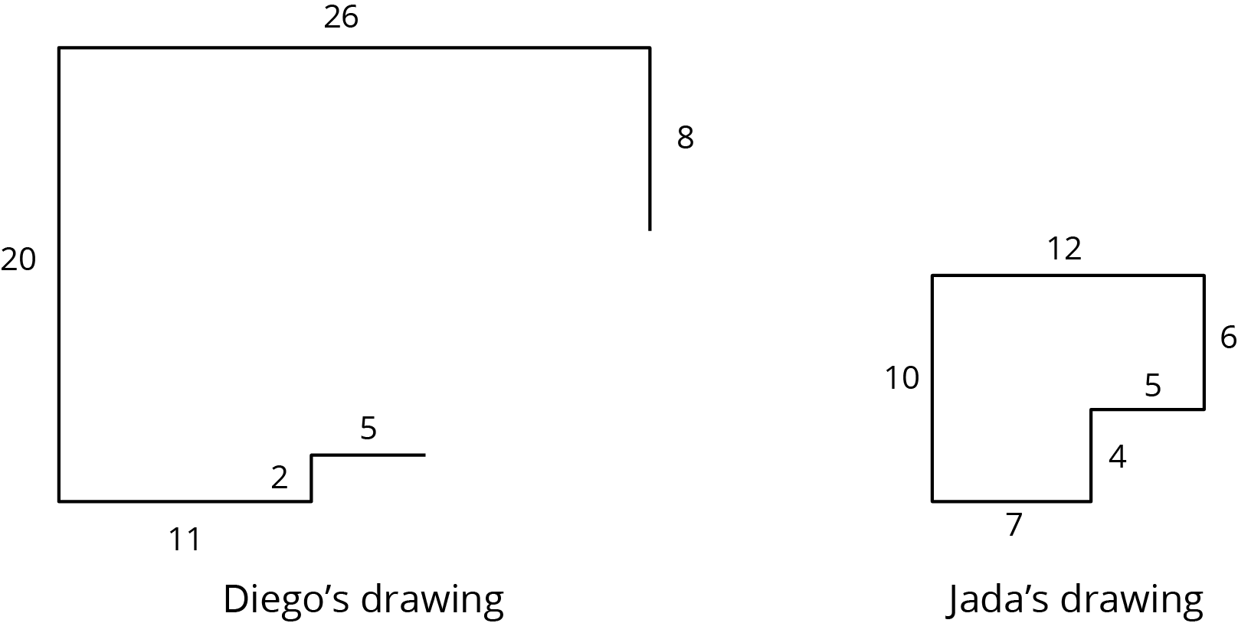
- What operation do you think Diego used to calculate the lengths for his drawing?
- What operation do you think Jada used to calculate the lengths for her drawing?
- Did each method produce a scaled copy of the polygon? Explain your reasoning.

4 Which Operations? (Part 2)

Student Task Statement
Andre wants to make a scaled copy of Jada's drawing so the side that corresponds to 4 units in Jada’s polygon is 8 units in his scaled copy.
- Andre says “I wonder if I should add 4 units to the lengths of all of the segments?” What would you say in response to Andre? Explain or show your reasoning.
- Create the scaled copy that Andre wants. If you get stuck, consider using the edge of an index card or paper to measure the lengths needed to draw the copy.
- 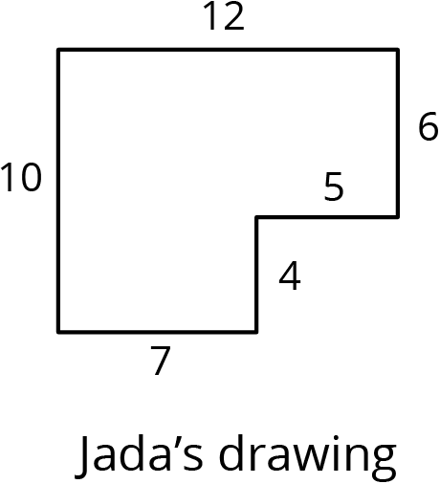
© CC BY Open Up Resources. Adaptations CC BY IM.

