Unit 1 Lesson 4: Scaled Relationships

1 Three Quadrilaterals (Part 1) (Warm up)

Student Task Statement
Each of these polygons is a scaled copy of the others.
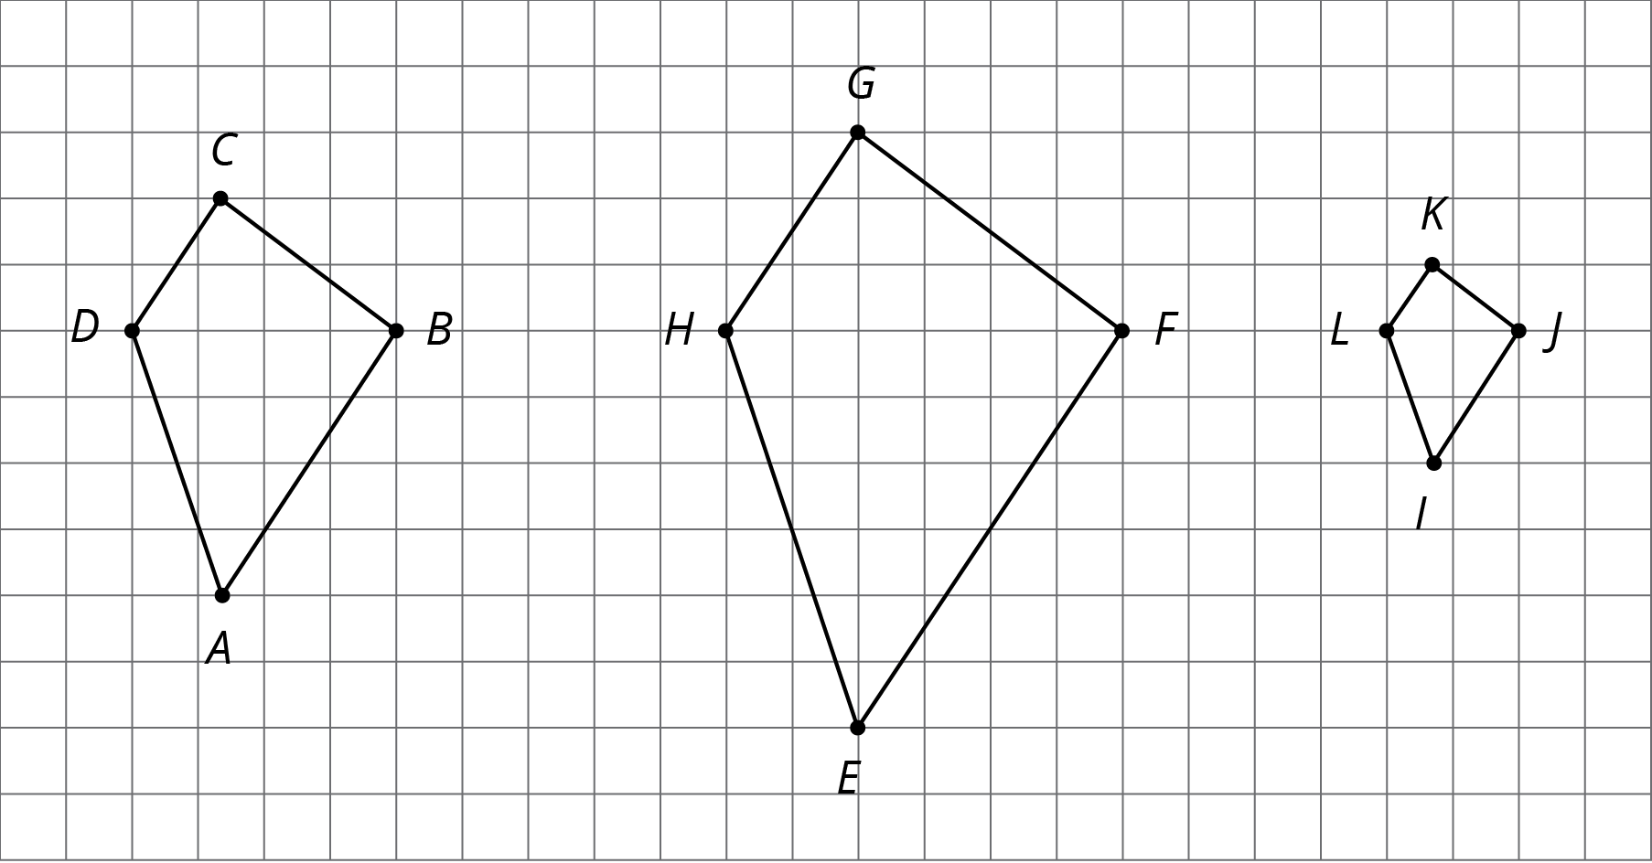
- Name two pairs of corresponding angles. What can you say about the sizes of these angles?
- Check your prediction by measuring at least one pair of corresponding angles using a protractor. Record your measurements to the nearest $5^{∘}$.

2 Three Quadrilaterals (Part 2)

Student Task Statement
Each of these polygons is a scaled copy of the others. You already checked their corresponding angles.
- The side lengths of the polygons are hard to tell from the grid, but there are other corresponding distances that are easier to compare. Identify the distances in the other two polygons that correspond to $DB$ and $AC$, and record them in the table.
- quadrilateral | - distance that  corresponds to $DB$ | - distance that  corresponds to $AC$
- $ABCD$ | - $DB=4$ | - $AC=6$
- $EFGH$
- $IJKL$
- Look at the values in the table. What do you notice?
- Pause here so your teacher can review your work.
- The larger figure is a scaled copy of the smaller figure.
- 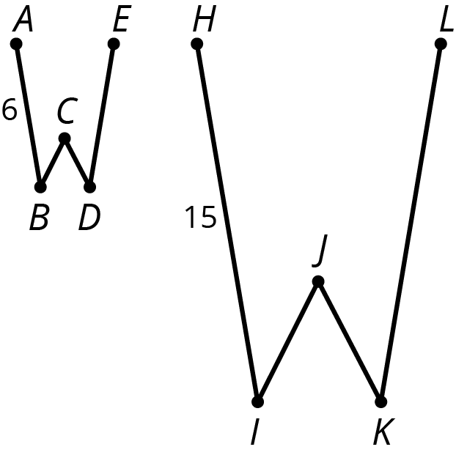
  - If $AE=4$, how long is the corresponding distance in the second figure? Explain or show your reasoning.
  - If $IK=5$, how long is the corresponding distance in the first figure? Explain or show your reasoning.

3 Scaled or Not Scaled?

Student Task Statement
Here are two quadrilaterals.
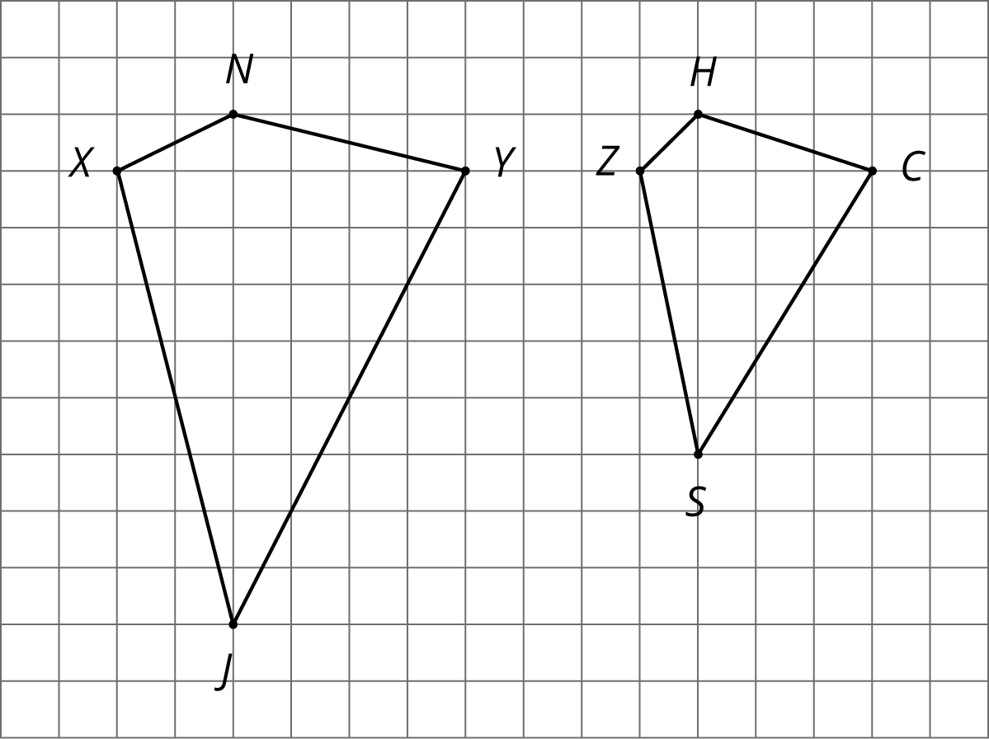
- Mai says that Polygon $ZSCH$ is a scaled copy of Polygon $XJYN$, but Noah disagrees. Do you agree with either of them? Explain or show your reasoning.
- Record the corresponding distances in the table. What do you notice?
- quadrilateral | - horizontal distance | - vertical distance
- $XJYN$ | - XY=33 | - JN=33
- $ZSCH$ | - ZC=33 | - SH=33
- Measure at least three pairs of corresponding angles in $XJYN$ and $ZSCH$ using a protractor. Record your measurements to the nearest $5^{∘}$. What do you notice?
- Do these results change your answer to the first question? Explain.
- Here are two more quadrilaterals.
- 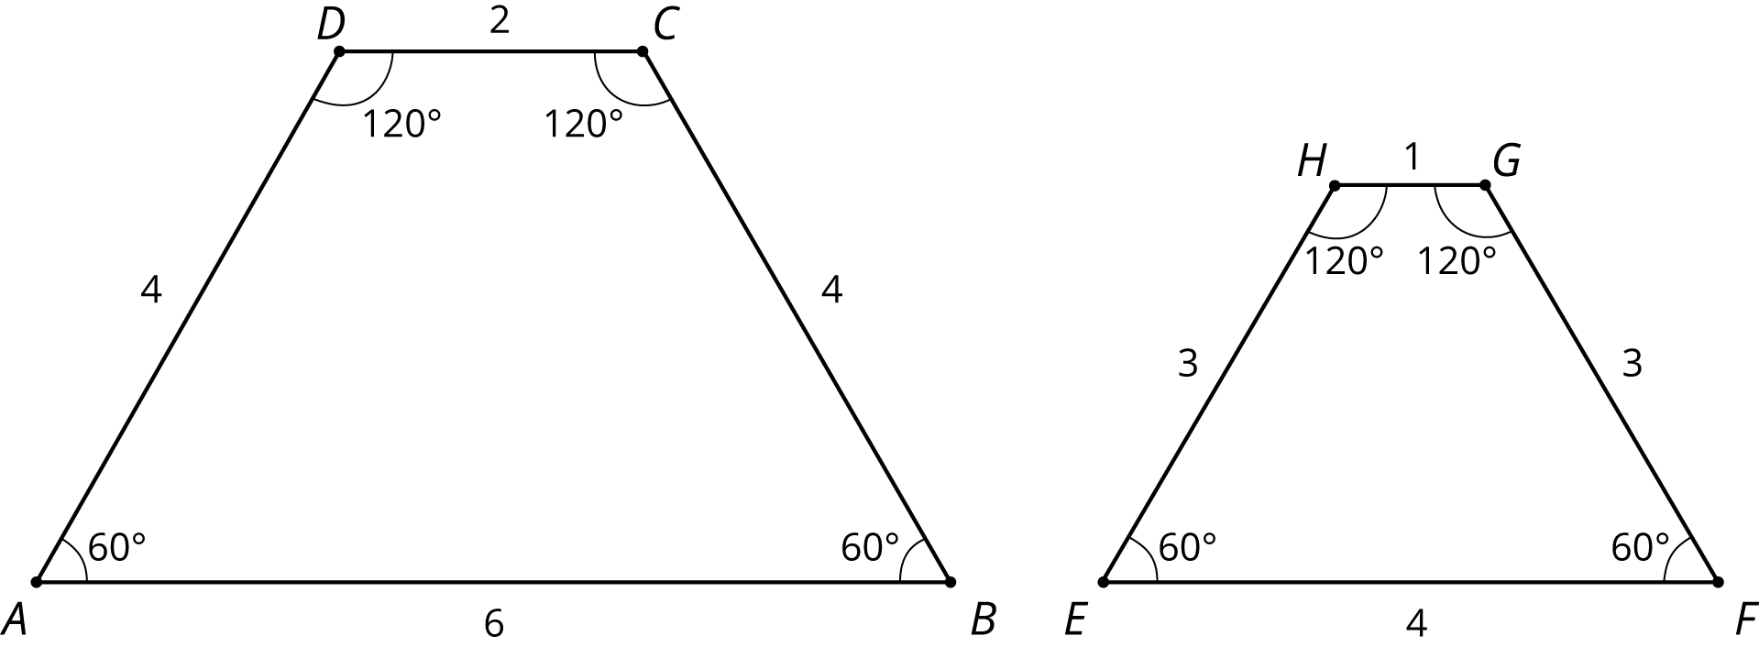
- Kiran says that Polygon $EFGH$ is a scaled copy of $ABCD$, but Lin disagrees. Do you agree with either of them? Explain or show your reasoning.

4 Comparing Pictures of Birds (Optional)

Student Task Statement
Here are two pictures of a bird. Find evidence that one picture is not a scaled copy of the other. Be prepared to explain your reasoning.
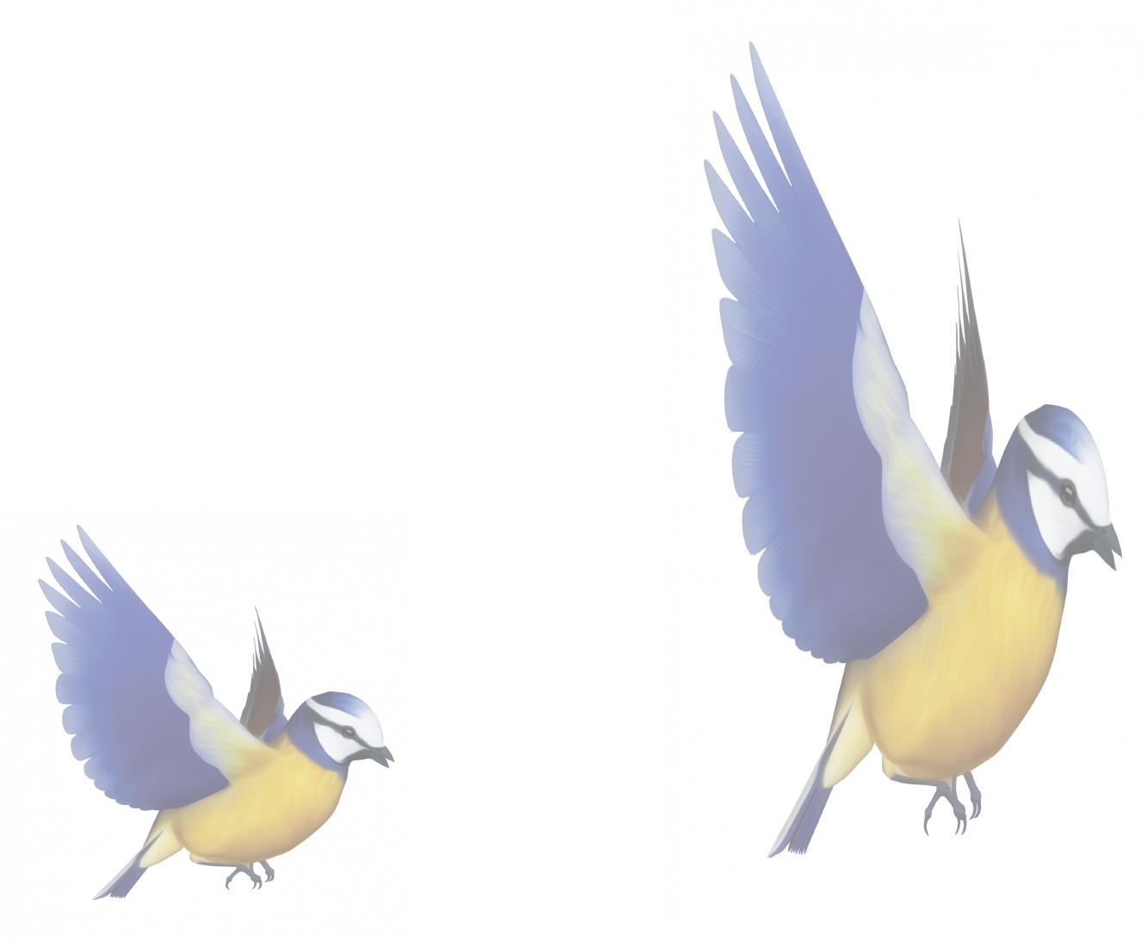

© CC BY Open Up Resources. Adaptations CC BY IM.

