Unit 7 Lesson 19: Drawing on the Coordinate Plane

1 Cat Pictures (Optional)

Student Task Statement
Use graphing technology to recreate this image. If graphing technology is not available, list the ordered pairs that make up this image. Then compare your list with a partner.
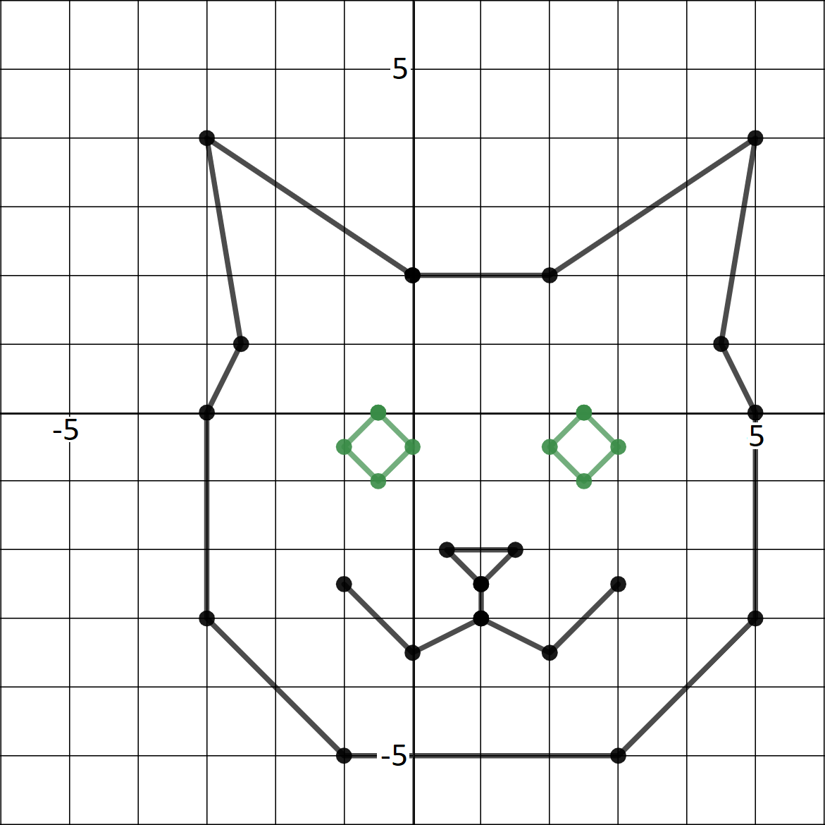

If you have time, consider adding more details to your image such as whiskers, the inside of the ears, a bow, or a body.

2 Design Your Own Image (Optional)

Student Task Statement
Use graphing technology to create an image of your own design. You could draw a different animal, a vehicle, a building, or something else. Make sure your image includes at least 4 points in each quadrant of the coordinate plane.
If graphing technology is not available, create your image on graph paper, and then list the ordered pairs that make up your image. Trade lists with a partner but do not show them your image. Graph your partner’s ordered pairs and see if your images match.
© CC BY Open Up Resources. Adaptations CC BY IM.

