Lesson 14: Parallel Lines and the Angles in a Triangle

14.1: True or False: Computational Relationships
Is each equation true or false?
$62−28=60−30$
$3⋅\text{-}8=(2⋅\text{-}8)−8$
$\frac{16}{\text{-}2}+\frac{24}{\text{-}2}=\frac{40}{\text{-}2}$

14.2: Angle Plus Two
Here is triangle $ABC$.
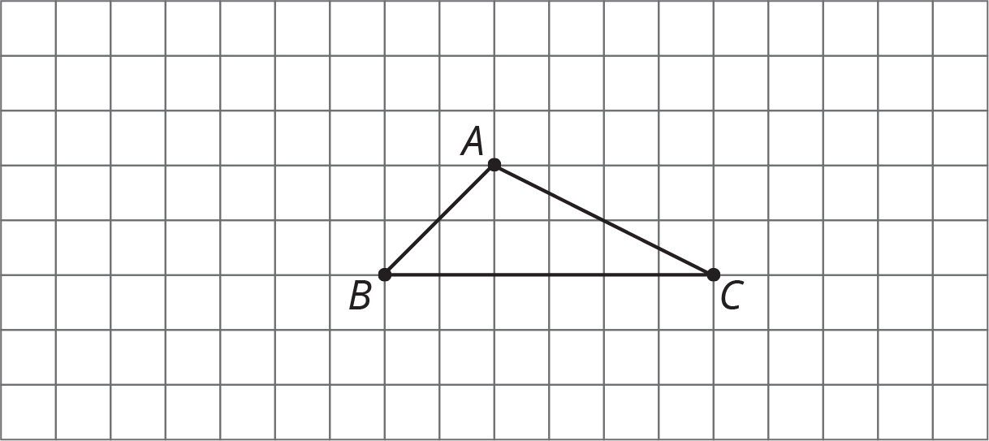
- Rotate triangle $ABC$ ${180}^{∘}$ around the midpoint of side $AC$. Label the new vertex $D$.
- Rotate triangle $ABC$ ${180}^{∘}$ around the midpoint of side $AB$. Label the new vertex $E$.
- Look at angles $EAB$, $BAC$, and $CAD$. Without measuring, write what you think is the sum of the measures of these angles. Explain or show your reasoning.
- Is the measure of angle $EAB$ equal to the measure of any angle in triangle $ABC$? If so, which one? If not, how do you know?
- Is the measure of angle $CAD$ equal to the measure of any angle in triangle $ABC$? If so, which one? If not, how do you know?
- What is the sum of the measures of angles $ABC$, $BAC$, and $ACB$?

14.3: Every Triangle in the World
Here is $△ABC$. Line $DE$ is parallel to line $AC$.
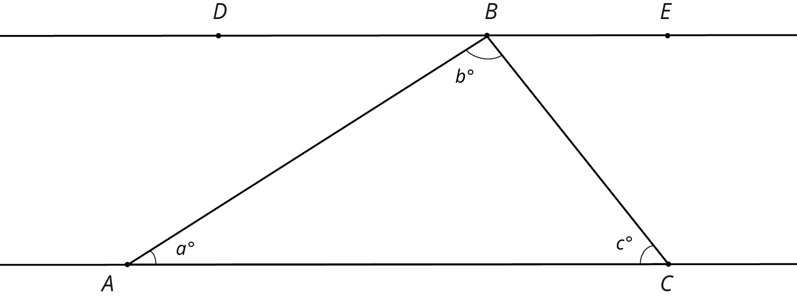
- What is $m∠DBA+b+m∠CBE$? Explain how you know.
- Use your answer to explain why $a+b+c=180$.
- Explain why your argument will work for any triangle: that is, explain why the sum of the angle measures in any triangle is ${180}^{∘}$.

Are you ready for more?
- Using a ruler, create a few quadrilaterals. Use a protractor to measure the four angles inside the quadrilateral. What is the sum of these four angle measures?
- Come up with an explanation for why anything you notice must be true (hint: draw one diagonal in each quadrilateral).

14.4: Four Triangles Revisited
This diagram shows a square $BDFH$ that has been made by images of triangle $ABC$ under rigid transformations.
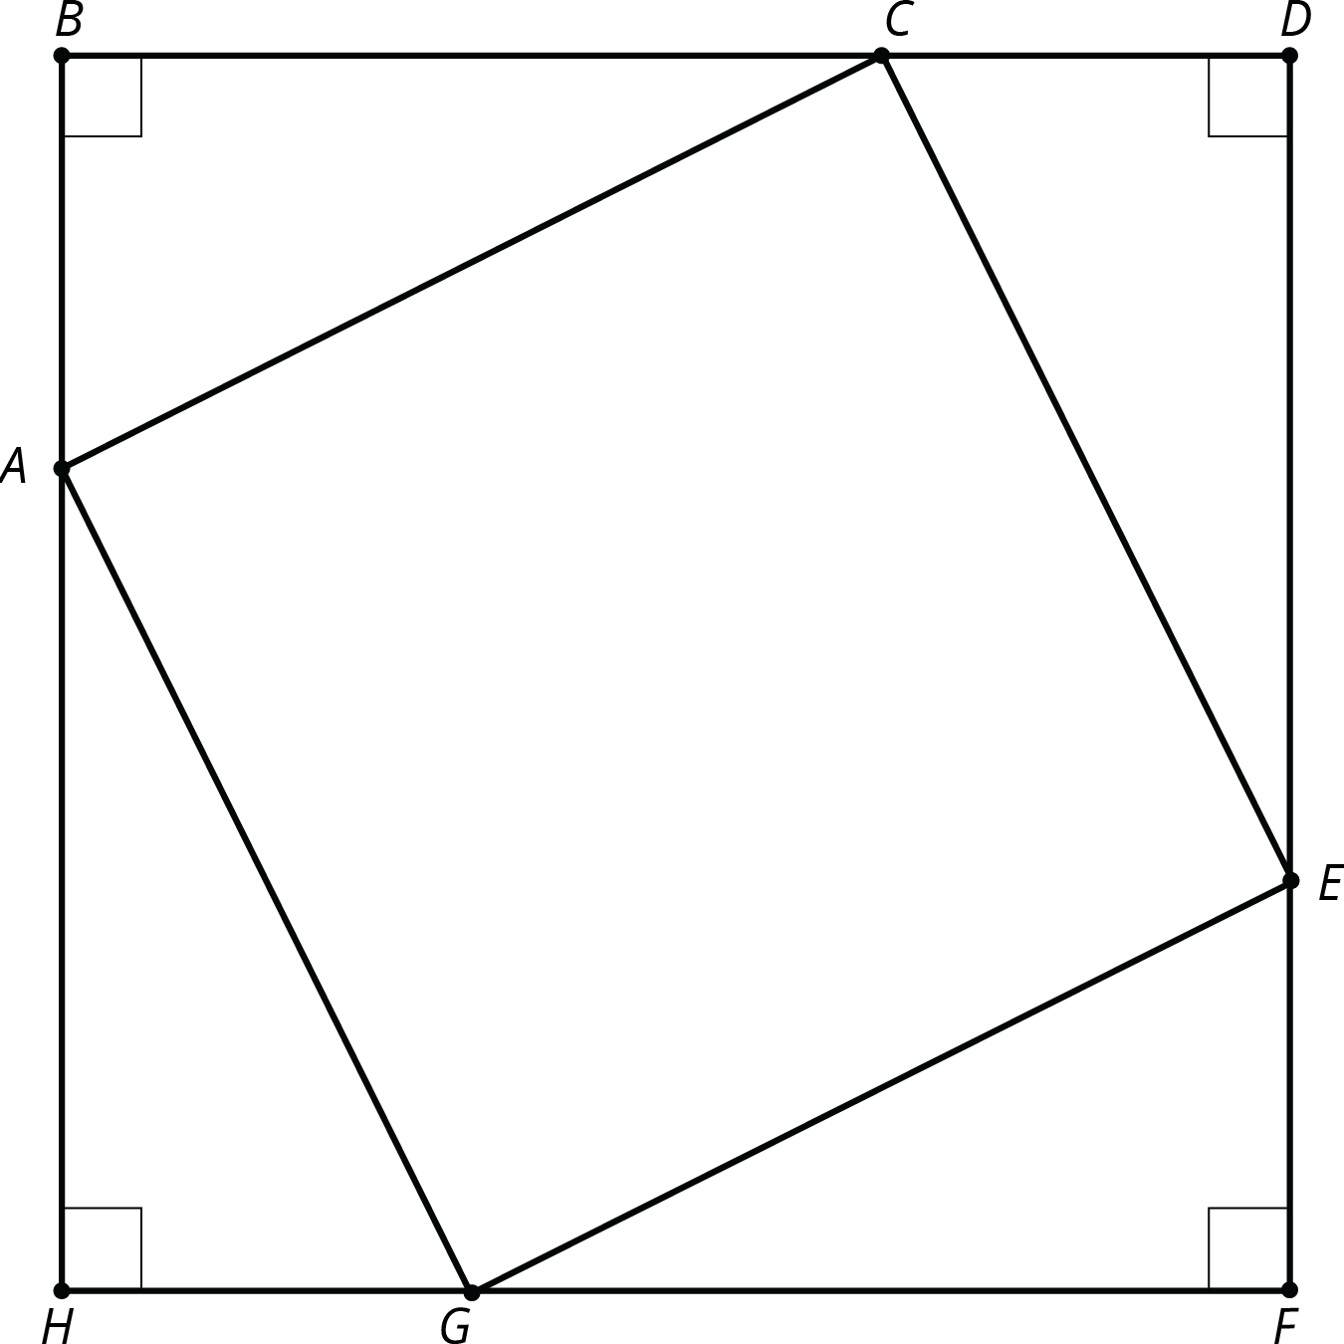
Given that angle $BAC$ measures 53 degrees, find as many other angle measures as you can.

Lesson 14 Summary
Using parallel lines and rotations, we can understand why the angles in a triangle always add to ${180}^{∘}$. Here is triangle $ABC$. Line $DE$ is parallel to $AC$ and contains $B$.
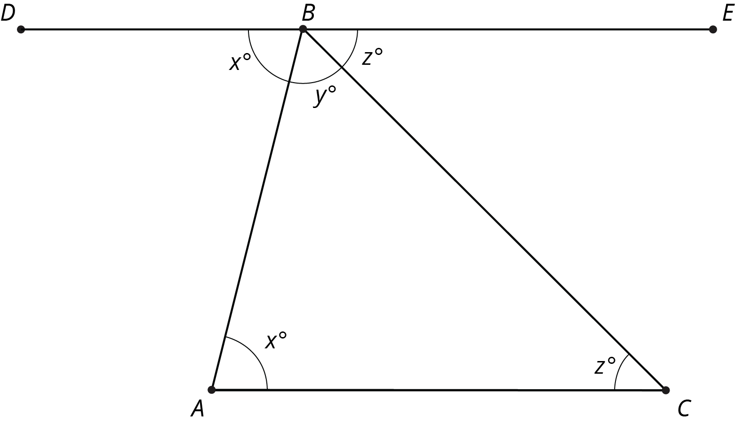
A 180 degree rotation of triangle $ABC$ around the midpoint of $AB$ interchanges angles $A$ and $DBA$ so they have the same measure: in the picture these angles are marked as $x^{∘}$. A 180 degree rotation of triangle $ABC$ around the midpoint of $BC$ interchanges angles $C$ and $CBE$ so they have the same measure: in the picture, these angles are marked as $z^{∘}$. Also, $DBE$ is a straight line because 180 degree rotations take lines to parallel lines. So the three angles with vertex $B$ make a line and they add up to ${180}^{∘}$ ($x+y+z=180$). But $x,y,z$ are the measures of the three angles in $△ABC$ so the sum of the angles in a triangle is always ${180}^{∘}$!
© CC BY Open Up Resources. Adaptations CC BY IM.

