Unit 1 Lesson 2 Cumulative Practice Problems
- The second H-shaped polygon is a scaled copy of the first.
- 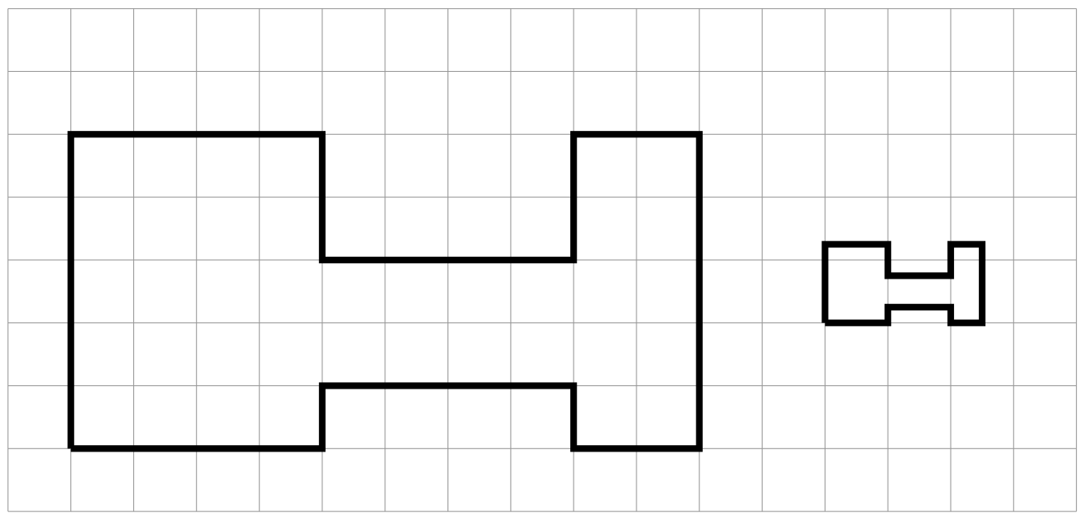
  - Show one pair of corresponding points and two pairs of corresponding sides in the original polygon and its copy. Consider using colored pencils to highlight corresponding parts or labeling some of the vertices.
  - What scale factor takes the original polygon to its smaller copy? Explain or show your reasoning.
- Figure B is a scaled copy of Figure A. Select all of the statements that must be true:
  - Figure B is larger than Figure A.
  - Figure B has the same number of edges as Figure A.
  - Figure B has the same perimeter as Figure A.
  - Figure B has the same number of angles as Figure A.
  - Figure B has angles with the same measures as Figure A.
- Polygon B is a scaled copy of Polygon A.
  - What is the scale factor from Polygon A to Polygon B? Explain your reasoning.
  - Find the missing length of each side marked with ? in Polygon B.
  - Determine the measure of each angle marked with ? in Polygon A.
- 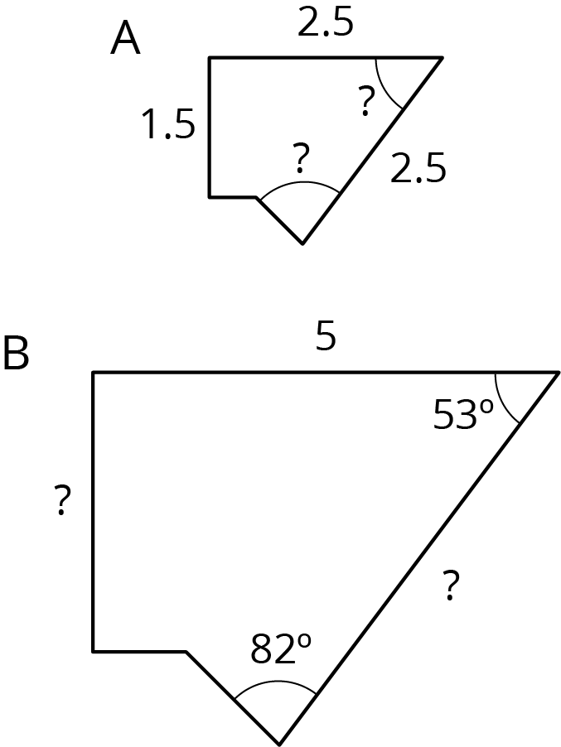
- Complete each equation with a number that makes it true.
  - $8⋅\text{______}=40$
  - $8+\text{______}=40$
  - $21÷\text{______}=7$
  - $21−\text{______}=7$
  - $21⋅\text{______}=7$
© CC BY Open Up Resources. Adaptations CC BY IM.

