Lesson 8: Make Numbers with 10 and Some More (Part 2)
- Let’s show numbers with 10-frames and dots or counters.

Warm-up: How Many Do You See: Numbers on a 10-frame
How many do you see?
How do you see them?
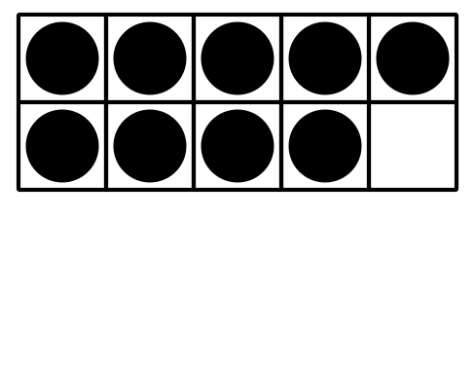
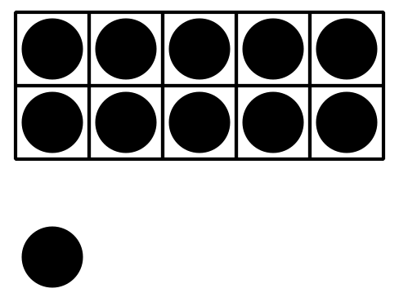
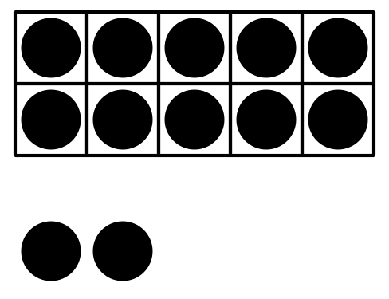
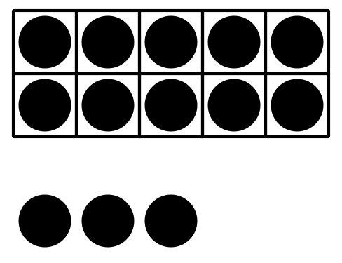

8.2: Make Each Number
11
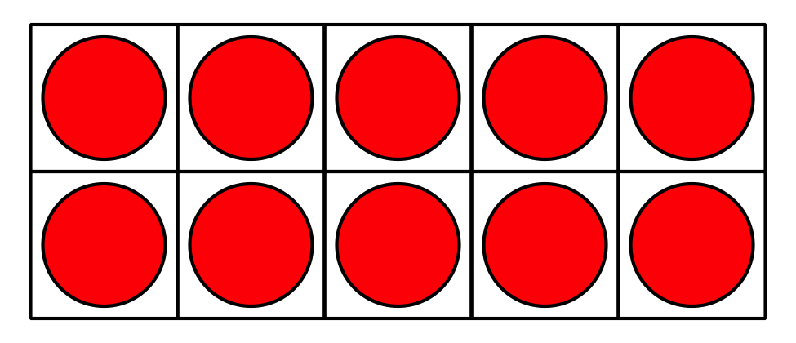
19
15
17
14
12
© CC BY 2021 Illustrative Mathematics®

