Lesson 13: Dominoes to 5
- Let’s sort different ways to make numbers to 5.

Warm-up: Notice and Wonder: Ways to Make 4
What do you notice?
What do you wonder?

13.1: Domino Sort
Sort the dominoes based on the total number of dots.
Choose 1 group.
Write an expression for each domino.
___________________________
___________________________
___________________________
___________________________
___________________________
___________________________

13.2: Compare Dots on Dominoes
Flip over a card.
Compare the number of dots using “fewer” or “the same number.”
Compare the number of dots using “more” or “the same number.”

13.3: Centers: Choice Time
Choose a center.
5-frames
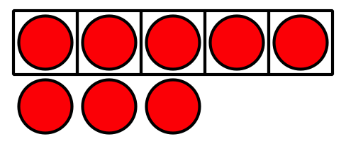
Roll and Add
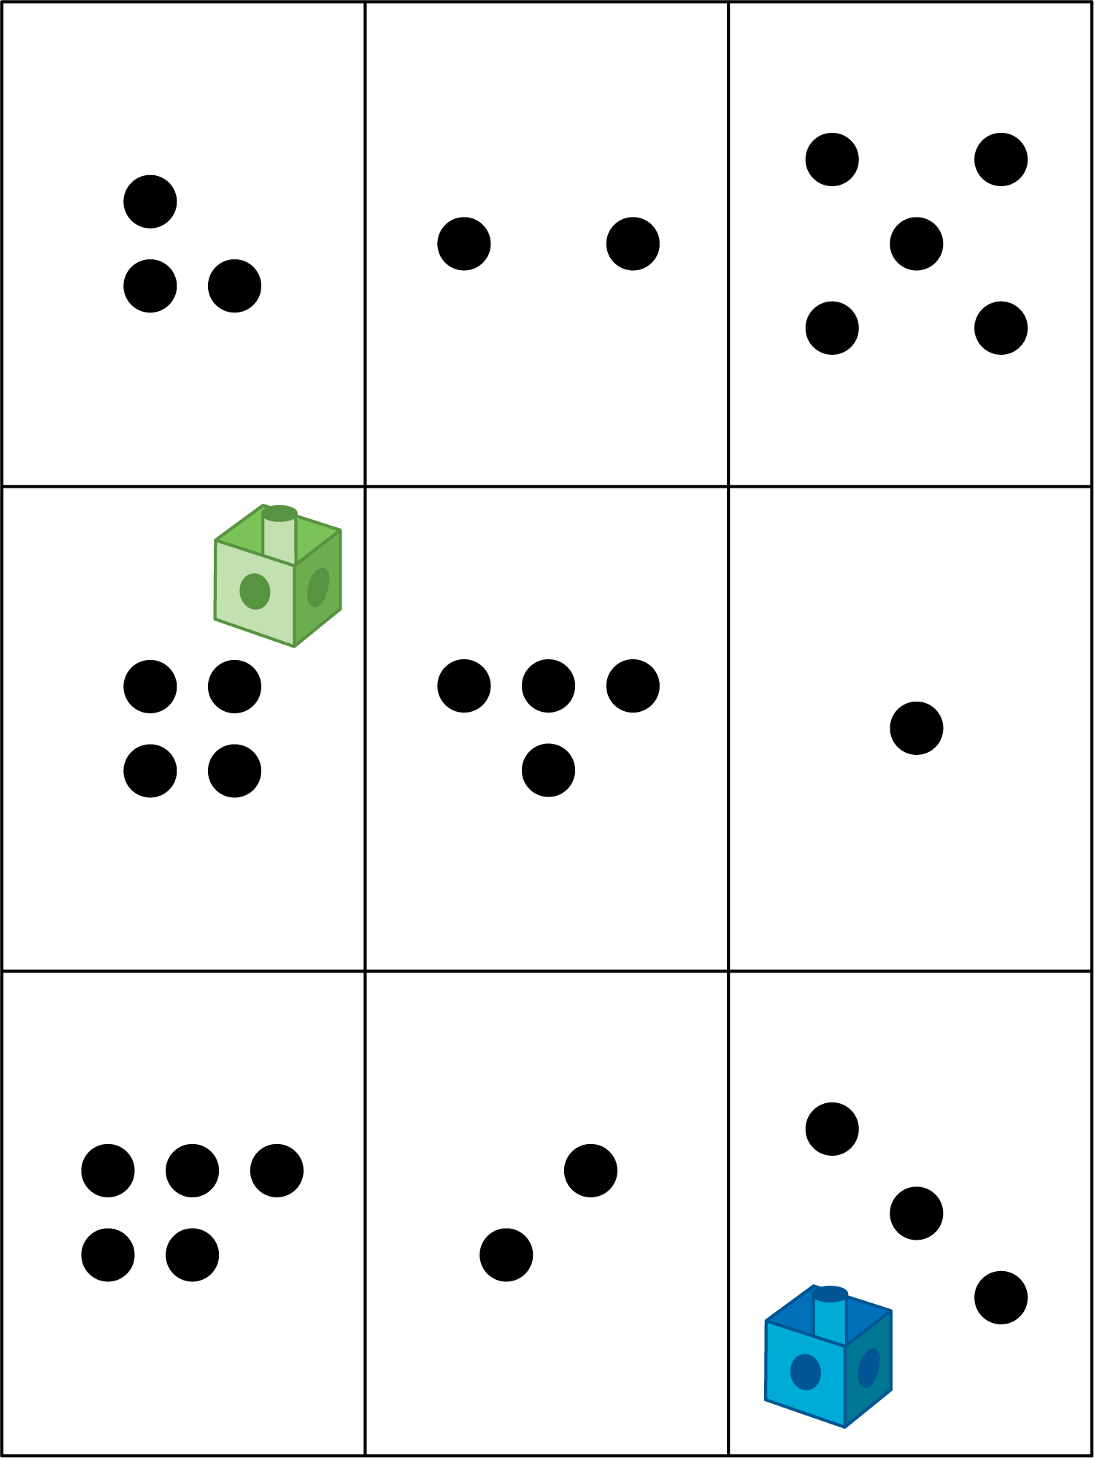
Bingo
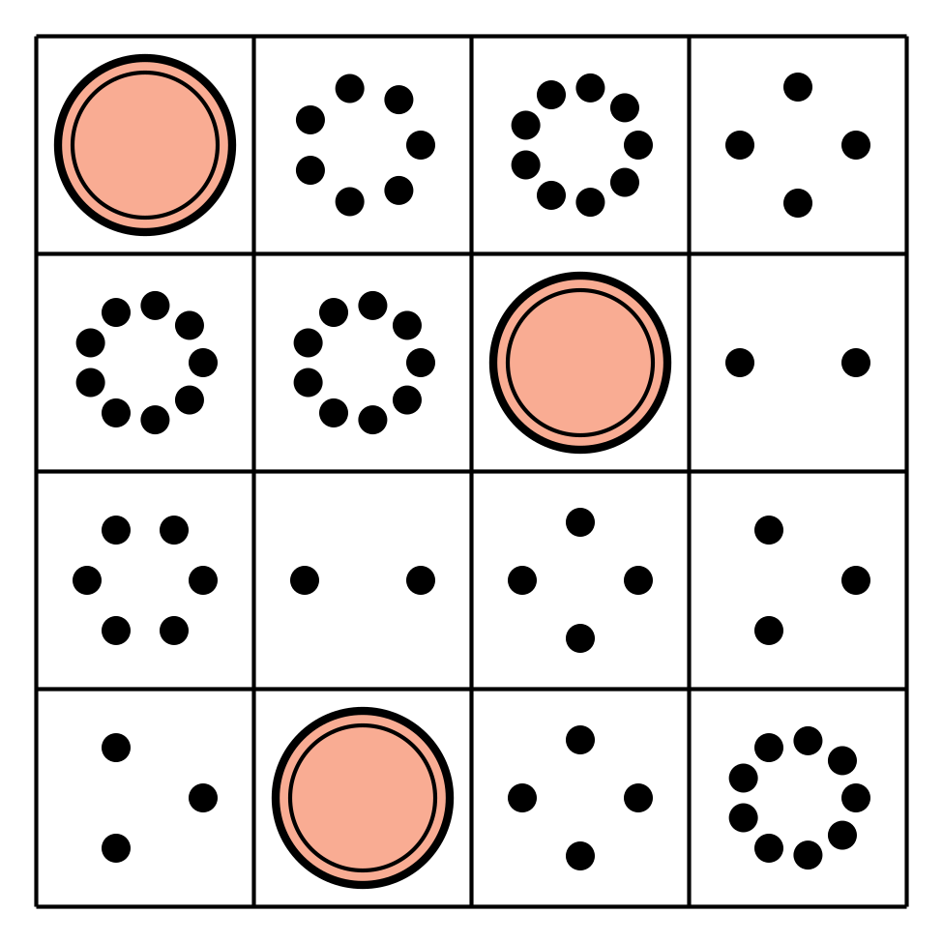
Geoblocks
Find the Value of Expressions
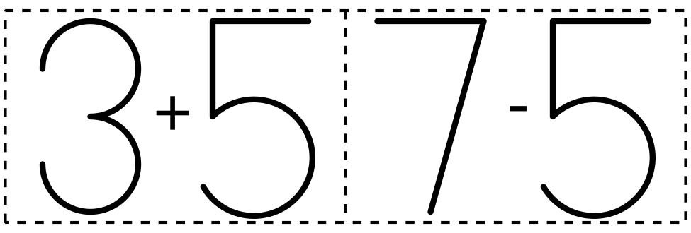
© CC BY 2021 Illustrative Mathematics®

