Lesson 11 Practice Problems
- What is the slope of the graph of $5x−2y=20$?
  - -10
  - $\frac{\text{-}2}{5}$
  - $\frac{5}{2}$
  - 5
- What is the $y$-intercept of each equation?
  - $y=6x+2$
  - $10x+5y=30$
  - $y−6=2\left(3x−4\right)$
- Han wanted to find the intercepts of the graph of the equation $10x+4y=20$. He decided to put the equation in slope-intercept form first. Here is his work:
- $\begin{matrix}10x+4y & =20 \\ 4y & =20−10x \\ y & =5−10x\end{matrix}$
- He concluded that the $x$-intercept is $\left(\frac{1}{2},0\right)$ and the $y$-intercept is $\left(0,5\right)$.
  - What error did Han make?
  - What are the $x$- and $y$-intercepts of the line? Explain or show your reasoning.
- Which graph represents the equation $12=3x+4y$? Explain how you know.
- 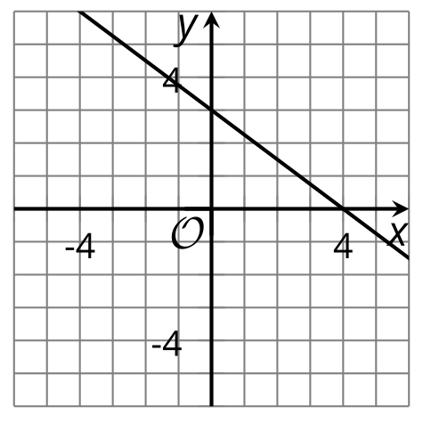
- 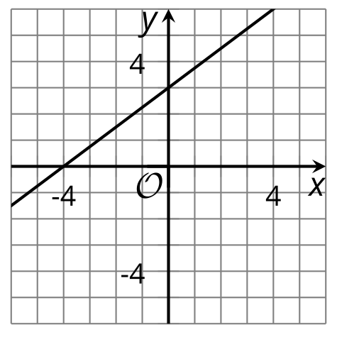
- 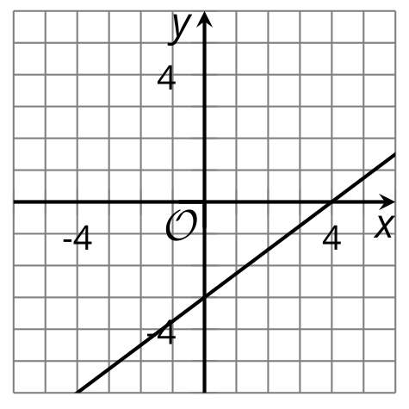

- Clare knows that Priya has a bunch of nickels and dimes in her pocket and that the total amount is $1.25.
  - Find one possibility for the number of nickels and number of dimes that could be in Priya's pocket.
  - Write an equation that describes the relationship between the number of dimes and the number of nickels in Priya's pocket.
  - Explain what the point $\left(13,6\right)$ means in this situation.
  - Is the point $\left(13,6\right)$ a solution to the equation you wrote? Explain your reasoning.
- (From Unit 2, Lesson 5.)
- A large company releases summary statistics about the annual salaries for its employees.
- mean | - standard deviation | - minimum | - Q1 | - median | - Q3 | - maximum
- $63,429 | - $38,439 | - $18,000 | - $50,000 | - $58,000 | - $68,000 | - $350,000
- Based on this information, are there any outliers in the data? Explain your reasoning.
- (From Unit 1, Lesson 14.)
- The graph shows how much money Priya has in her savings account weeks after she started saving on a regular basis.
  - How much money does Priya have in the account after 10 weeks?
  - How long did it take her to save $200?
  - How much money did Priya have in her savings account when she started to save regularly?
  - Write an equation to represent the dollar amount in her savings account and the number of weeks of saving. Be sure to specify what each variable represents.
- 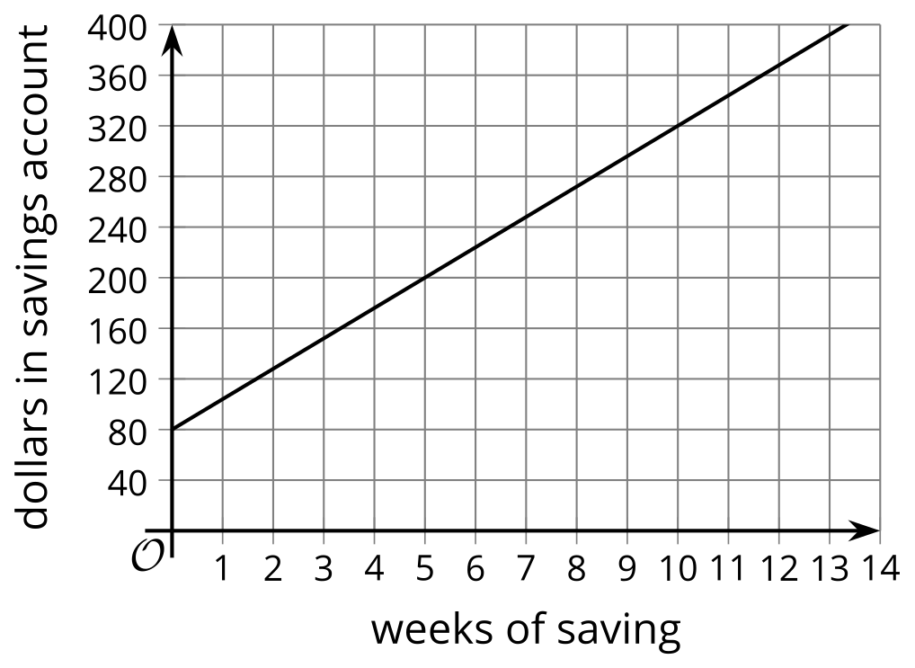
- (From Unit 2, Lesson 10.)
- Noah has a coin jar containing $d$ dimes and $q$ quarters worth a total of $5.00.
- Select all the equations that represent this situation.
  - $d+q=5$
  - $d+q=500$
  - $0.1d+0.25q=5$
  - $10d+25q=500$
  - $d=50$
  - $q=20$
- (From Unit 2, Lesson 6.)
- Noah orders an extra-large pizza. It costs $12.49 for the pizza plus $1.50 for each topping. He orders an extra-large pizza with $t$ toppings that costs a total of $d$ dollars.
- Select all of the equations that represent the relationship between the number of toppings $t$ and total cost $d$ of the pizza with $t$ toppings.
  - $12.49+t=d$
  - $12.49+1.50t=d$
  - $12.49+1.50d=t$
  - $12.49=d+1.50t$
  - $t=\frac{d−12.49}{1.5}$
  - $t=d−\frac{12.49}{1.5}$
- (From Unit 2, Lesson 9.)
- A school sells adult tickets and student tickets for a play. It collects $1,400 in total.
- 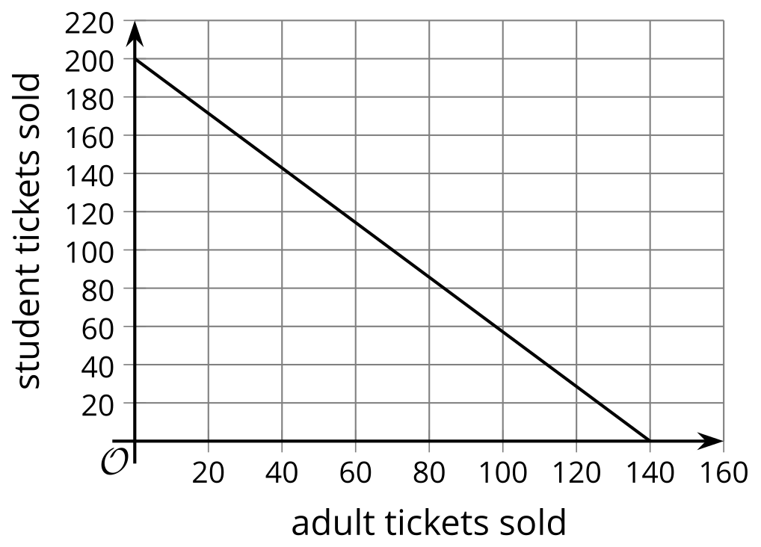
- The graph shows the possible combinations of the number of adult tickets sold and the number of student tickets sold.
- What does the vertical intercept (0, 200) tell us in this situation?
  - It tells us the decrease in the sale of adult tickets for each student ticket sold.
  - It tells us the decrease in the sale of student tickets for each adult ticket sold.
  - It tells us that if no adult tickets were sold, then 200 students tickets were sold.
  - It tells us that if no students tickets were sold, then 200 adult tickets were sold.
- (From Unit 2, Lesson 10.)
© CC BY 2019 by Illustrative Mathematics®

