Teacher Presentation Materials

Unit 5 Lesson 9: Scaling the Inputs

1 Out and Back (Warm up)

Student Task Statement
Every weekend, Elena takes a walk along the straight road in front of her house for 2 miles, then turns around and comes back home. Let’s assume Elena walks at a constant speed.
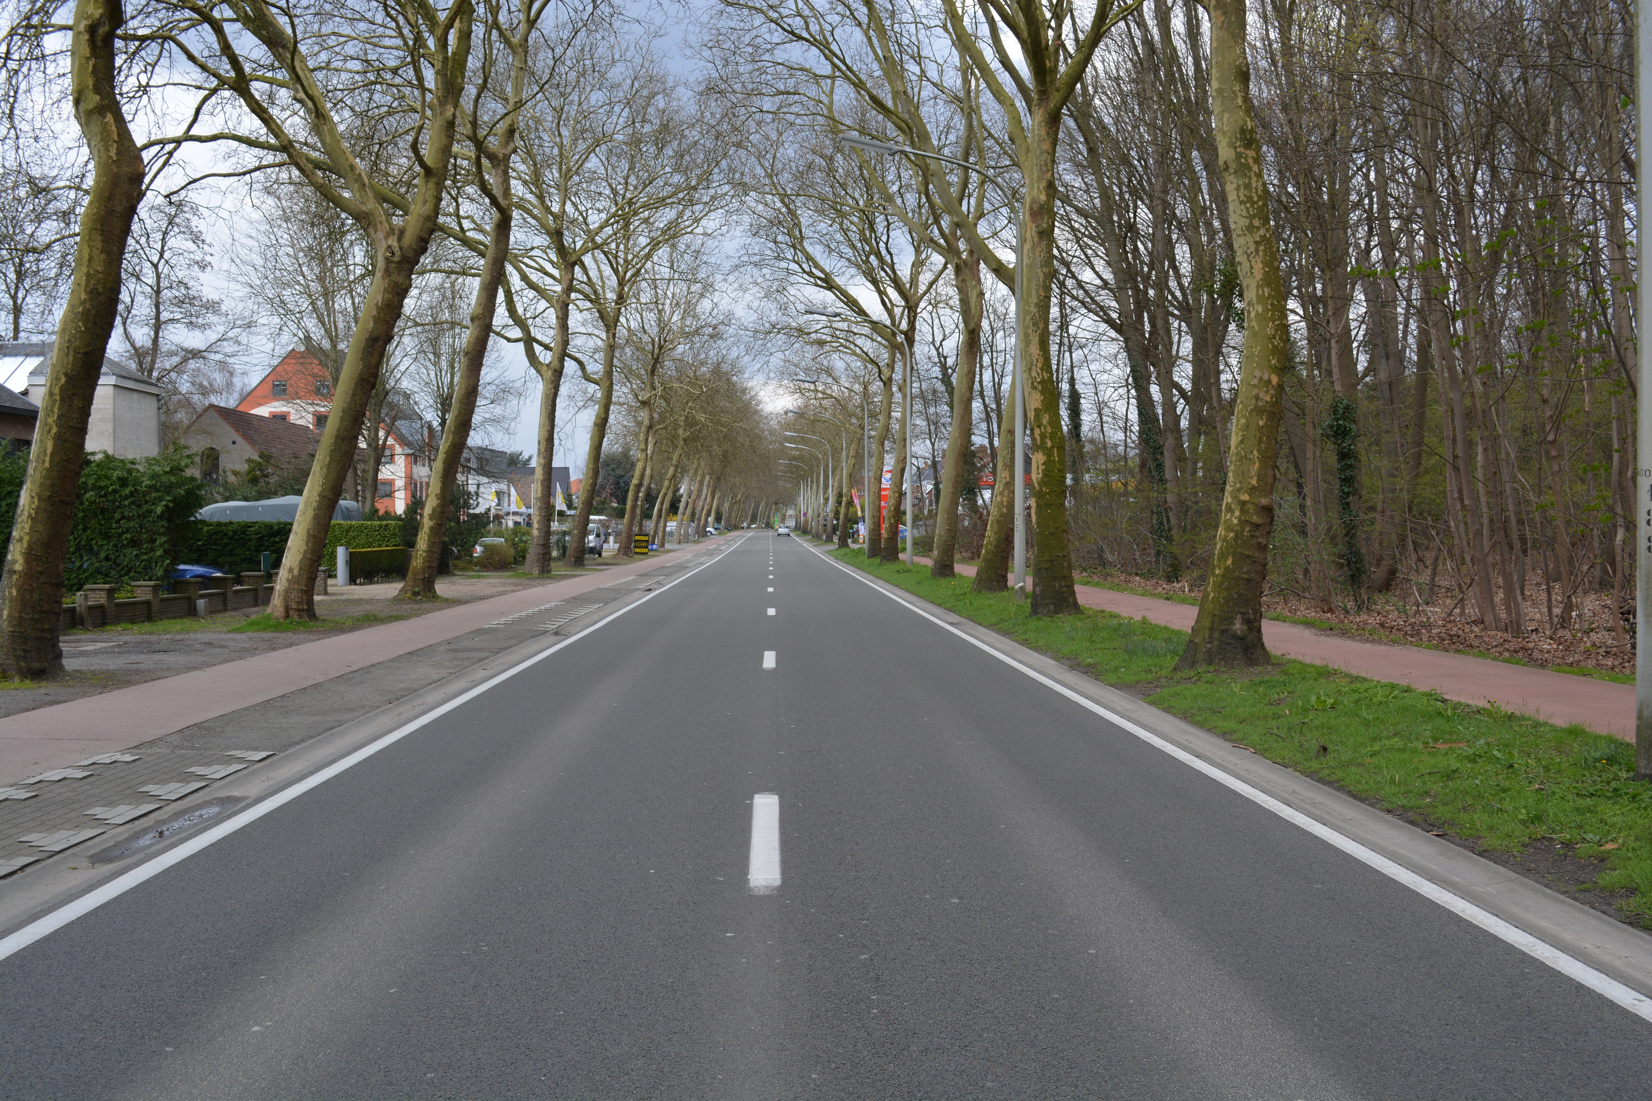
Here is a graph of the function $f$ that gives her distance $f(t)$, in miles, from home as a function of time $t$ if she walks 2 miles per hour.
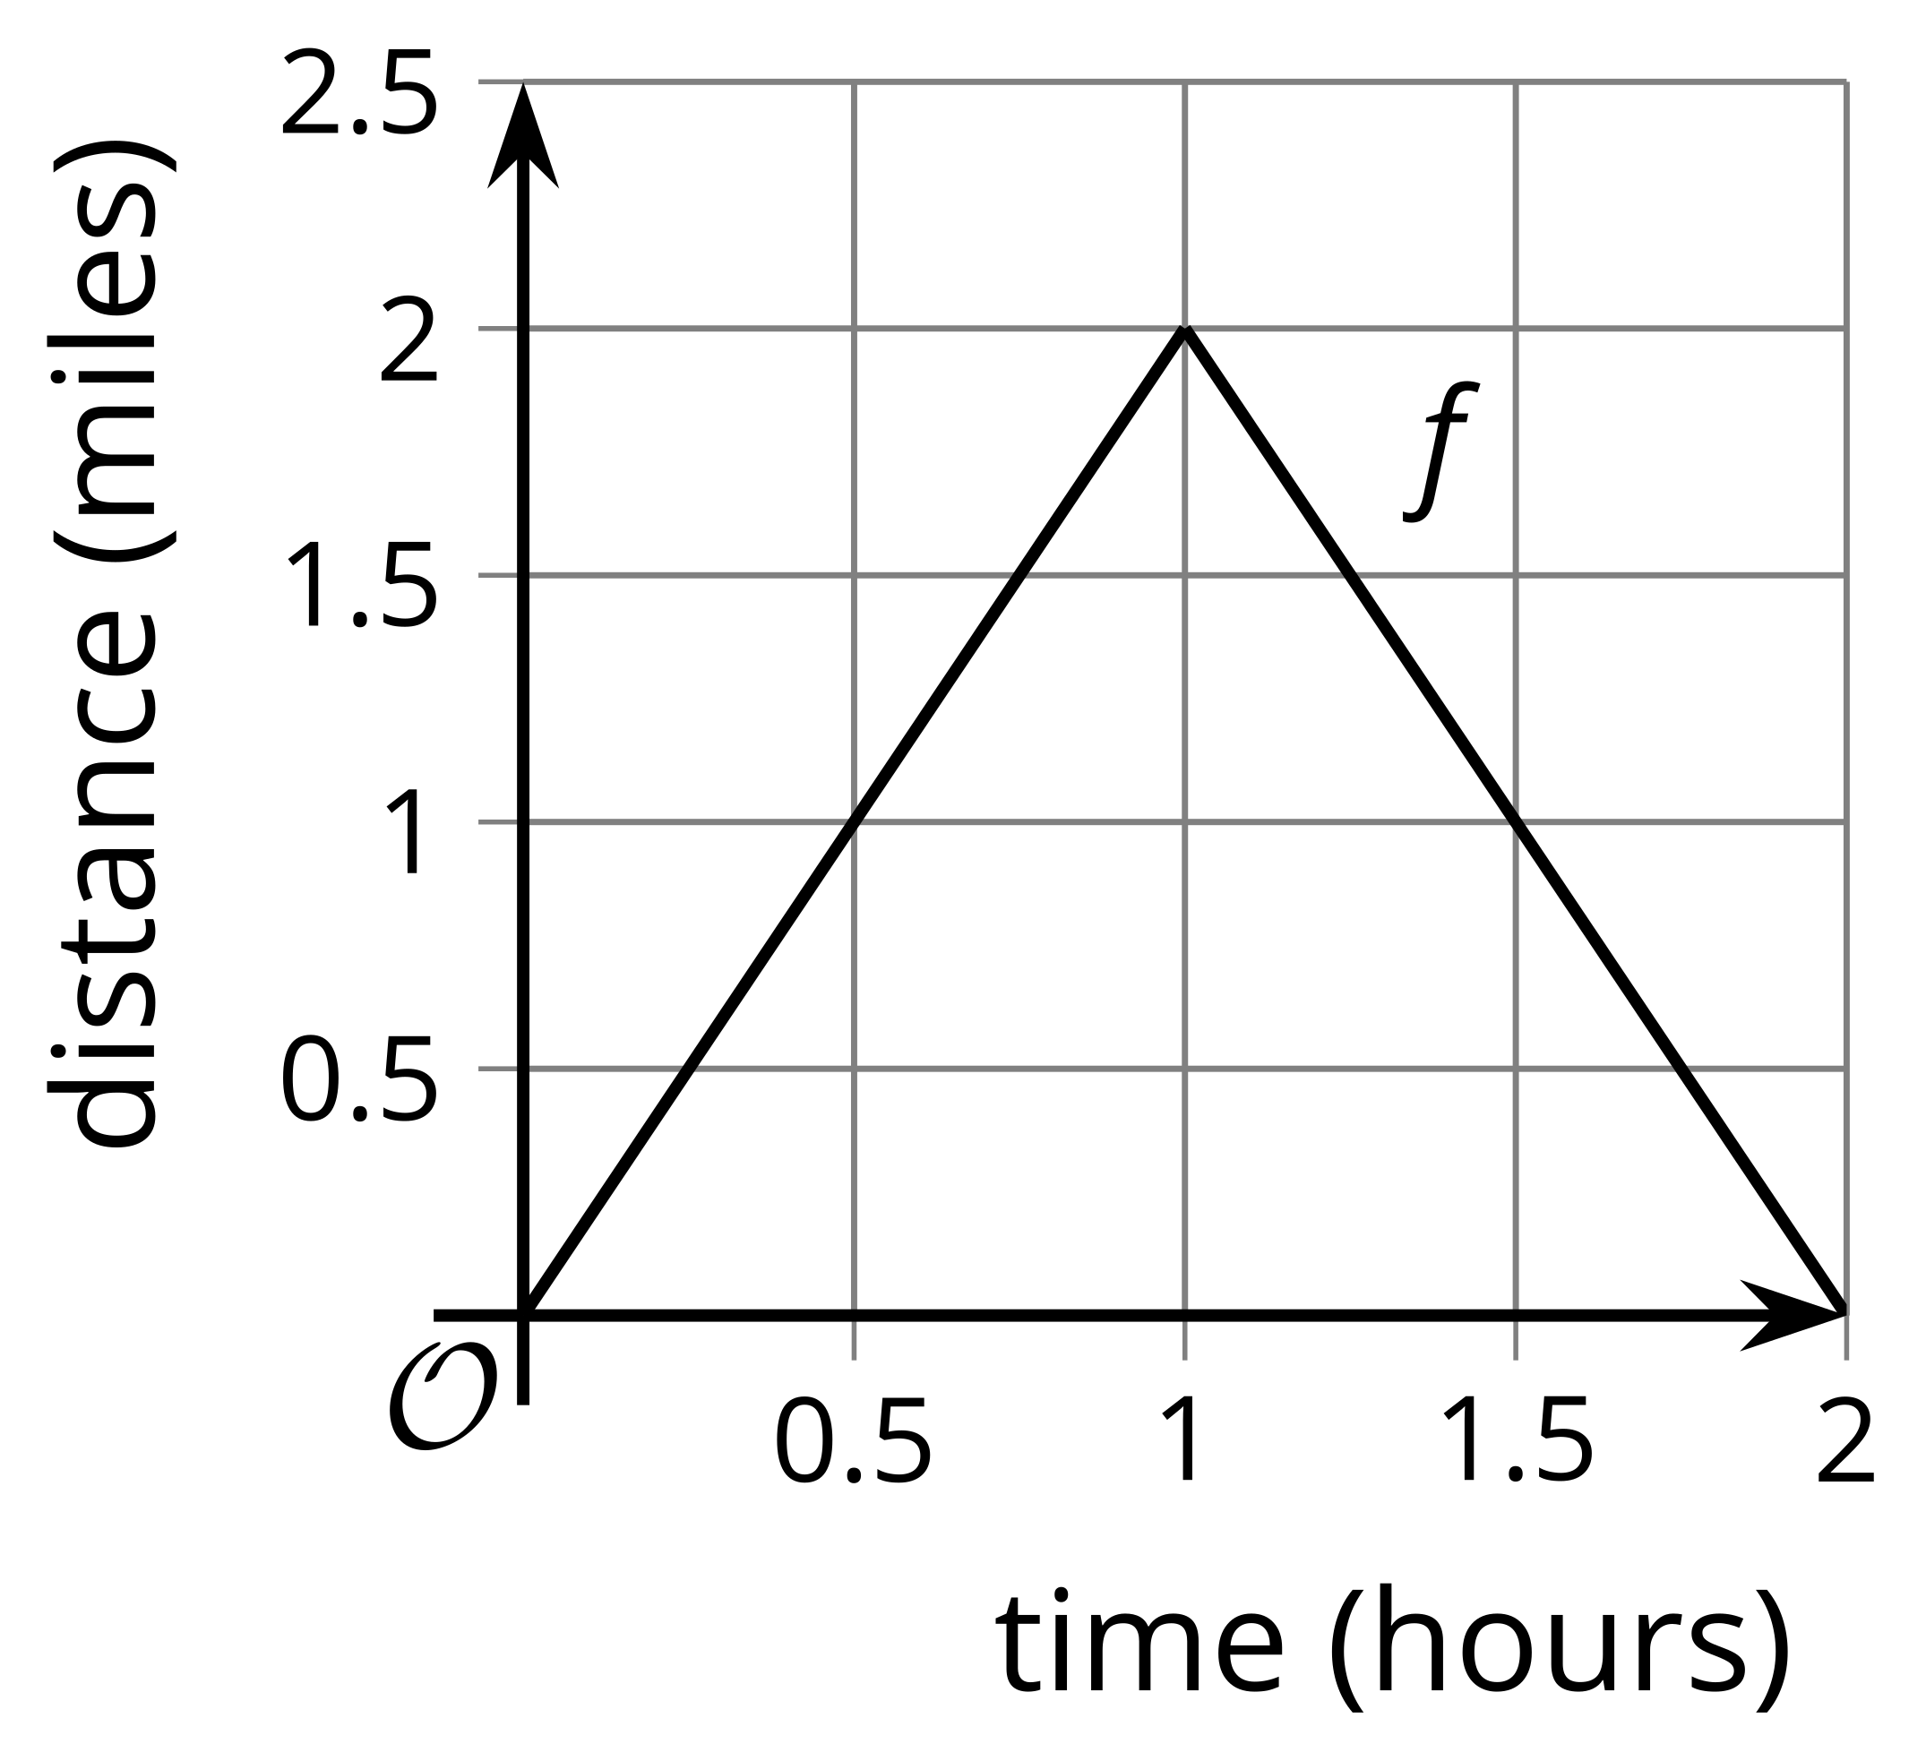
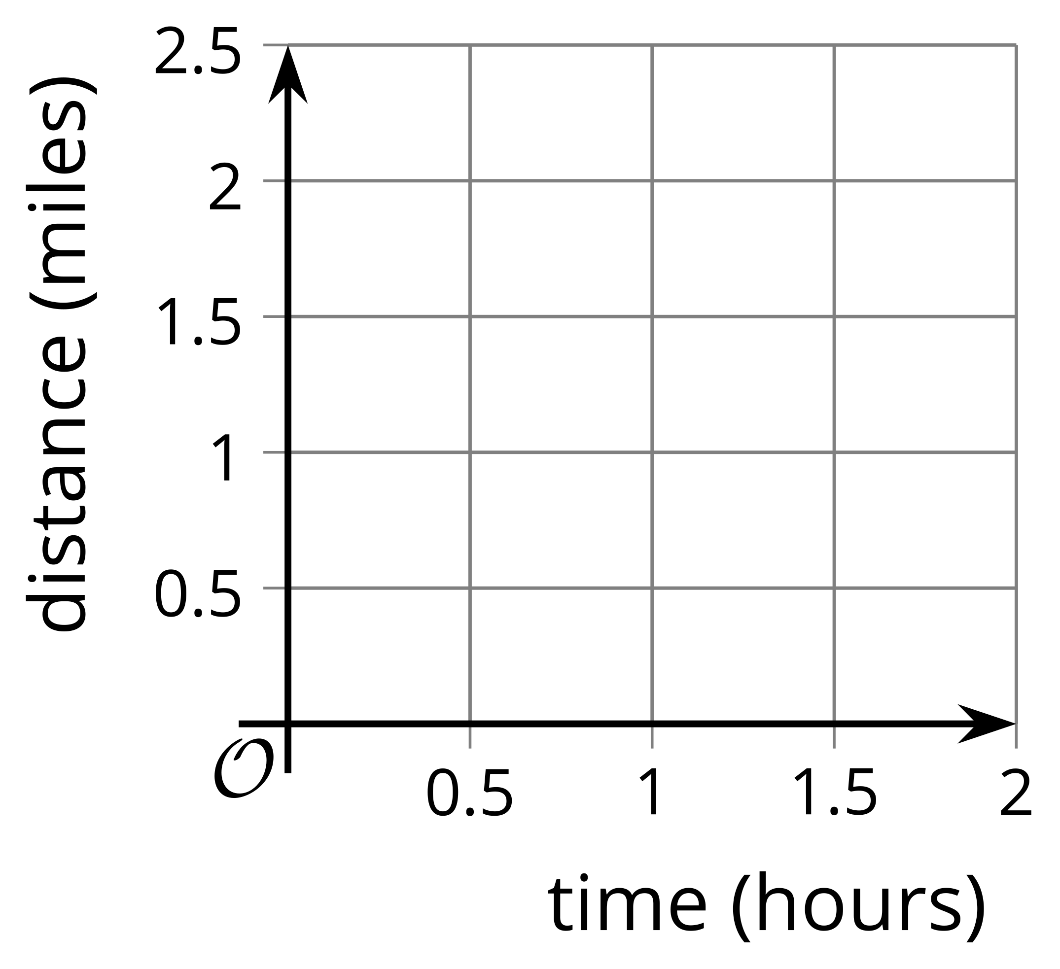
- Sketch a graph of the function $g$ that gives her distance $g(t)$, in miles, from home as a function of time $t$ if she walks 4 miles per hour.
- Write an equation for $g$ in terms of $f$. Be prepared to explain why your equation makes sense.

2 A New Set of Wheels

Student Task Statement
Remember Clare on the Ferris wheel? In the table, we have the function $F$ which gives her height $F(t)$ above the ground, in feet, $t$ seconds after starting her descent from the top. Today Clare tried out two new Ferris wheels.
- The first wheel is twice the height of $F$ and rotates at the same speed. The function $g$ gives Clare's height $g(t)$, in feet, $t$ seconds after starting her descent from the top.
- The second wheel is the same height as $F$ but rotates at half the speed. The function $h$ gives Clare's height $h(t)$, in feet, $t$ seconds after starting her descent from the top.
$t$ | $F(t)$ | $g(t)$ | $h(t)$
0 | 212
20 | 181
40 | 106
60 | 31
80 | 0
- Complete the table for the function $g$.
- Explain why there is not enough information to find the exact values for $h(20)$ and $h(60)$.
- Complete as much of the table as you can for the function $h$, modeling Claire's height on the second Ferris wheel.
- Express $g$ and $h$ in terms of $f$. Be prepared to explain your reasoning.

3 The Many Transformations of a Function $P$

Student Task Statement
Function $k$ is a transformation of function $P$ due to a scale factor.
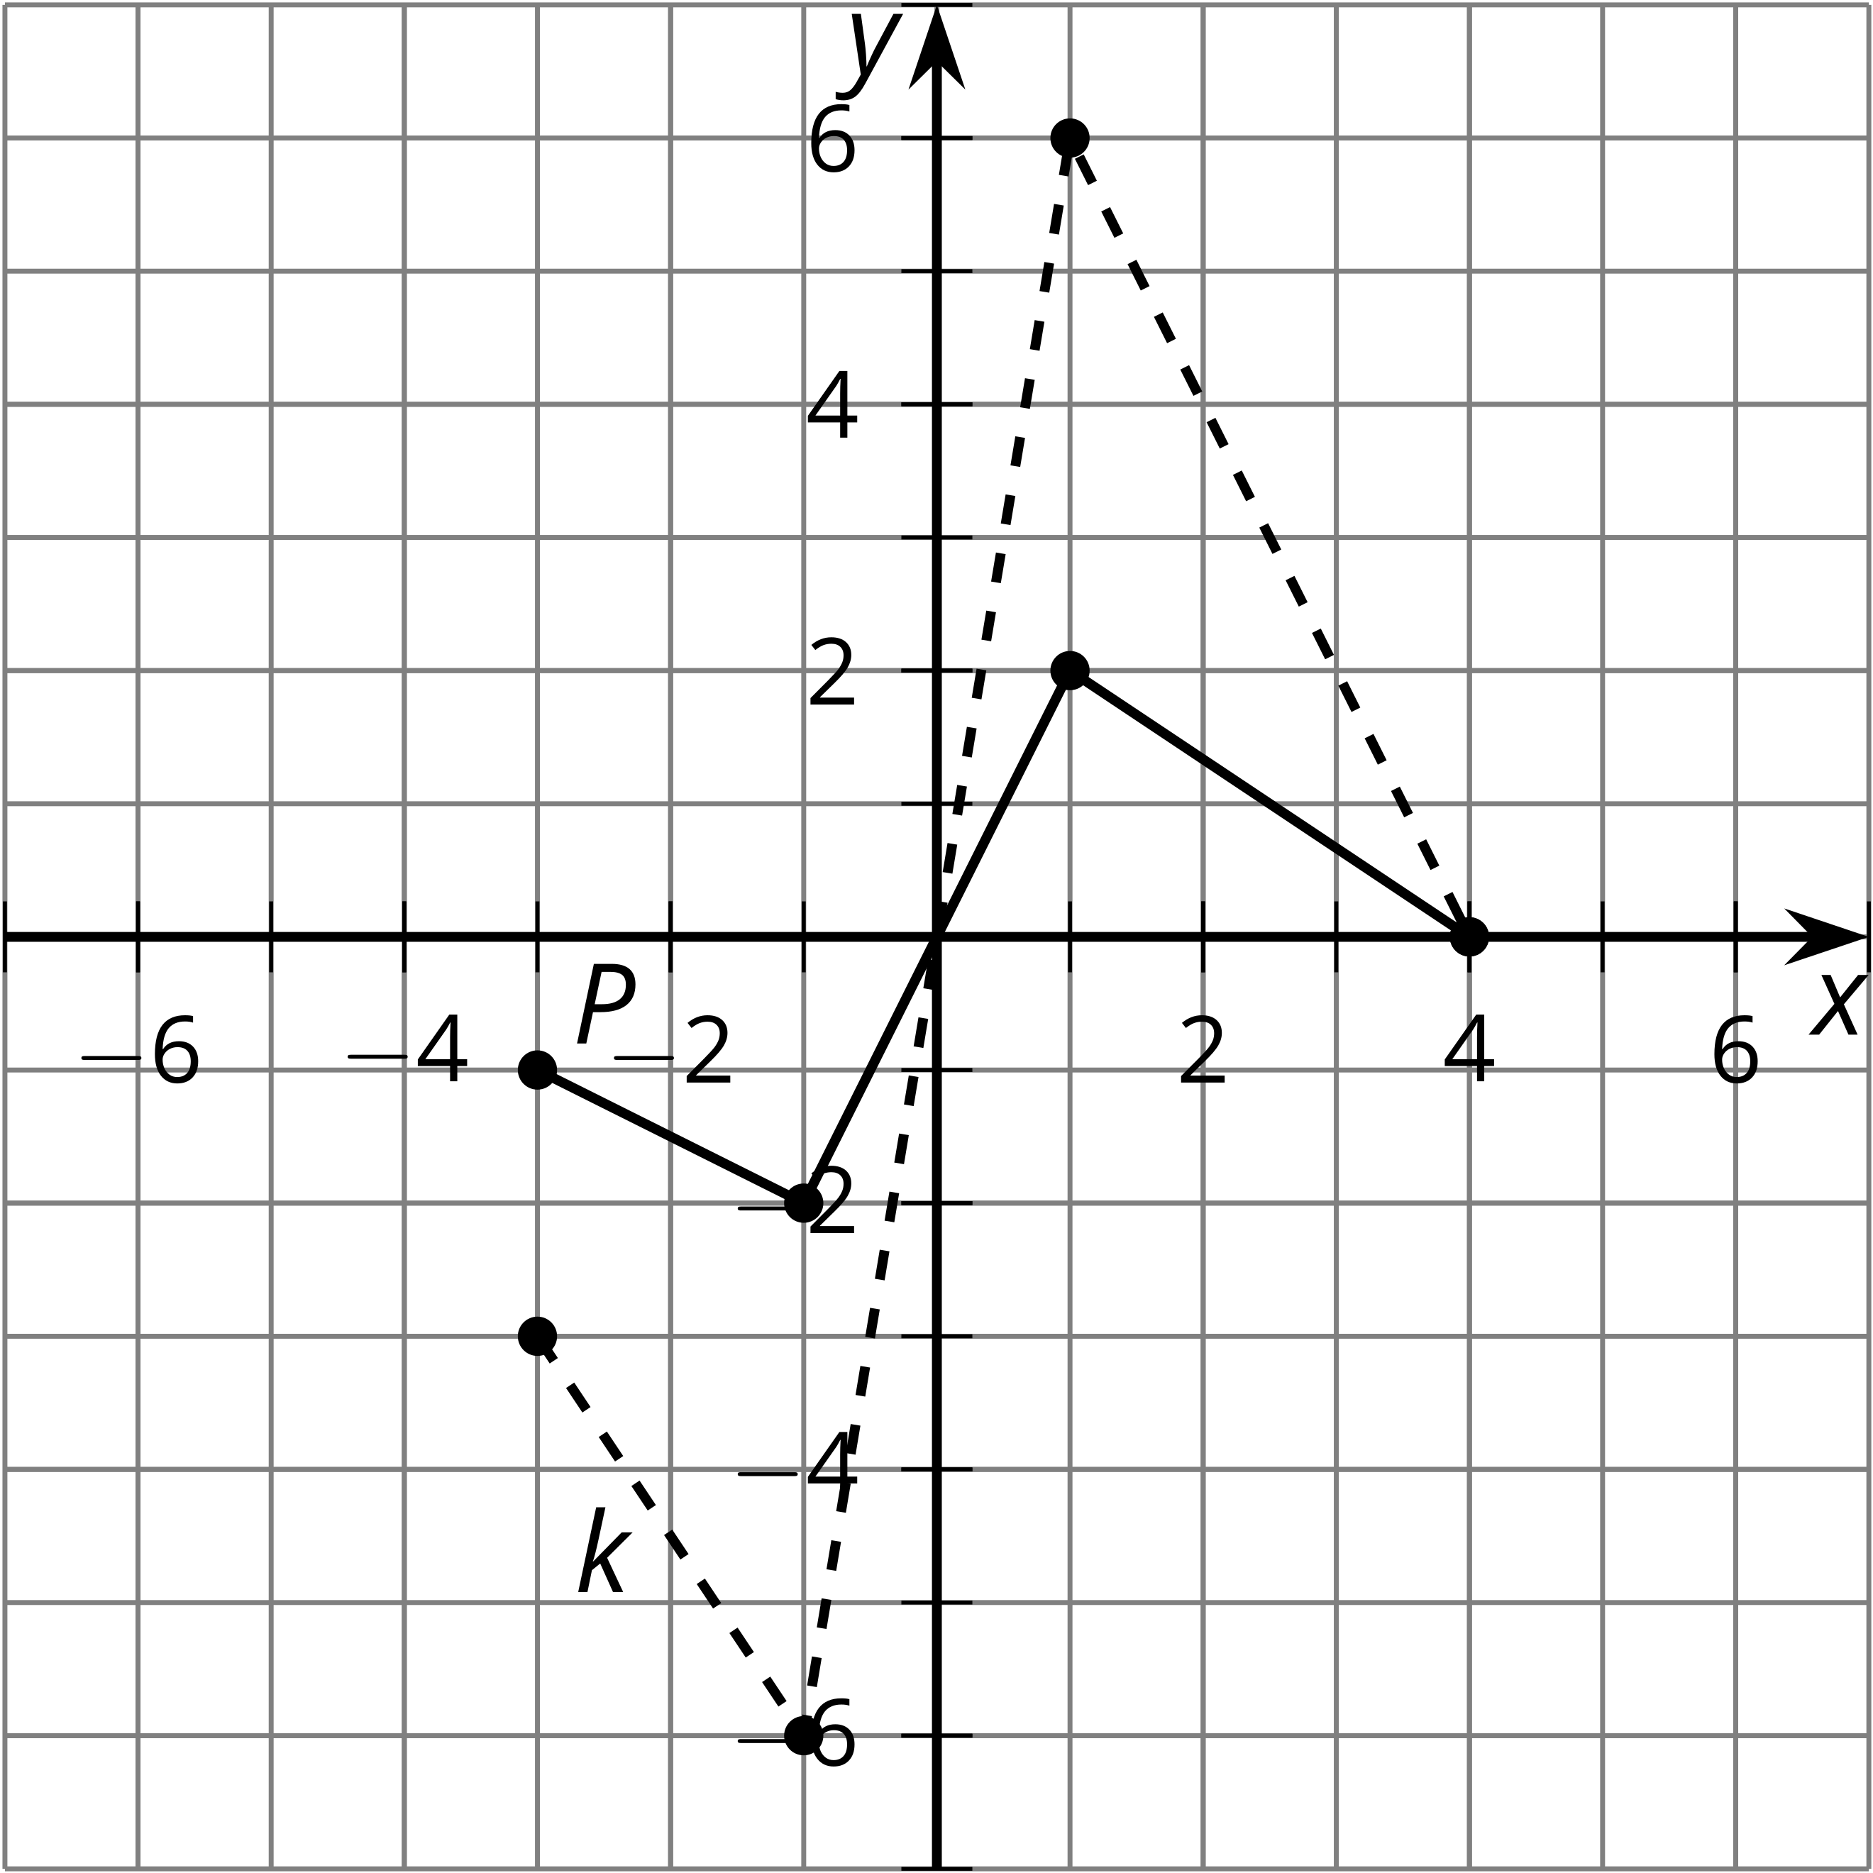
- Write an equation for $k$ in terms of $P$.
- On the same axes, graph the function $m$ where $m(x)=P(0.75x)$.
- The highest point on the graph of $P$ is $(1,2)$. What is the highest point on the graph of a function $n$ where $n(x)=P(5x)$? Explain or show your reasoning.
- The point furthest to the right on the graph of $P$ is $(4,0)$. If the point furthest to the right on the graph of a function $q$ is $(18,0)$, write a possible equation for $q$ in terms of $P$.
© CC BY 2019 by Illustrative Mathematics

