Lesson 11: Congruence

11.1: Translated Images
All of these triangles are congruent. Sometimes we can take one figure to another with a translation. Shade the triangles that are images of triangle $ABC$ under a translation.
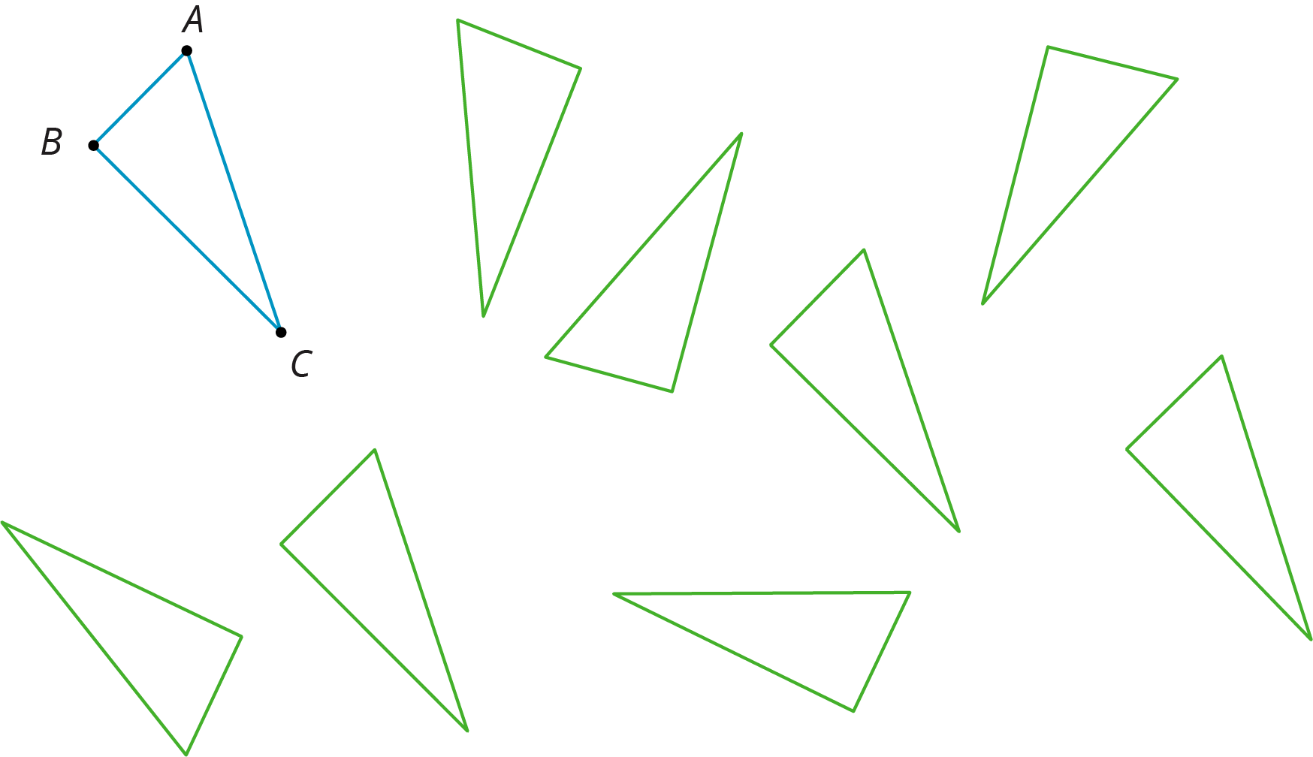

11.2: Congruent Pairs
For each of the following pairs of shapes, decide whether or not they are congruent. Explain your reasoning.

- 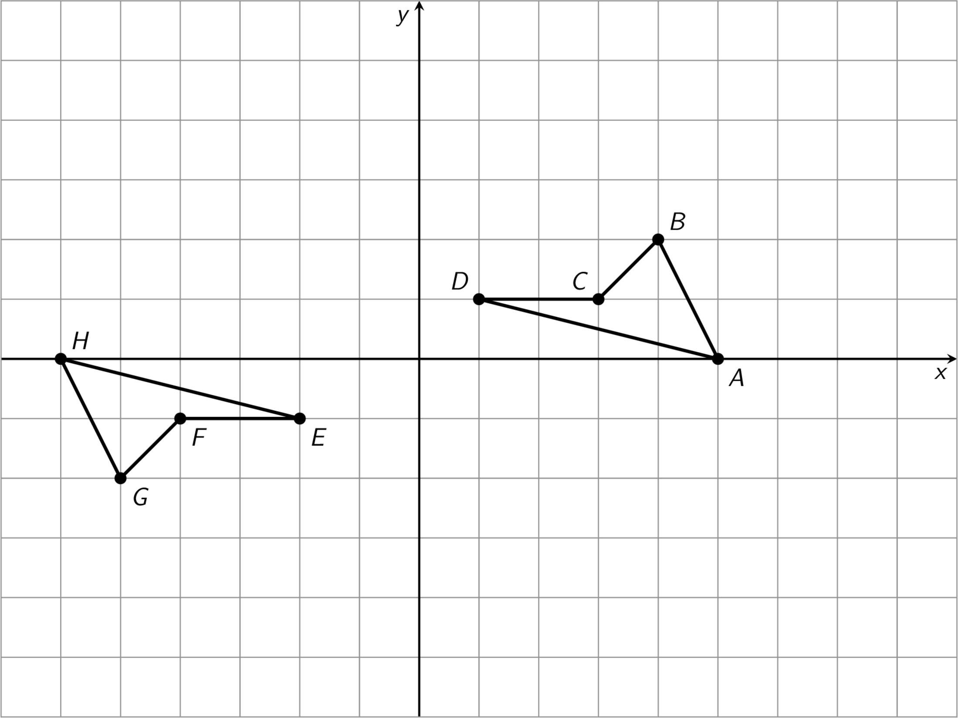

- 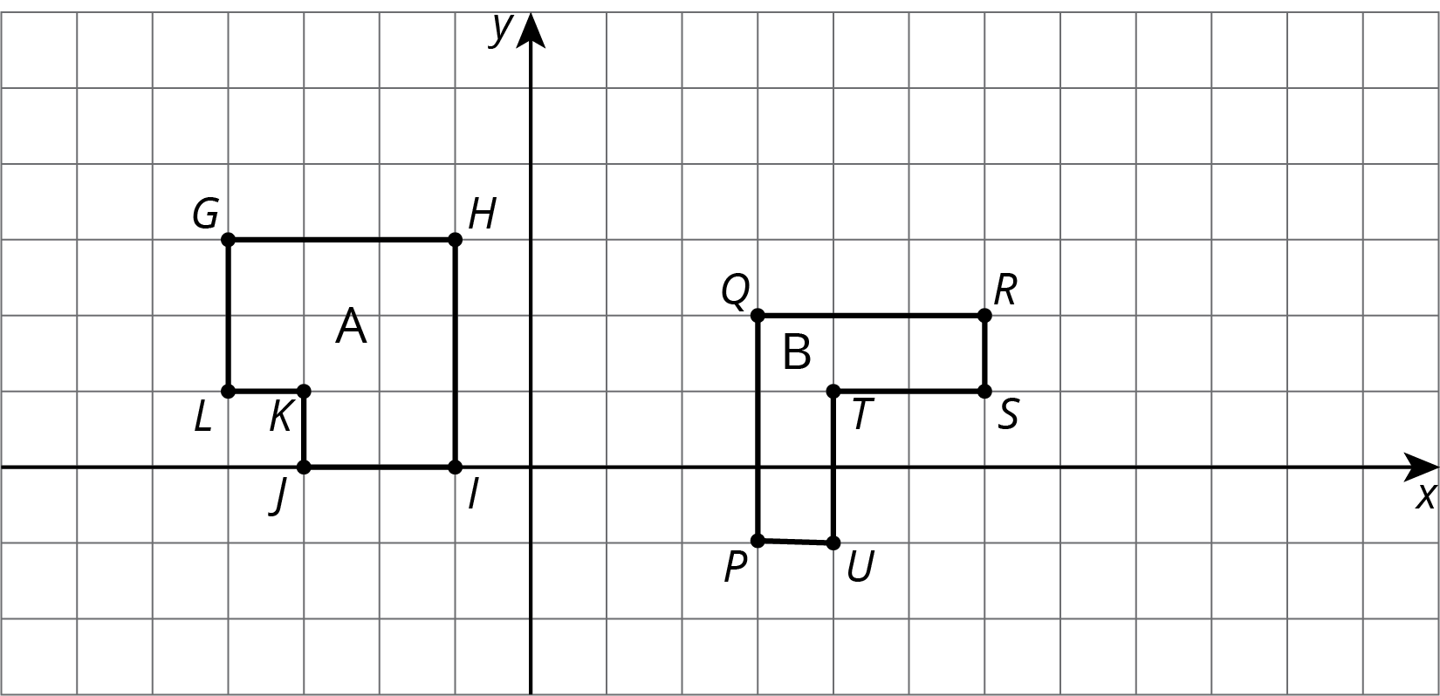

- 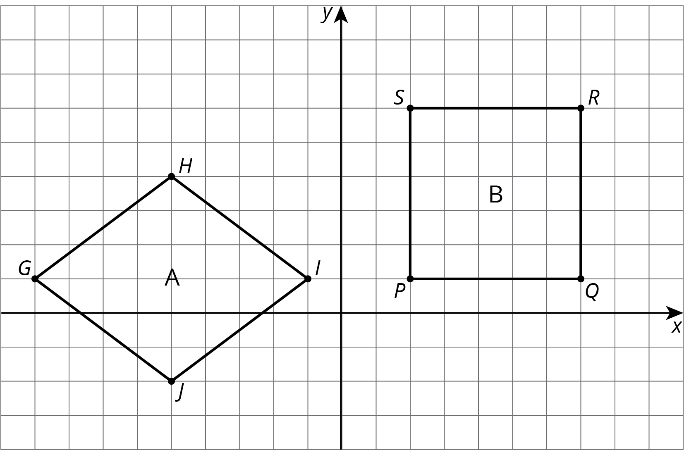

- 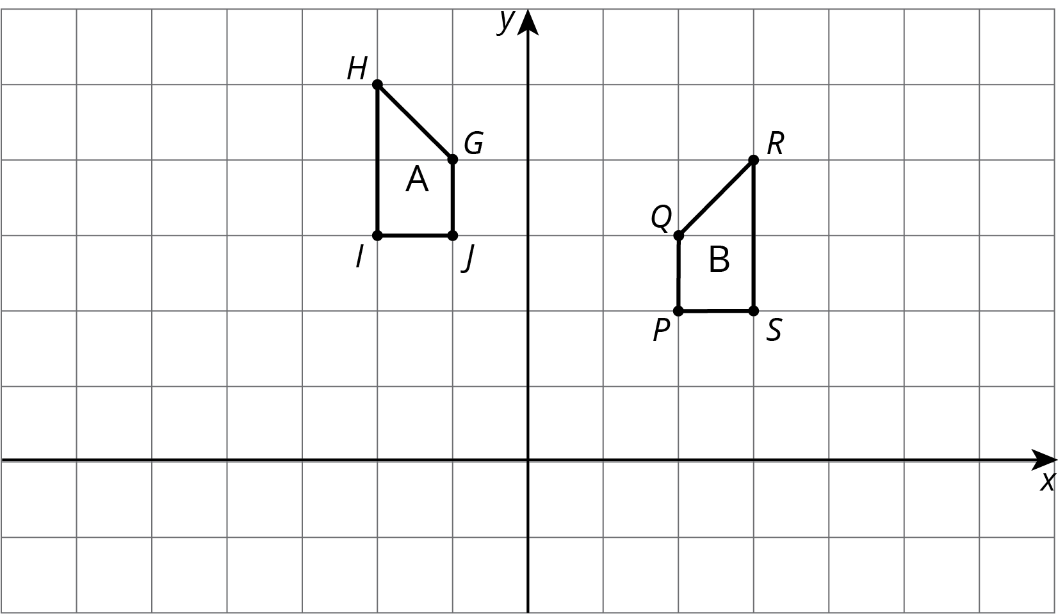

- 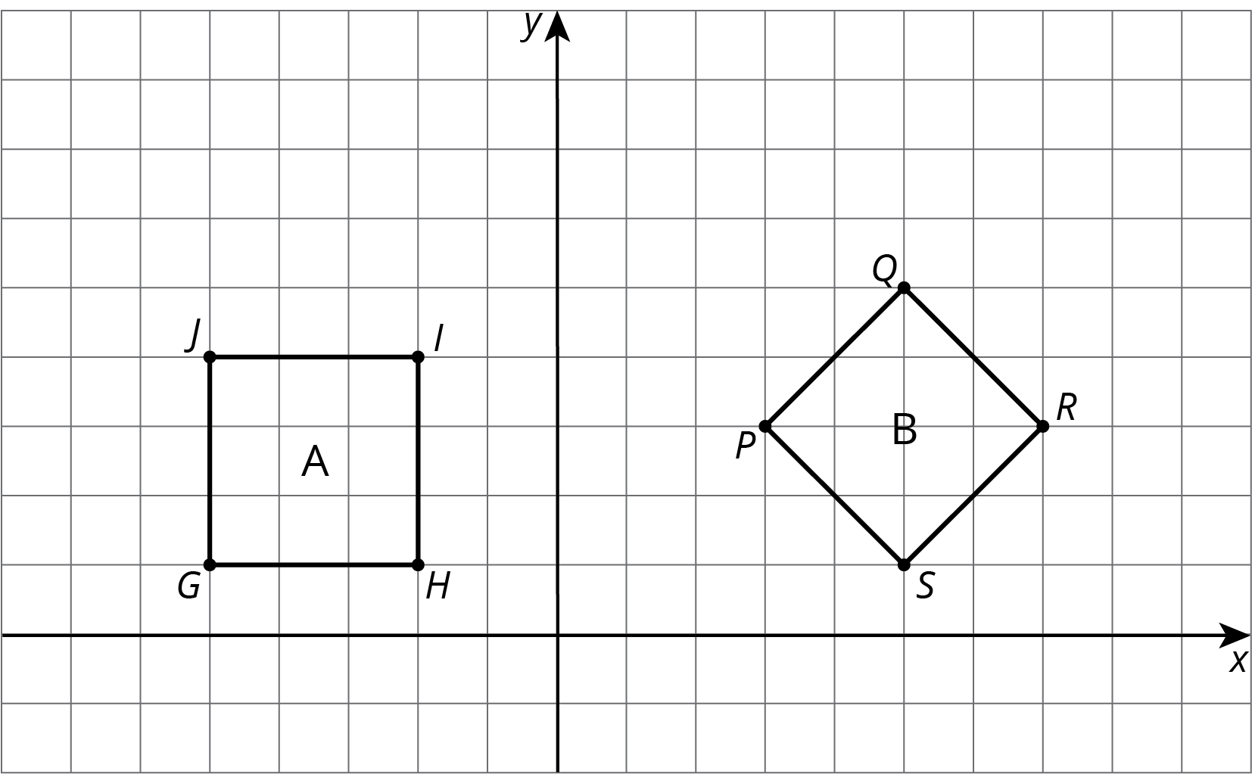

Are you ready for more?
A polygon has 8 sides: five of length 1, two of length 2, and one of length 3. All sides lie on grid lines. (It may be helpful to use graph paper when working on this problem.)
- Find a polygon with these properties.
- Is there a second polygon, not congruent to your first, with these properties?

11.3: Corresponding Points in Congruent Figures
Here are two congruent shapes with some corresponding points labeled.
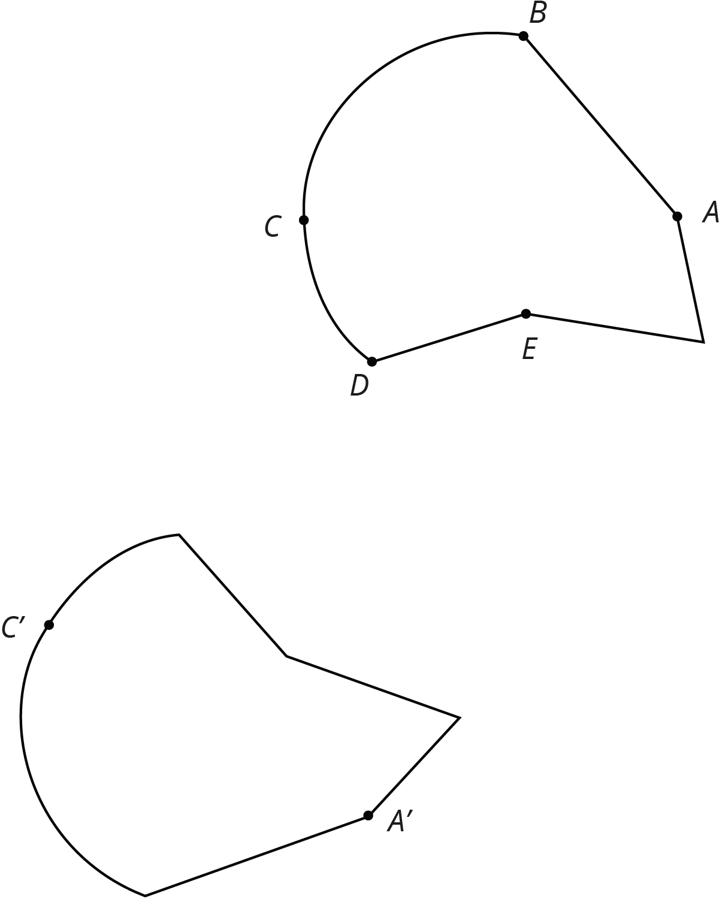
- Draw the points corresponding to $B$, $D$, and $E$, and label them $B^{′}$, $D^{′}$, and $E^{′}$.
- Draw line segments $AD$ and $A^{′}D^{′}$ and measure them. Do the same for segments $BC$ and $B^{′}C^{′}$ and for segments $AE$ and $A^{′}E^{′}$. What do you notice?
- Do you think there could be a pair of corresponding segments with different lengths? Explain.

Lesson 11 Summary
How do we know if two figures are congruent?
- If we copy 1 figure on tracing paper and move the paper so the copy covers the other figure exactly, then that suggests they are congruent.
- We can prove that 2 figures are congruent by describing a sequence of translations, rotations, and reflections that move 1 figure onto the other so they match up exactly.
- Distances between corresponding points on congruent figures are always equal, even for curved shapes. For example, corresponding segments $AB$ and $A^{′}B^{′}$ on these congruent ovals have the same length:
- 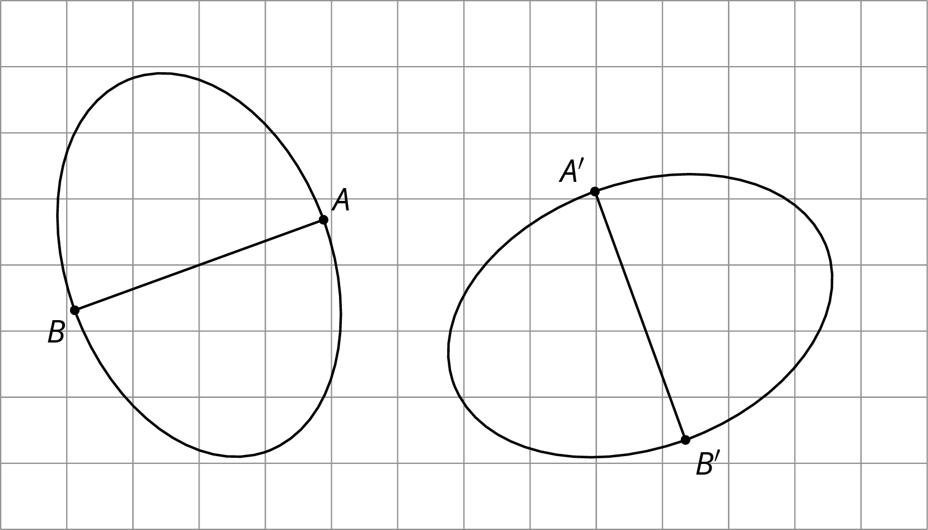
How do we know that 2 figures are not congruent?
- If there is no correspondence between the figures where the parts have equal measure, that proves that the two figures are not congruent. In particular,
  - If two polygons have different sets of side lengths, they can’t be congruent. For example, the figure on the left has side lengths 3, 2, 1, 1, 2, 1. The figure on the right has side lengths 3, 3, 1, 2, 2, 1. There is no way to make a correspondence between them where all corresponding sides have the same length.
  - 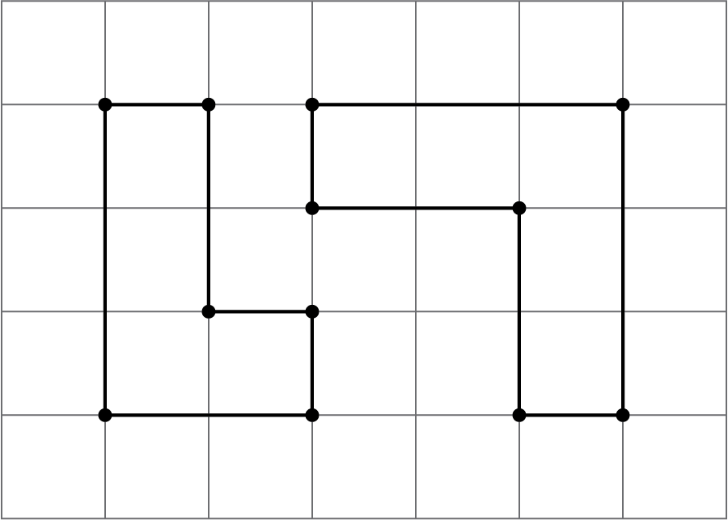
  - If two polygons have the same side lengths, but their orders can’t be matched as you go around each polygon, the polygons can’t be congruent. For example, rectangle $ABCD$ can’t be congruent to quadrilateral $EFGH$. Even though they both have two sides of length 3 and two sides of length 5, they don’t correspond in the same order. In $ABCD$, the order is 3, 5, 3, 5 or 5, 3, 5, 3; in $EFGH$, the order is 3, 3, 5, 5 or 3, 5, 5, 3 or 5, 5, 3, 3.
  - 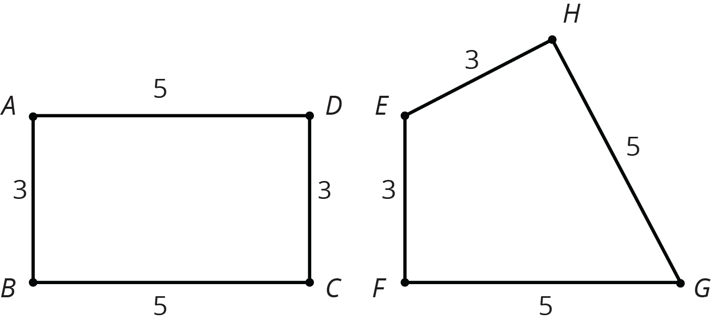
  - If two polygons have the same side lengths, in the same order, but different corresponding angles, the polygons can’t be congruent. For example, parallelogram $JKLM$ can’t be congruent to rectangle $ABCD$. Even though they have the same side lengths in the same order, the angles are different. All angles in $ABCD$ are right angles. In $JKLM$, angles $J$ and $L$ are less than 90 degrees and angles $K$ and $M$ are more than 90 degrees.
  - 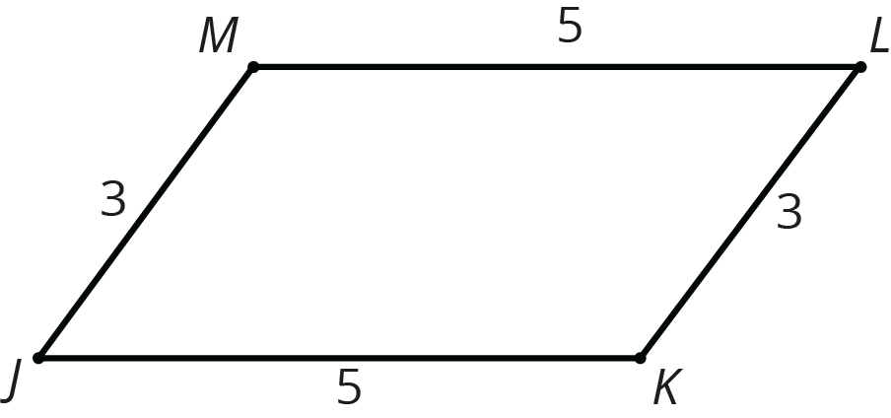
  - If you have curved figures, like these 2 ovals, you can find parts of the figures that should correspond but that have different measurements. On both, the longest distance from left to right is 5 units across, and the longest distance from top to bottom is 4 units. The line segment from the highest to lowest point is in the middle of the left oval, but in the right oval, it’s 2 units from the right end and 3 units from the left end. This proves they are not congruent.
  - 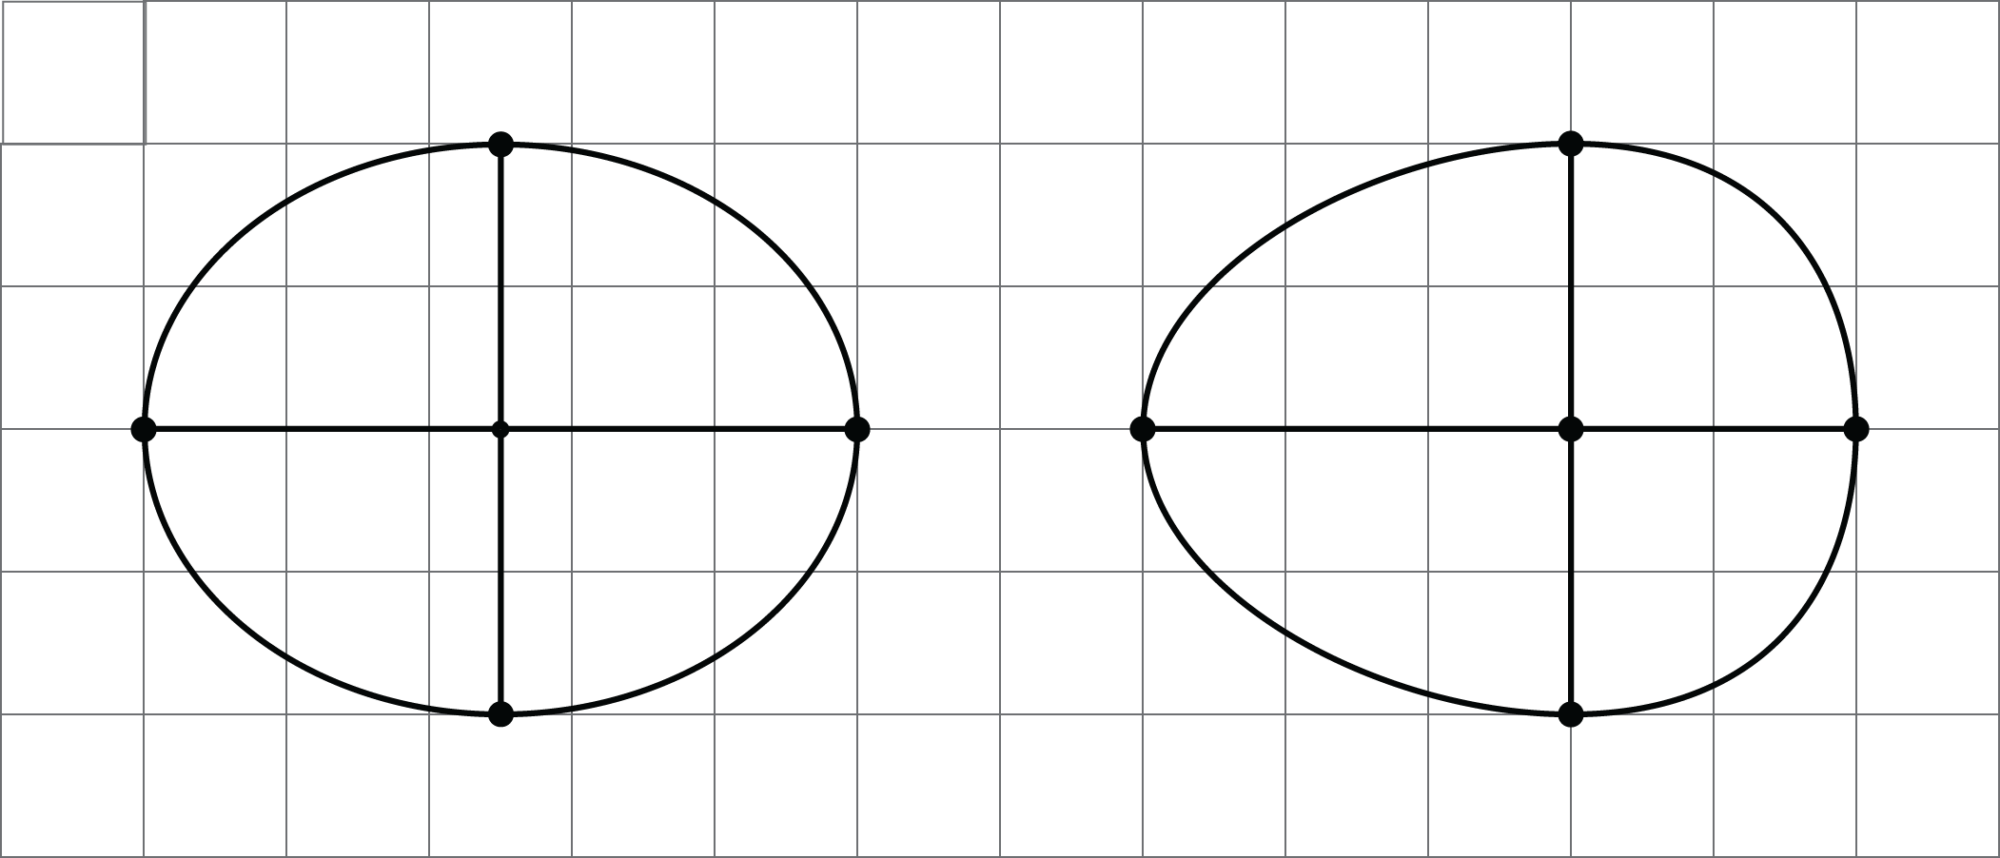
© CC BY Open Up Resources. Adaptations CC BY IM.

