Lesson 9: More and Less than 1%

9.1: Number Talk: What Percentage?
Determine the percentage mentally.
10 is what percentage of 50?
5 is what percentage of 50?
1 is what percentage of 50?
17 is what percentage of 50?

9.2: Waiting Tables
During one waiter’s shift, he delivered 13 appetizers, 17 entrées, and 10 desserts.
- What percentage of the dishes he delivered were:
  - desserts?
  - appetizers?
  - entrées?
- What do your percentages add up to?

9.3: Fractions of a Percent
- Find each percentage of 60. What do you notice about your answers?
- 30% of 60
- 3% of 60
- 0.3% of 60
- 0.03% of 60
- 20% of 5,000 is 1,000 and 21% of 5,000 is 1,050. Find each percentage of 5,000 and be prepared to explain your reasoning. If you get stuck, consider using the double number line diagram.
  - 1% of 5,000
  - 0.1% of 5,000
  - 20.1% of 5,000
  - 20.4% of 5,000
- 15% of 80 is 12 and 16% of 80 is 12.8. Find each percentage of 80 and be prepared to explain your reasoning.
  - 15.1% of 80
  - 15.7% of 80

Are you ready for more?
To make Sierpinski's triangle,
- Start with an equilateral triangle. This is step 1.
- Connect the midpoints of every side, and remove the middle triangle, leaving three smaller triangles. This is step 2.
- Do the same to each of the remaining triangles. This is step 3.
- Keep repeating this process.
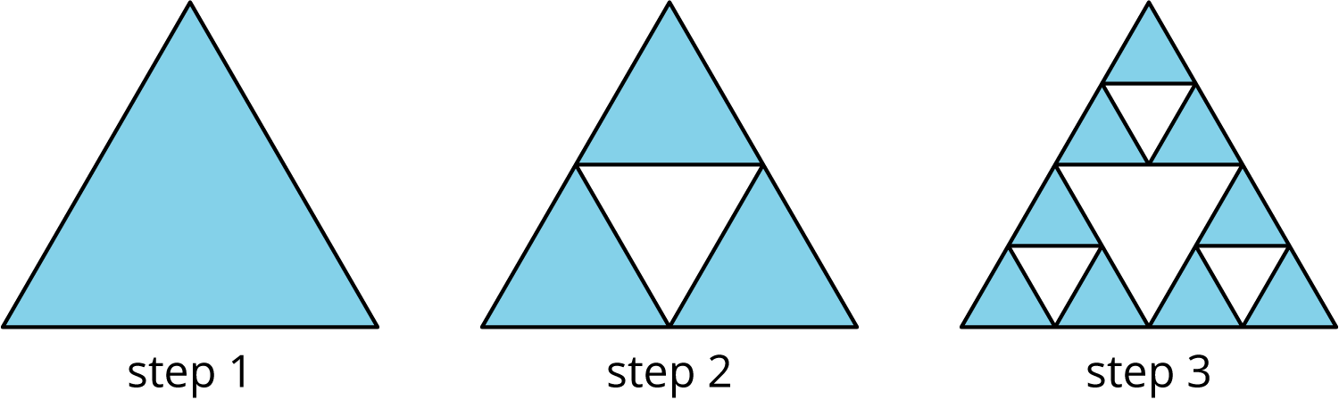
- What percentage of the area of the original triangle is left after step 2? Step 3? Step 10?
- At which step does the percentage first fall below 1%?

9.4: Population Growth
- The population of City A was approximately 243,000 people, and it increased by 8% in one year. What was the new population?
- The population of city B was approximately 7,150,000, and it increased by 0.8% in one year. What was the new population?

Lesson 9 Summary
A percentage, such as 30%, is a rate per 100. To find 30% of a quantity, we multiply it by $30÷100$, or 0.3.
The same method works for percentages that are not whole numbers, like 7.8% or 2.5%. In the square, 2.5% of the area is shaded.
To find 2.5% of a quantity, we multiply it by $2.5÷100$, or 0.025. For example, to calculate 2.5% interest on a bank balance of $80, we multiply $(0.025)⋅80=2$, so the interest is $2.
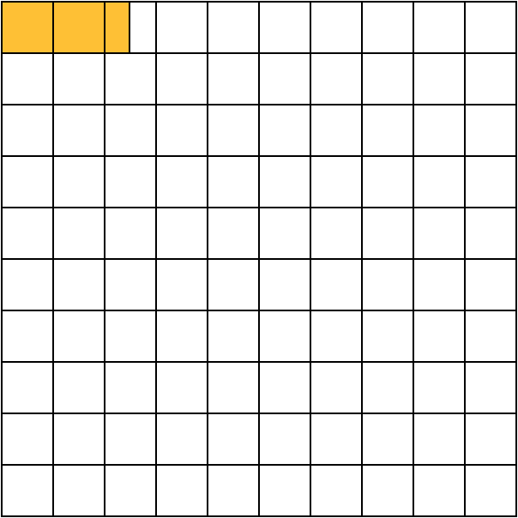
We can sometimes find percentages like 2.5% mentally by using convenient whole number percents. For example, 25% of 80 is one fourth of 80, which is 20. Since 2.5 is one tenth of 25, we know that 2.5% of 80 is one tenth of 20, which is 2.
© CC BY Open Up Resources. Adaptations CC BY IM.

