Lesson 7: A Proof of the Pythagorean Theorem
Let’s prove the Pythagorean Theorem.

7.1: Notice and Wonder: A Square and Four Triangles
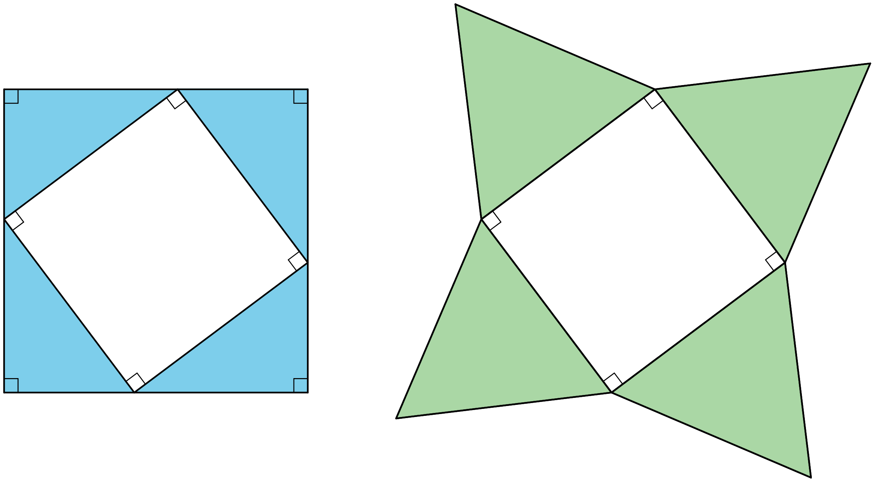
What do you notice? What do you wonder?

7.2: Adding Up Areas
Both figures shown here are squares with a side length of $a+b$. Notice that the first figure is divided into two squares and two rectangles. The second figure is divided into a square and four right triangles with legs of lengths $a$ and $b$. Let’s call the hypotenuse of these triangles $c$.
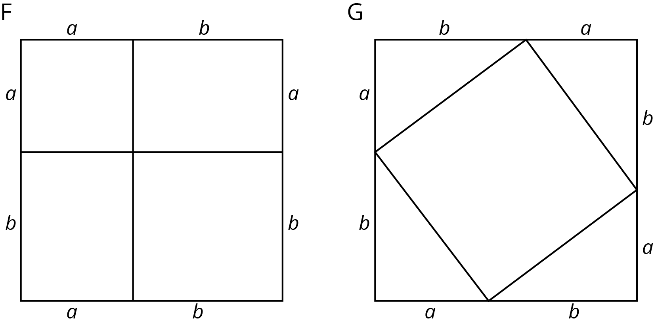
- What is the total area of each figure?
- Find the area of each of the 9 smaller regions shown the figures and label them.
- Add up the area of the four regions in Figure F and set this expression equal to the sum of the areas of the five regions in Figure G. If you rewrite this equation using as few terms as possible, what do you have?

Are you ready for more?
Take a 3-4-5 right triangle, add on the squares of the side lengths, and form a hexagon by connecting vertices of the squares as in the image. What is the area of this hexagon?
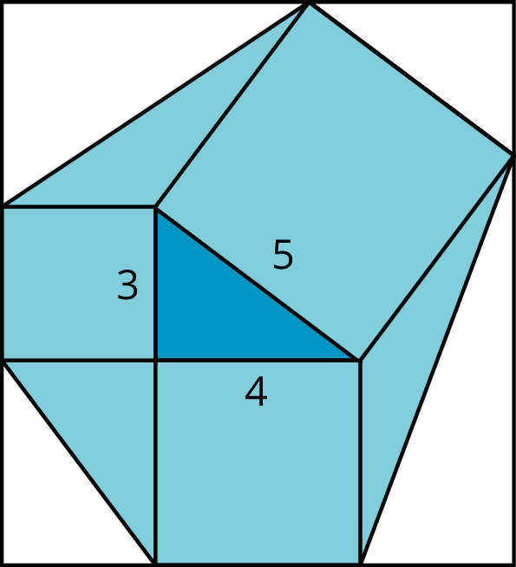

7.3: Let’s Take it for a Spin
Find the unknown side lengths in these right triangles.
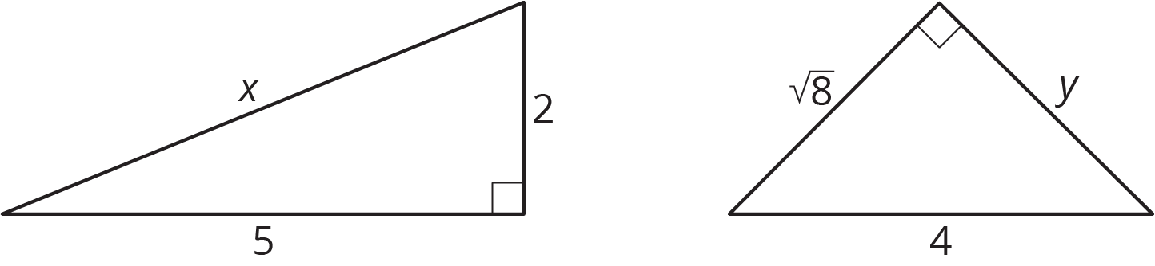

7.4: A Transformational Proof
Your teacher will give your group a sheet with 4 figures and a set of 5 cut out shapes labeled D, E, F, G, and H.
- Arrange the 5 cut out shapes to fit inside Figure 1. Check to see that the pieces also fit in the two smaller squares in Figure 4.
- Explain how you can transform the pieces arranged in Figure 1 to make an exact copy of Figure 2.
- Explain how you can transform the pieces arranged in Figure 2 to make an exact copy of Figure 3.
- Check to see that Figure 3 is congruent to the large square in Figure 4.
- If the right triangle in Figure 4 has legs $a$ and $b$ and hypotenuse $c$, what have you just demonstrated to be true?

Lesson 7 Summary
The figures shown here can be used to see why the Pythagorean Theorem is true. Both large squares have the same area, but they are broken up in different ways. (Can you see where the triangles in Square G are located in Square F? What does that mean about the smaller squares in F and H?) When the sum of the four areas in Square F are set equal to the sum of the 5 areas in Square G, the result is $a^{2}+b^{2}=c^{2}$, where $c$ is the hypotenuse of the triangles in Square G and also the side length of the square in the middle. Give it a try!
This is true for any right triangle. If the legs are $a$ and $b$ and the hypotenuse is $c$, then $a^{2}+b^{2}=c^{2}$. This property can be used any time we can make a right triangle. For example, to find the length of this line segment:
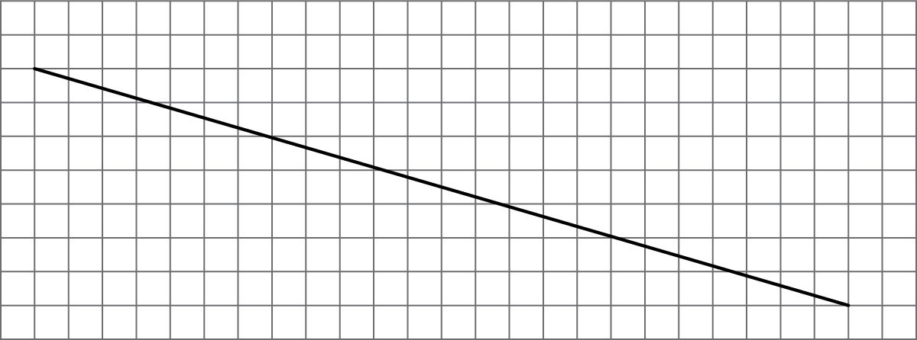
The grid can be used to create a right triangle, where the line segment is the hypotenuse and the legs measure 24 units and 7 units:
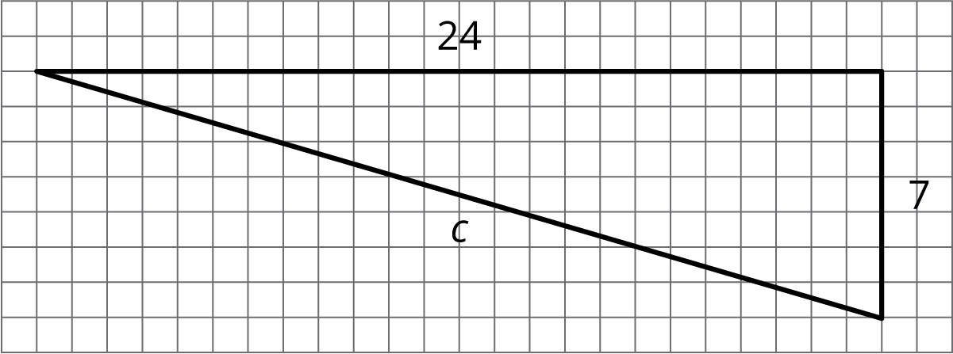
Since this is a right triangle, ${24}^{2}+7^{2}=c^{2}$. The solution to this equation (and the length of the line segment) is $c=25$.
© CC BY Open Up Resources. Adaptations CC BY IM.

