Lesson 10: Comparing Situations by Examining Ratios

10.1: Treadmills
Mai and Jada each ran on a treadmill. The treadmill display shows the distance, in miles, each person ran and the amount of time it took them, in minutes and seconds.
Here is Mai’s treadmill display:
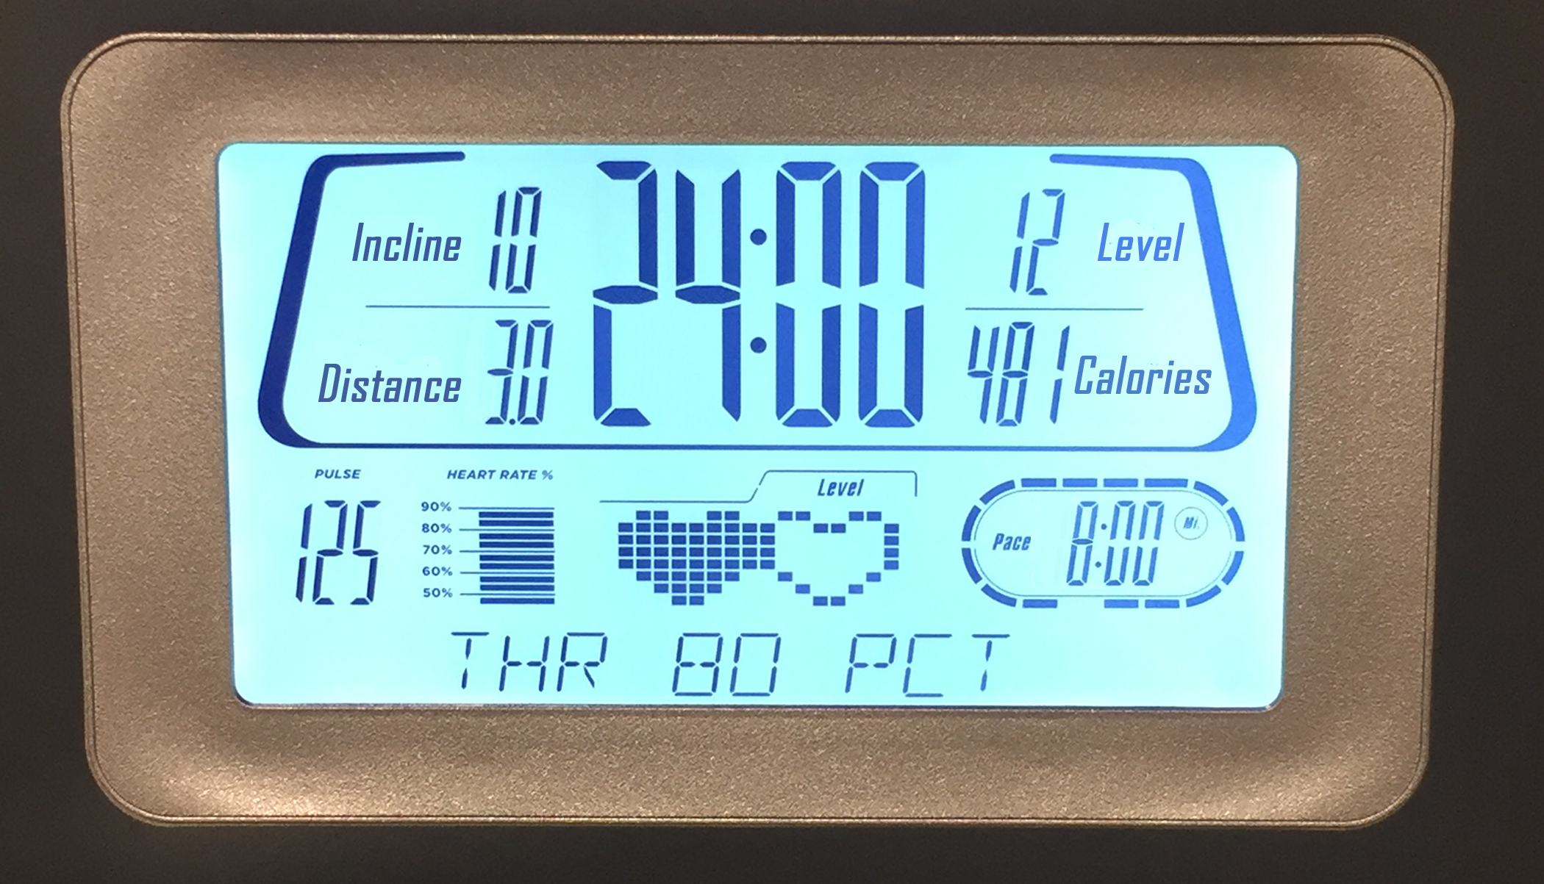
Here is Jada’s treadmill display:
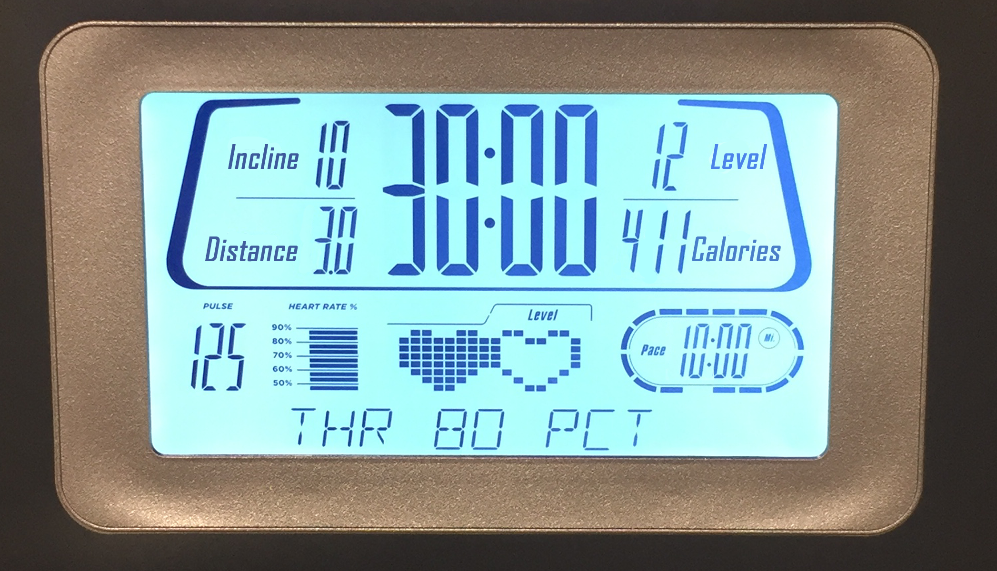
- What is the same about their workouts? What is different about their workouts?
- If each person ran at a constant speed the entire time, who was running faster? Explain your reasoning.

10.2: Concert Tickets
Diego paid $47 for 3 tickets to a concert. Andre paid $141 for 9 tickets to a concert. Did they pay at the same rate? Explain your reasoning.

10.3: Sparkling Orange Juice
Lin and Noah each have their own recipe for making sparkling orange juice.
- Lin mixes 3 liters of orange juice with 4 liters of soda water.
- Noah mixes 4 liters of orange juice with 5 liters of soda water.
How do the two mixtures compare in taste? Explain your reasoning.

Are you ready for more?
- How can Lin make her sparkling orange juice taste the same as Noah’s just by adding more of one ingredient? How much will she need?
- How can Noah make his sparkling orange juice taste the same as Lin’s just by adding more of one ingredient? How much will he need?

Lesson 10 Summary
Sometimes we want to know whether two situations are described by the same rate. To do that, we can write an equivalent ratio for one or both situations so that one part of their ratios has the same value. Then we can compare the other part of the ratios.
For example, do these two paint mixtures make the same shade of orange?
- Kiran mixes 9 teaspoons of red paint with 15 teaspoons of yellow paint.
- Tyler mixes 7 teaspoons of red paint with 10 teaspoons of yellow paint.
Here is a double number line that represents Kiran's paint mixture. The ratio $9:15$ is equivalent to the ratios $3:5$ and $6:10$.
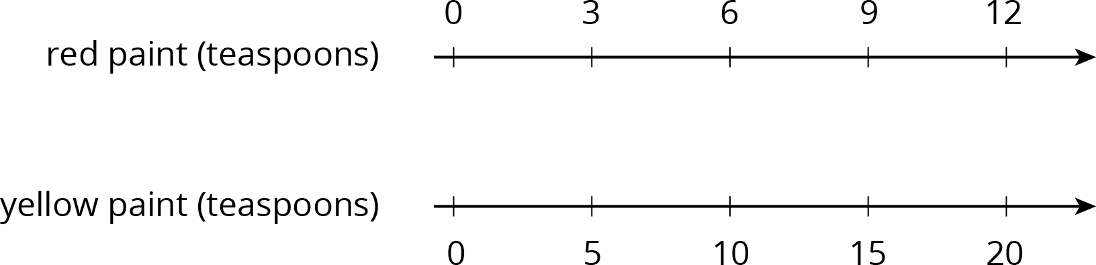
For 10 teaspoons of yellow paint, Kiran would mix in 6 teaspoons of red paint. This is less red paint than Tyler mixes with 10 teaspoons of yellow paint. The ratios $6:10$ and $7:10$ are not equivalent, so these two paint mixtures would not be the same shade of orange.
When we talk about two things happening at the same rate, we mean that the ratios of the quantities in the two situations are equivalent. There is also something specific about the situation that is the same.
- If two ladybugs are moving at the same rate, then they are traveling at the same constant speed.
- If two bags of apples are selling for the same rate, then they have the same unit price.
- If we mix two kinds of juice at the same rate, then the mixtures have the same taste.
- If we mix two colors of paint at the same rate, then the mixtures have the same shade.
© CC BY Open Up Resources. Adaptations CC BY IM.

