Unit 3 Lesson 1: Scale Drawings

1 Is That the Same Hippo? (Warm up)

Student Task Statement
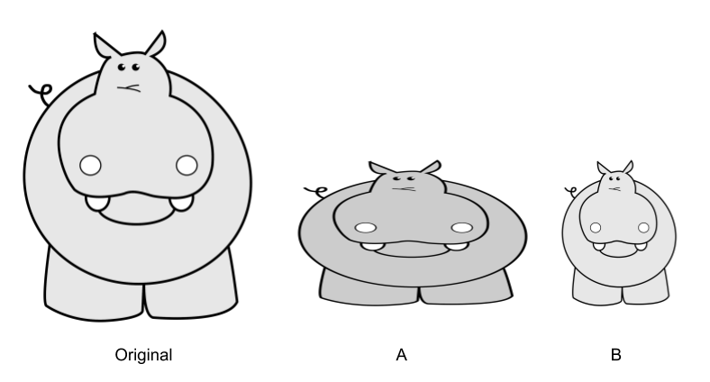
Diego took a picture of a hippo and then edited it. Which is the distorted image? How can you tell?
Is there anything about the pictures you could measure to test whether there’s been a distortion?

Activity Synthesis

Scale factor is 2 or $\frac{1}{2}$

2 Sketching Stretching

Student Task Statement
A dilation with center $O$ and positive scale factor $r$ takes a point $P$ along the ray $OP$ to another point whose distance is $r$ times farther away from $O$ than $P$ is. If $r$ is less than 1 then the new point is really closer to $O$, not farther away.
- Dilate $H$ using $C$ as the center and a scale factor of 3. $H$ is 40 mm from $C$.
- Dilate $K$ using $O$ as the center and a scale factor of $\frac{3}{4}$. $K$ is 40 mm from $O$.

Activity Synthesis

3 Mini Me

Student Task Statement
- Dilate the figure using center $P$ and scale factor $\frac{1}{2}$.

- What do you notice? What do you wonder?

Images for Activity Synthesis

$PA^{′}=k⋅PA$
© CC BY 2019 by Illustrative Mathematics®

