Lesson 5: How Many Fingers? How Many Dots?
- Let’s figure out how many things there are.

Warm-up: Estimation Exploration: Connecting Cubes
How many cubes are there?
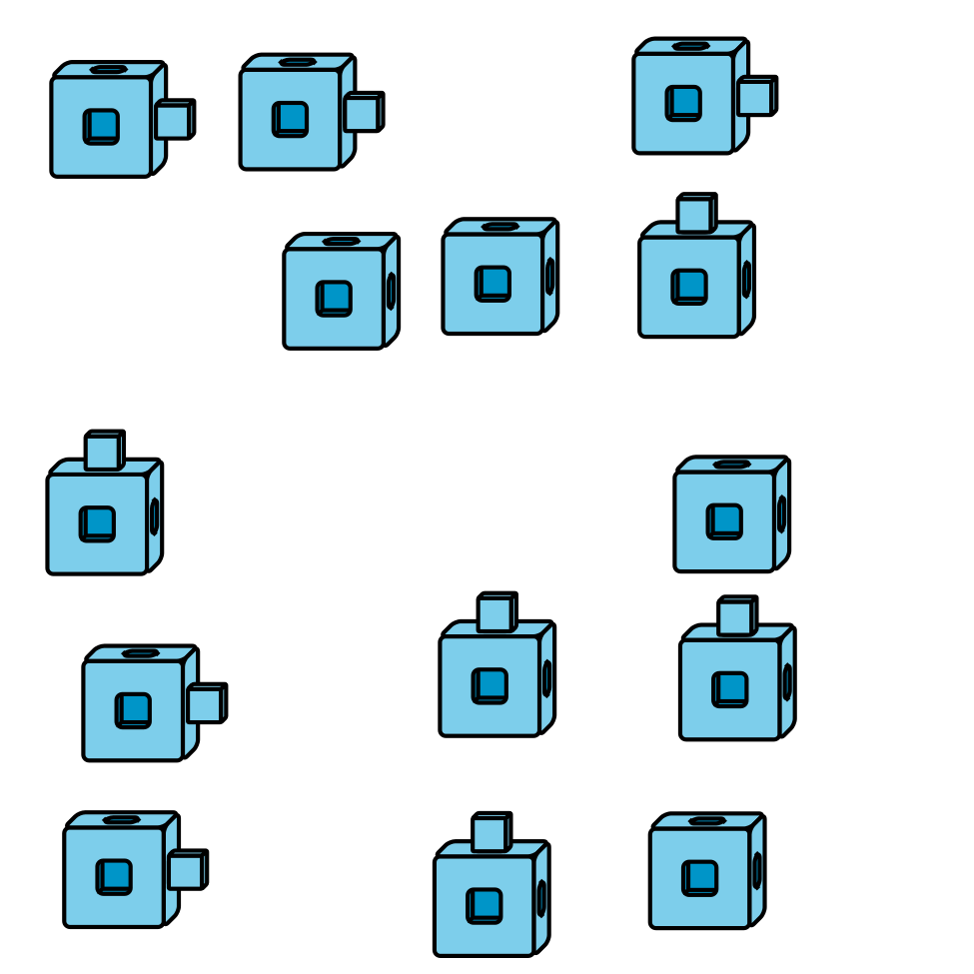
Record an estimate that is:
too low | about right | too high
How many cubes are there?
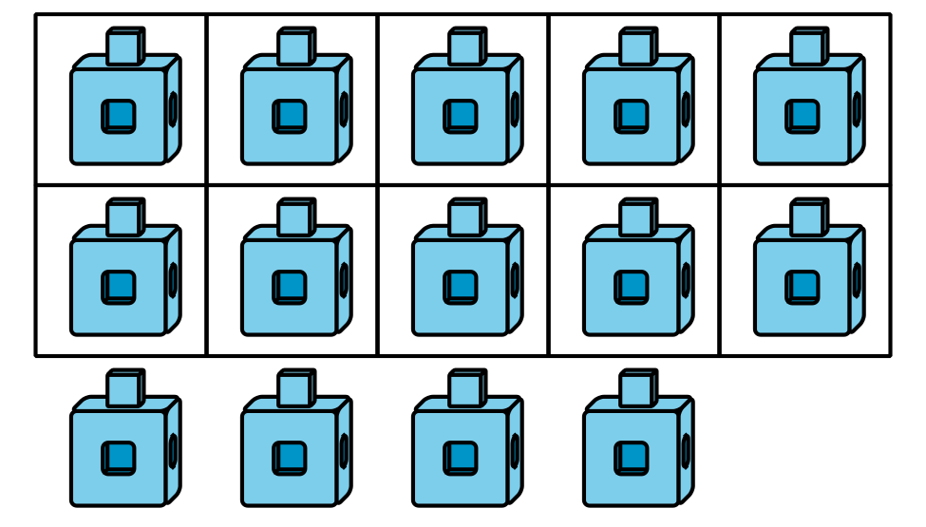
Record an estimate that is:
too low | about right | too high

5.1: How Many Fingers?
- 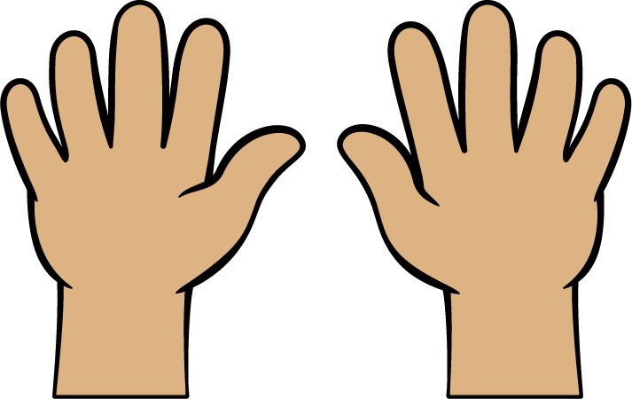
- 14
- 17
- 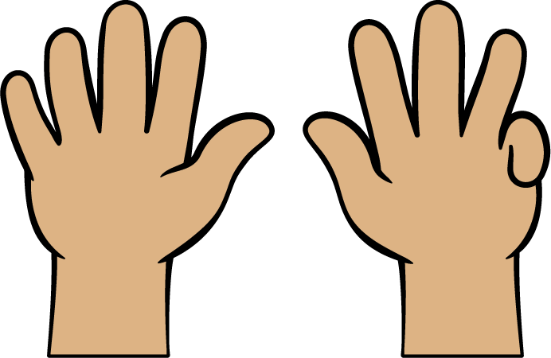
- 13
- 19
- 16

5.2: How Many Dots in 10-frames?

- 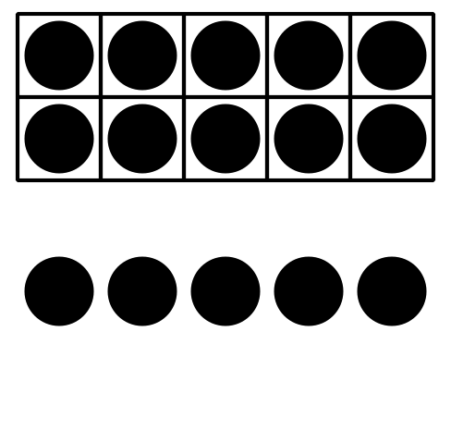
- 10 12 15

- 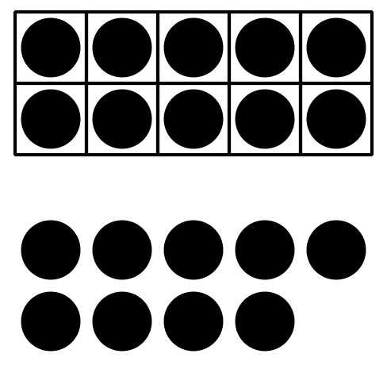
- 19 11 14

- 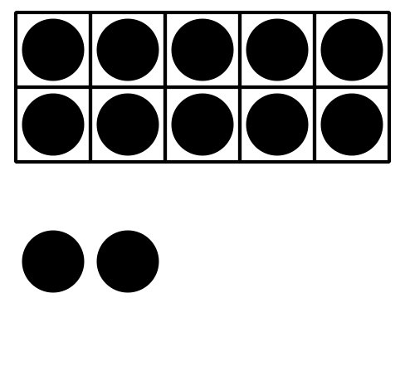
- 13 15 12

- 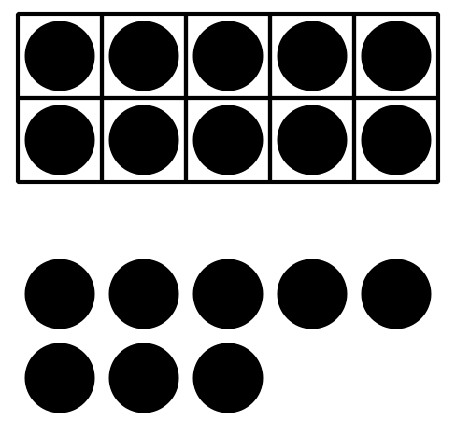
- 18 14 17

- 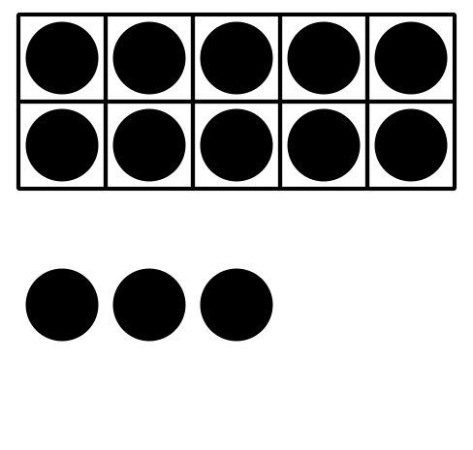
- 15 13 11

5.3: Introduce Grab and Count, Pattern Blocks
Choose a center.
Grab and Count
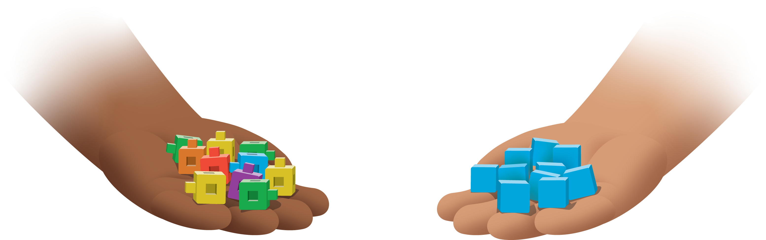
Find the Pair
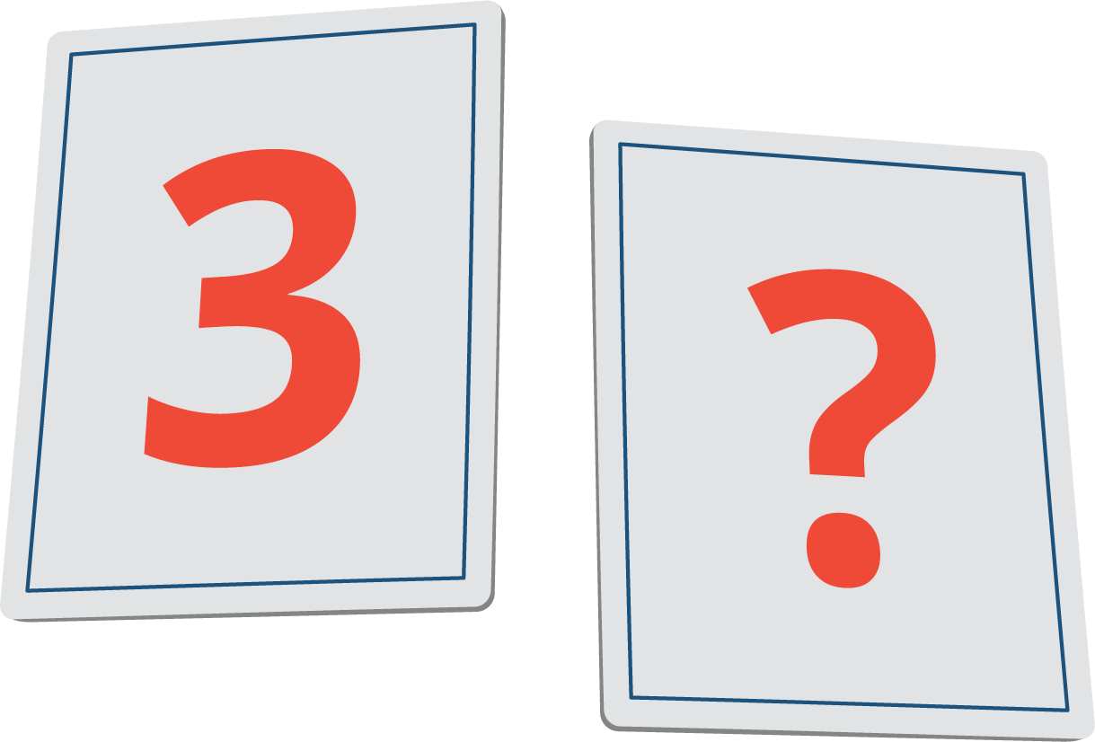
Tower Build
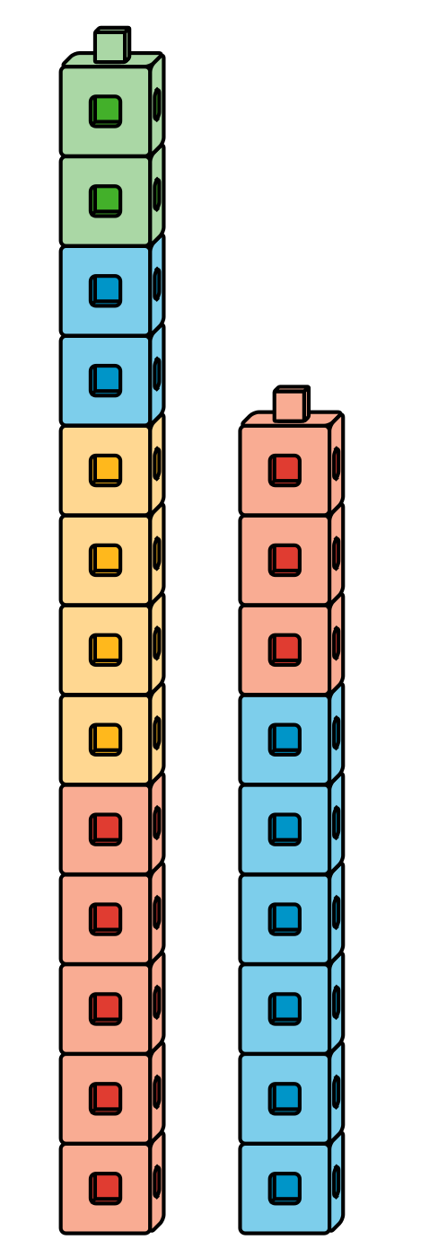
© CC BY 2021 Illustrative Mathematics®

