Lesson 10: Tell Stories about Our School
- Let’s tell math stories about our school.

Warm-up: Notice and Wonder: Bubbles in the Park
What do you notice?
What do you wonder?
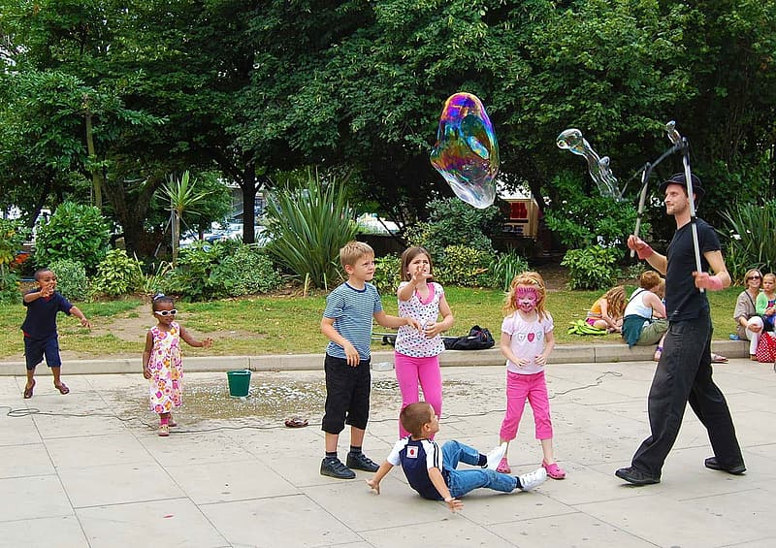

10.2: Write Story Problems About Our School

10.3: Centers: Choice Time
Choose a center.
Find the Pair
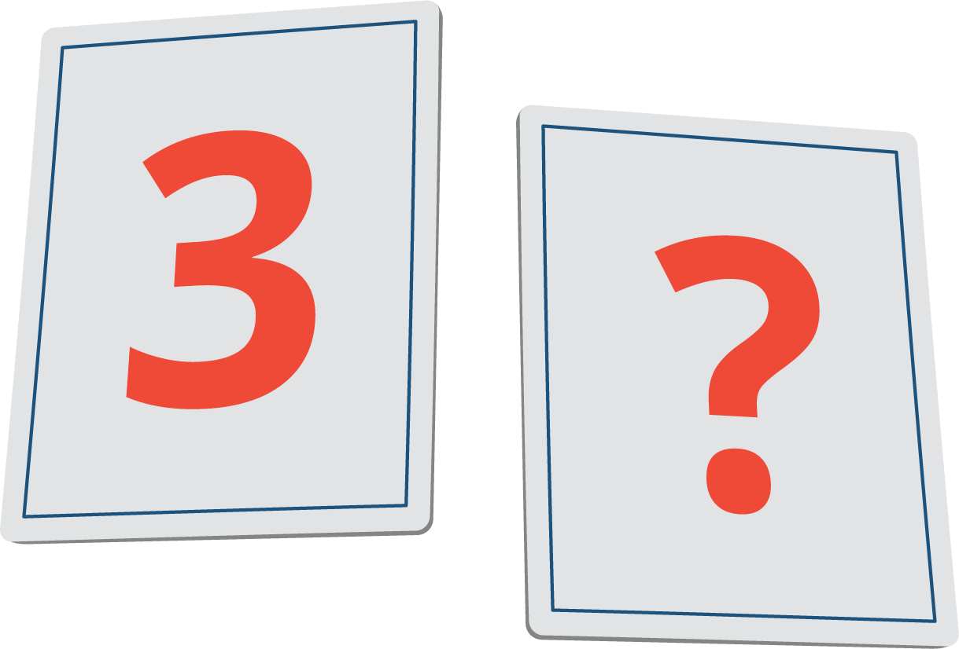
Math Stories
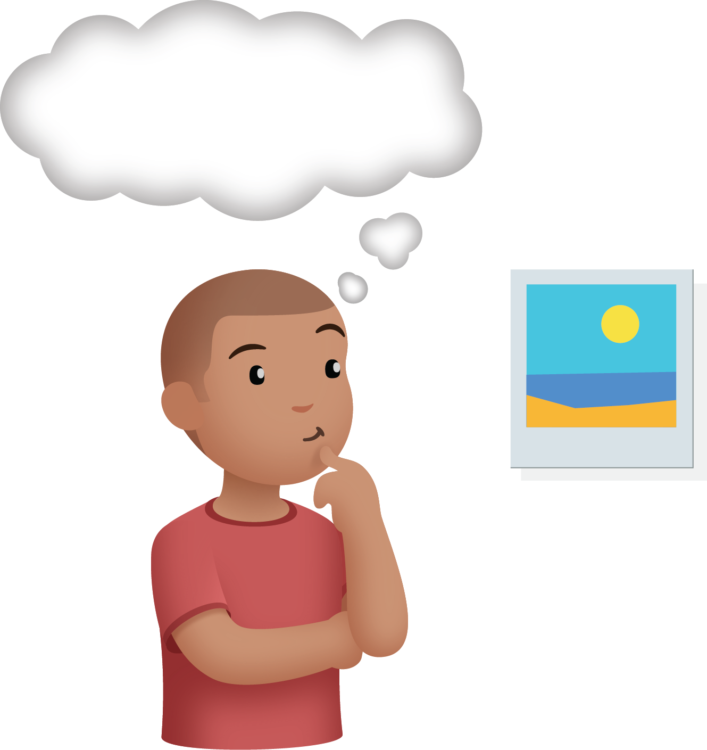
Build Shapes
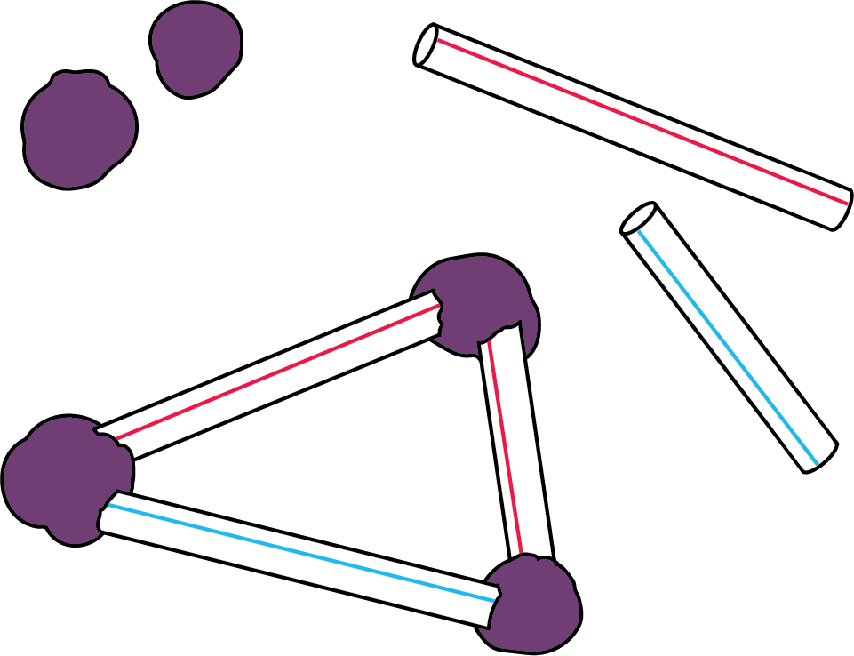
Make or Break Apart Numbers
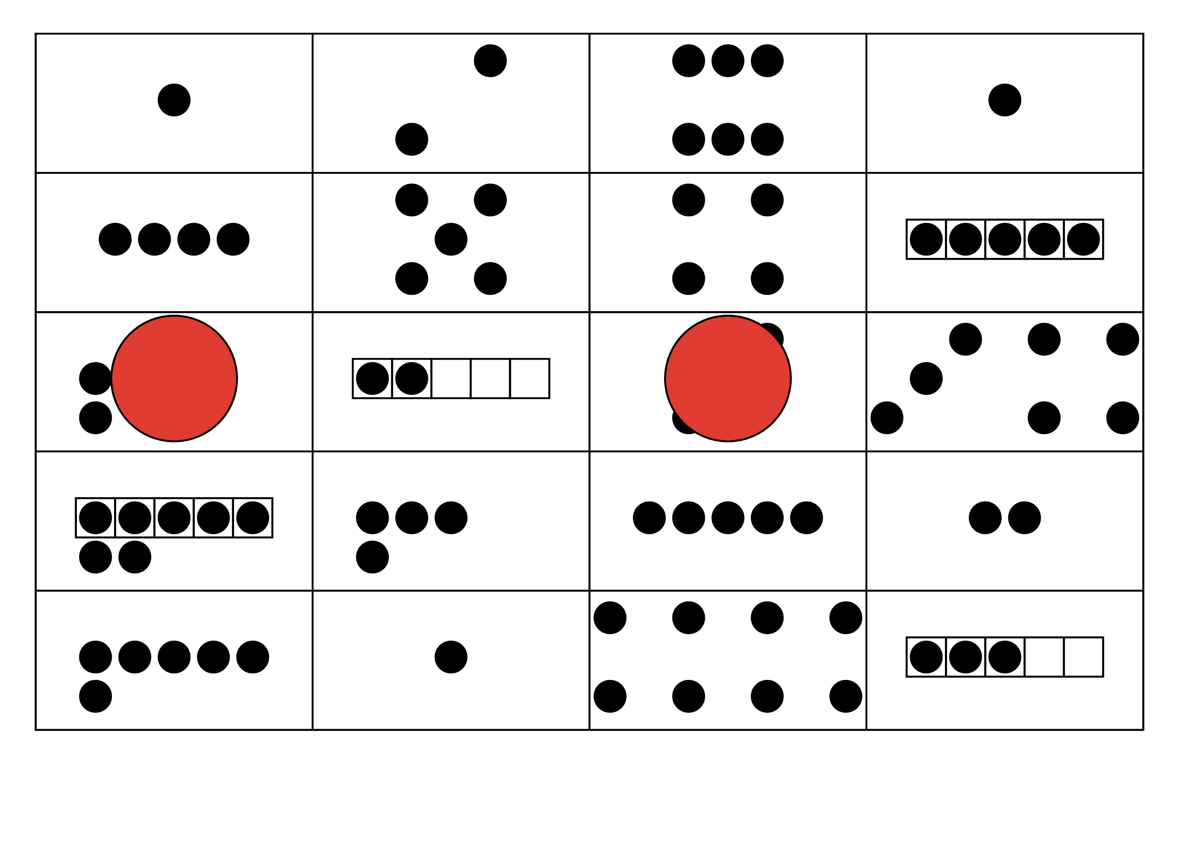
Picture Books
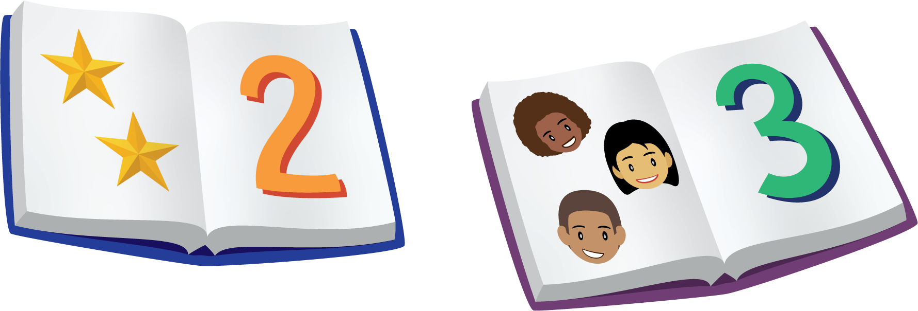
© CC BY 2021 Illustrative Mathematics®

