Unit 4 Lesson 2: Understanding Points in Situations

1 A Day of Temperature (Warm up)

Student Task Statement
The temperature for a city is a function of time after midnight. The graph shows the values on a particular spring day.
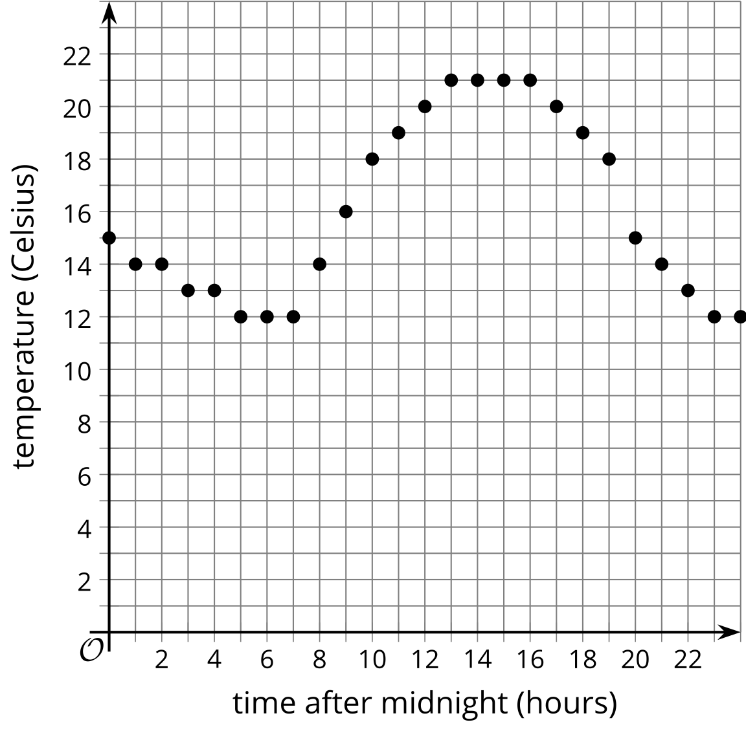
- What does the point on the graph where $x=15$ mean?
- What is the temperature at 5 p.m.?
- What is the hottest it gets on this day?
- What is the coldest it gets on this day?

2 What Happens to -2?

Student Task Statement
For each of these equations, find the value of $y$ when $x=\text{-}2$.
- $y=3x−4$
- $y=10−2x$
- $y=\frac{3}{2}x+5$
- $y=2\left(x−1\right)+4$
- $y=\text{-}x+19$
- $y=\frac{x−3}{8}$
- $y=0.3x+5$

3 It’s Heating Up!

Student Task Statement
The temperature, in degrees Fahrenheit, of a scientific sample being warmed steadily as a function of time in seconds after the sample is put in a machine can be represented by the equation $y=2.1x+86$.
- What does it mean when $x=2$?
- What is the temperature in that situation?
- What does it mean when $y=122$?
- A graph of this equation goes through the point $\left(60,212\right)$. What does that mean?
- Give 2 values for $x$ that do not make sense. Explain your reasoning.
- Give 2 values for $y$ that do not make sense. Explain your reasoning.
© CC BY 2019 by Illustrative Mathematics®

