Lesson 10 Practice Problems
- A quadratic function $f$ is defined by $f(x)=(x−7)(x+3)$.
  - Without graphing, identify the $x$-intercepts of the graph of $f$. Explain how you know.
  - Expand $(x−7)(x+3)$ and use the expanded form to identify the $y$-intercept of the graph of $f$.
- What are the $x$-intercepts of the graph of the function defined by $(x−2)(2x+1)$?
  - $(2,0)$ and $(\text{-}1,0)$
  - $(2,0)$ and $\left(\text{-}\frac{1}{2},0\right)$
  - $(\text{-}2,0)$ and $(1,0)$
  - $(\text{-}2,0)$ and $(\frac{1}{2},0)$
- Here is a graph that represents a quadratic function.
- Which expression could define this function?
- 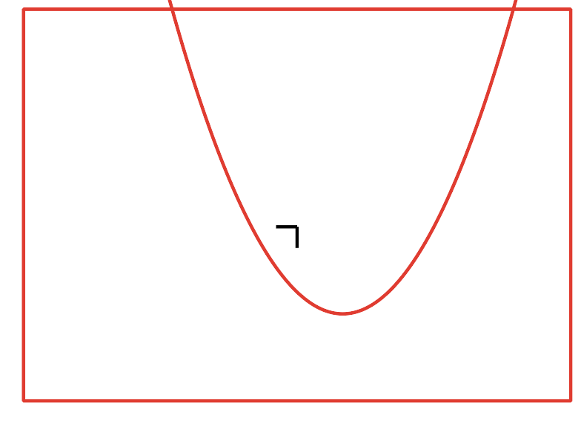
  - $(x+3)(x+1)$
  - $(x+3)(x−1)$
  - $(x−3)(x+1)$
  - $(x−3)(x−1)$
  - What is the $y$-intercept of the graph of the equation $y=x^{2}−5x+4$?
  - An equivalent way to write this equation is $y=(x−4)(x−1)$. What are the $x$-intercepts of this equation’s graph?
- Noah said that if we graph $y=(x−1)(x+6)$, the $x$-intercepts will be at $(1,0)$ and $(\text{-}6,0)$. Explain how you can determine, without graphing, whether Noah is correct.
- A company sells a video game. If the price of the game in dollars is $p$ the company estimates that it will sell $20,​000−500p$ games.
- Which expression represents the revenue in dollars from selling games if the game is priced at $p$ dollars?
  - $(20,​000−500p)+p$
  - $(20,​000−500p)−p$
  - $\frac{20,000−500p}{p}$
  - $(20,​000−500p)⋅p$
- (From Unit 6, Lesson 7.)
- Write each quadratic expression in standard form. Draw a diagram if needed.
  - $(x−3)(x−6)$
  - $(x−4)^{2}$
  - $(2x+3)(x−4)$
  - $(4x−1)(3x−7)$
- (From Unit 6, Lesson 9.)
- Consider the expression $(5+x)(6−x)$.
  - Is the expression equivalent to $x^{2}+x+30$? Explain how you know.
  - Is the expression $30+x−x^{2}$ in standard form? Explain how you know.
- (From Unit 6, Lesson 9.)
- Here are graphs of the functions $f$ and $g$ given by $f(x)=100⋅{\left(\frac{3}{5}\right)}^{x}$ and $g(x)=100⋅{\left(\frac{2}{5}\right)}^{x}$.
- Which graph corresponds to $f$ and which graph corresponds to $g$? Explain how you know.
- 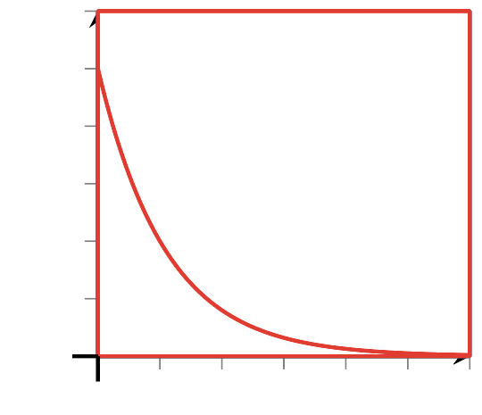
- (From Unit 5, Lesson 12.)
- Here are graphs of two functions $f$ and $g$.
- An equation defining $f$ is $f(x)=100⋅2^{x}$.
- Which of these could be an equation defining the function $g$?
- 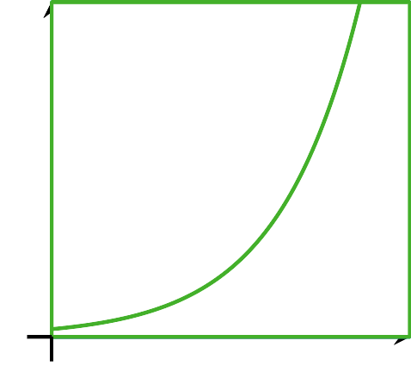
  - $g(x)=25⋅3^{x}$
  - $g(x)=50⋅(1.5)^{x}$
  - $g(x)=100⋅3^{x}$
  - $g(x)=200⋅(1.5)^{x}$
- (From Unit 5, Lesson 13.)
© CC BY 2019 by Illustrative Mathematics®

