Unit 1 Lesson 6: Area of Parallelograms

1 Missing Dots (Warm up)

Student Task Statement
How many dots are in the image?
How do you see them?

2 More Areas of Parallelograms

Student Task Statement
- Find the area of each parallelogram. Show your reasoning.
- 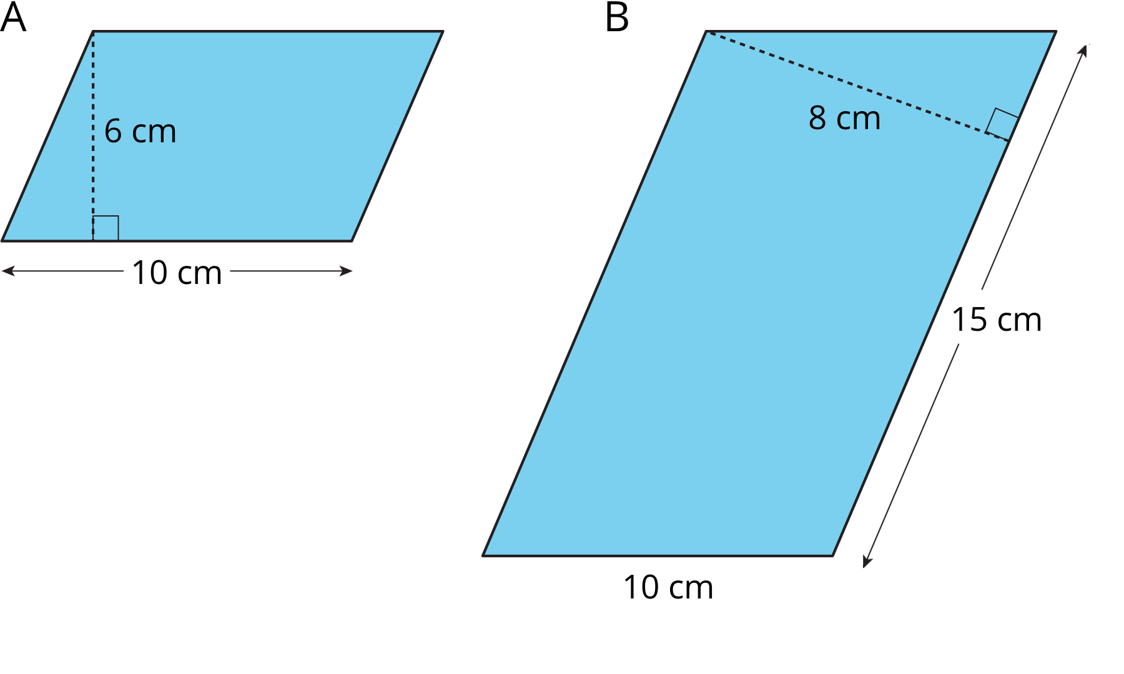
- 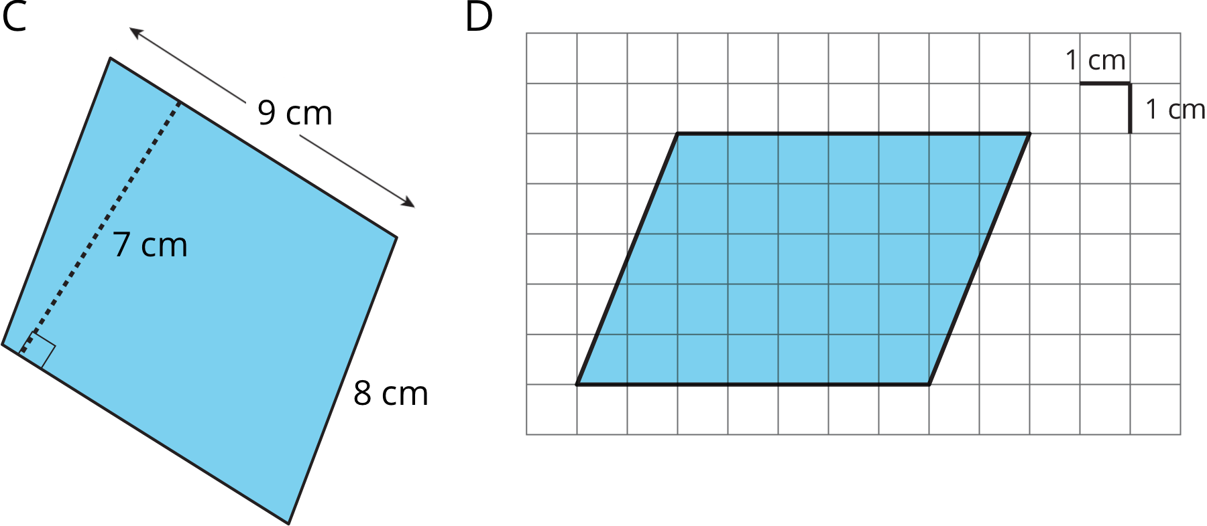
- In Parallelogram B, what is the corresponding height for the base that is 10 cm long? Explain or show your reasoning.
- Two different parallelograms P and Q both have an area of 20 square units. Neither of the parallelograms are rectangles.
- On the grid, draw two parallelograms that could be P and Q.
© CC BY Open Up Resources. Adaptations CC BY IM.

