Unit 4 Lesson 13: Create Story Problems

WU Questions About Us: Colors (Warm up)

Student Task Statement

1 Create a Story Problem

Student Task Statement

2 Switch the Operation

Student Task Statement

3 Revisit Math Stories, Act It Out

Student Task Statement
Choose a center.
Bingo
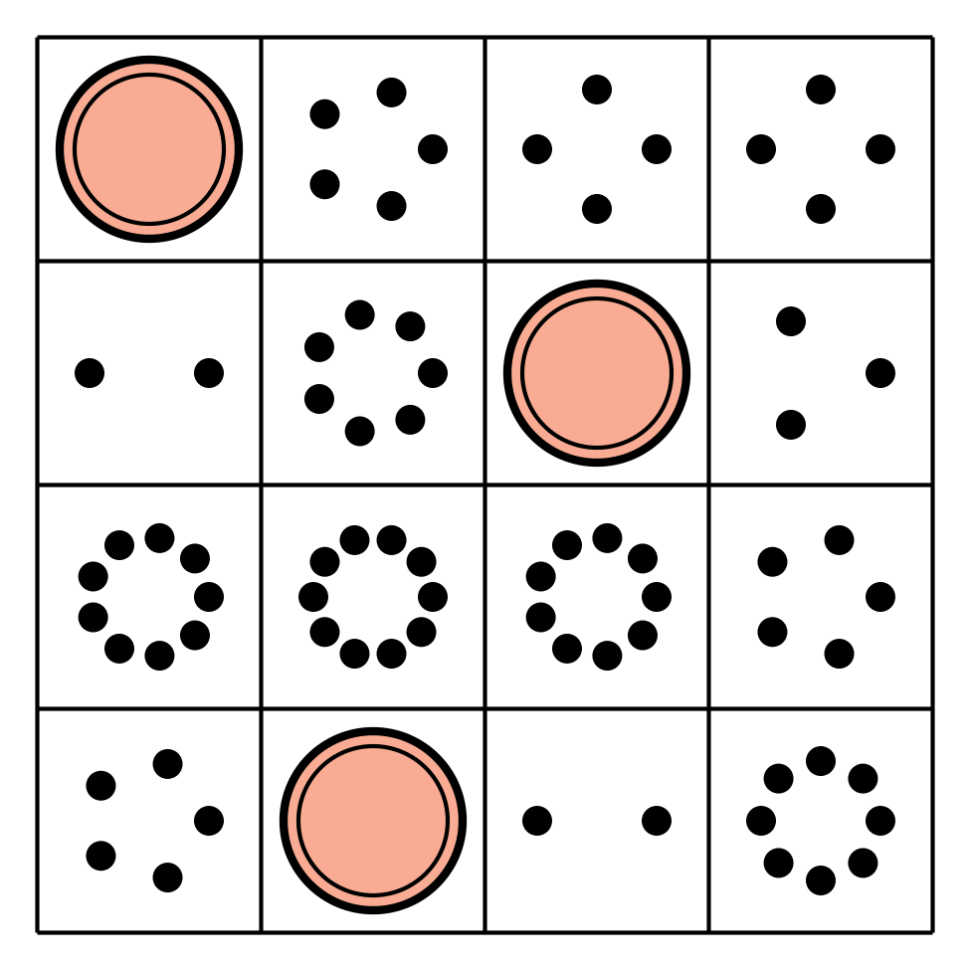
Math Fingers
Subtraction Towers
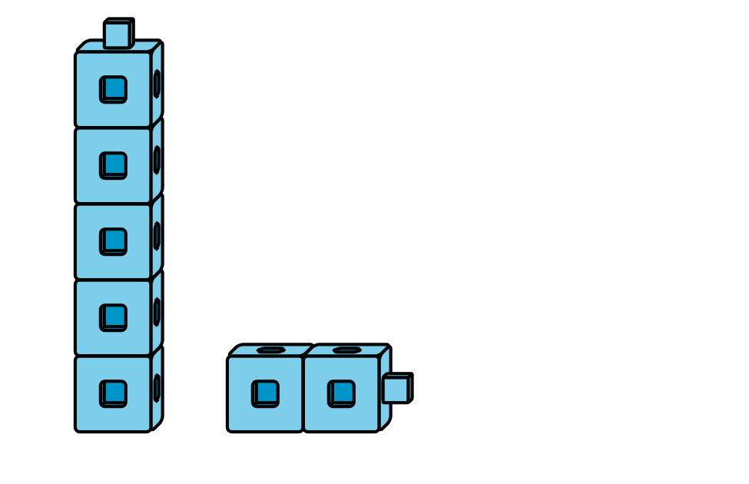
5-frames
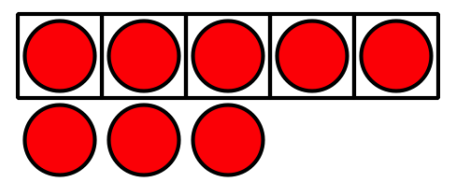
Math Stories
Counting Collections
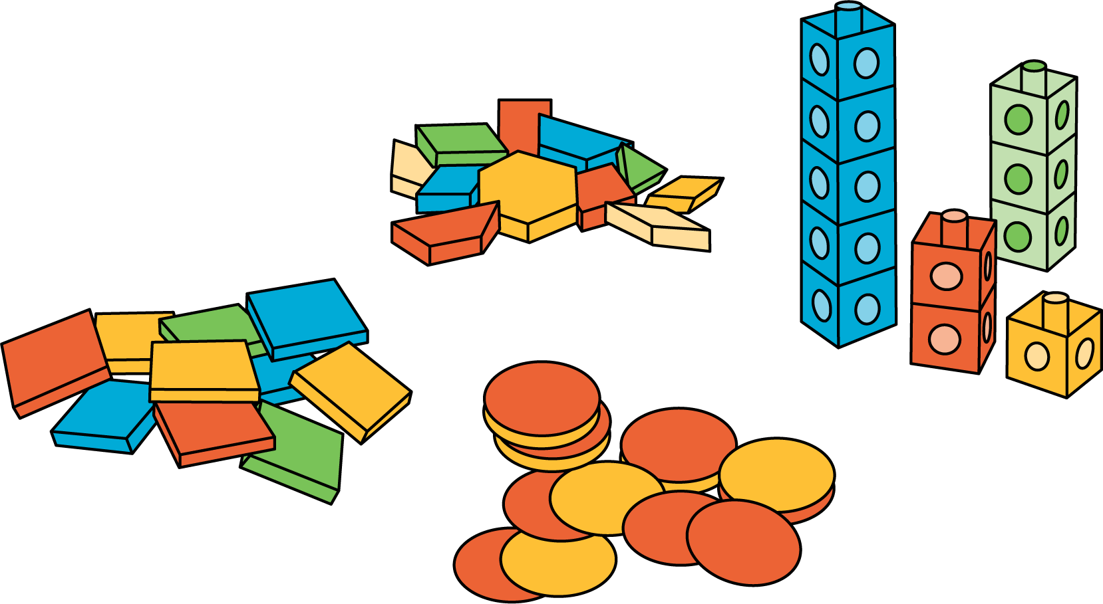
© CC BY 2021 Illustrative Mathematics®

