Lesson 12: Solve Problems Involving Multiplication
- Let’s solve problems using what we learned about multiplication of whole numbers.

Warm-up: What Do You Know About 1 Year?
What do you know about 1 year?

12.1: Time Flies When We Leap Years
- A baby elephant was born exactly 48 weeks ago. How many days old is she?
- A leap year has 366 days. A non-leap year (or a common year) has 365 days. How many days are in 3 leap years?
- In our calendar system, some months are 31 days long, some are 30 days long, and one month (February) is either 28 or 29 days long.
- What if the calendar system changed so that each month has 31 days? How many more days would there be in a year?
- 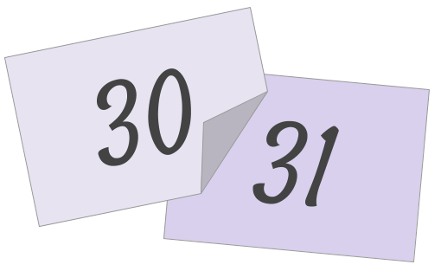

12.2: Coin Collection
- Lin’s family has collected 2,074 nickels over the years. How many pennies are worth the same amount?
- If Lin’s family saved 2,074 nickels each year for 4 years, how many nickels would her family have?
- Create a situation that involves a problem that can be solved by finding the value of $8×1,​049$. Solve the problem and show your reasoning.

Section Summary
Section Summary
In this section, we learned to multiply factors whose products are greater than 100, using different representations and strategies to do so.
When working with multi-digit factors, it helps to decompose them by place value before multiplying. For example, to find the value of $4×5,​342$, we can decompose the 5,342 into its expanded form, $5,​000+300+40+2$, and then use a diagram or an algorithm to help us multiply.
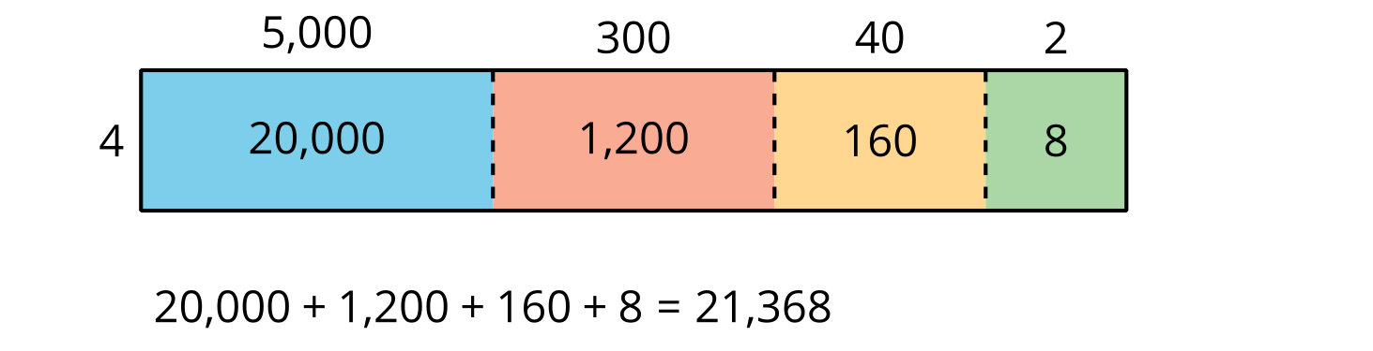
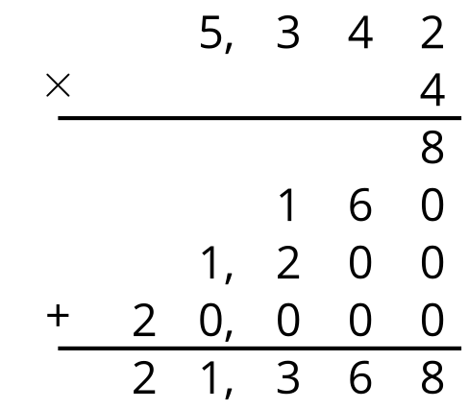
In both the diagram and the algorithm, the 20,000, 1,200, 160, and 8 are called the partial products. They are the result of multiplying each decomposed part of 5,342 by 4.
We can do the same to multiply a two-digit number by another two-digit number.
For example, here are two ways to find the value of $31×15$. The 31 is decomposed into $30+1$ and 15 is decomposed into $10+5$.
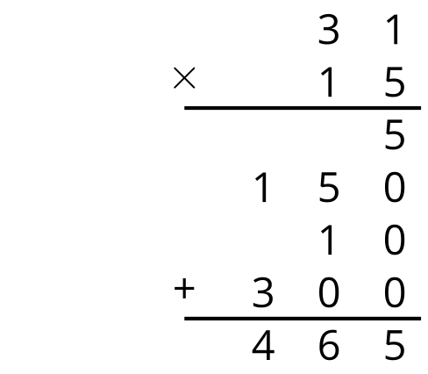
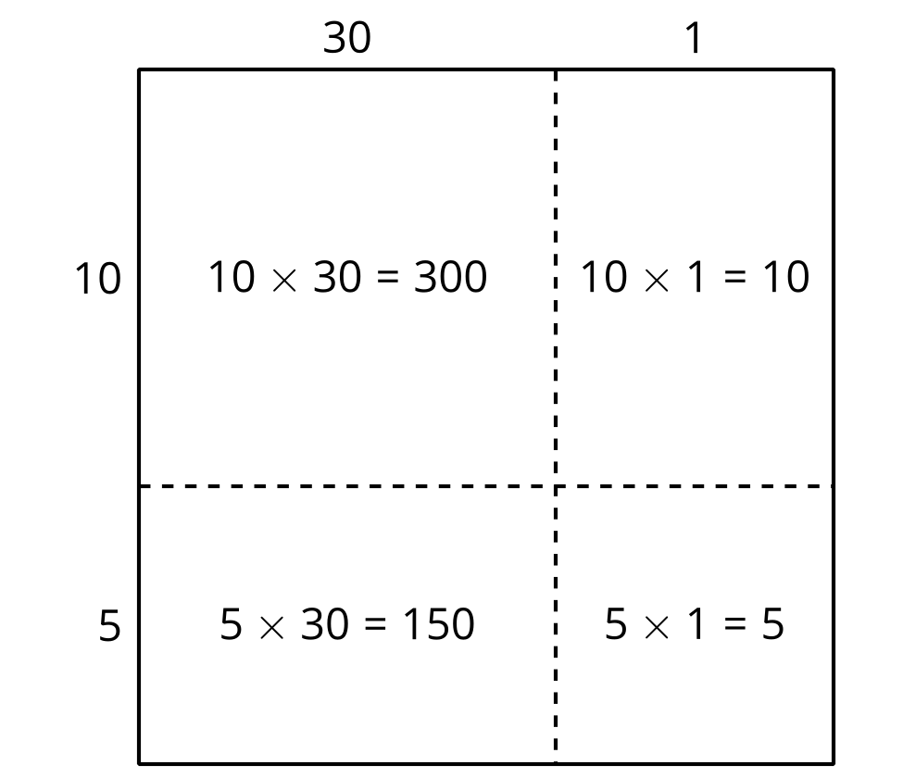
© CC BY 2021 Illustrative Mathematics®

