Unit 1 Lesson 1 Cumulative Practice Problems
- Here is a figure that looks like the letter A, along with several other figures. Which figures are scaled copies of the original A? Explain how you know.
- 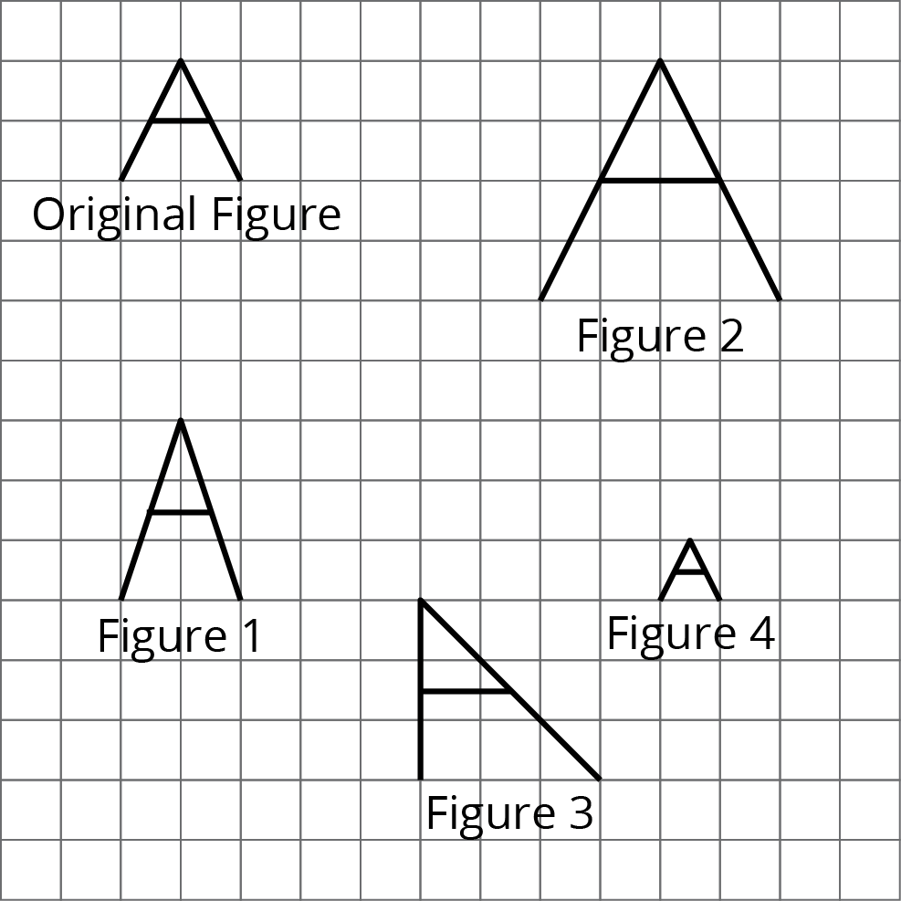
- Tyler says that Figure B is a scaled copy of Figure A because all of the peaks are half as tall.
- Do you agree with Tyler? Explain your reasoning.
- 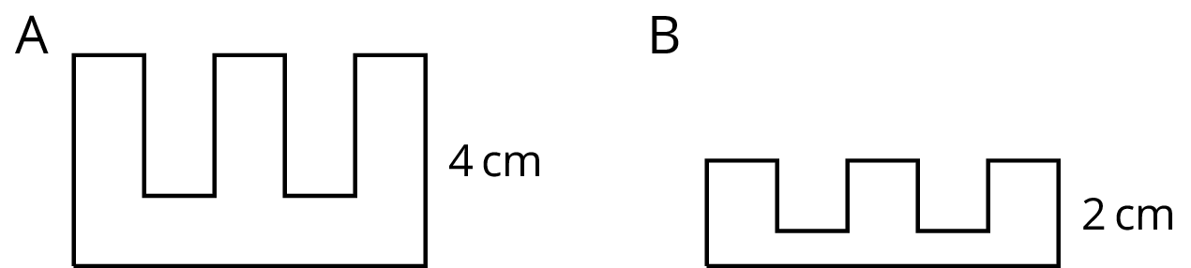
- Here is a picture of the Rose Bowl Stadium in Pasadena, CA.
- 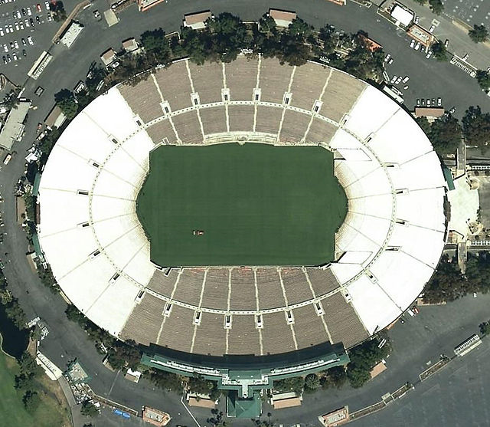
- Here are some copies of the picture. Select all the pictures that are scaled copies of the original picture.
- 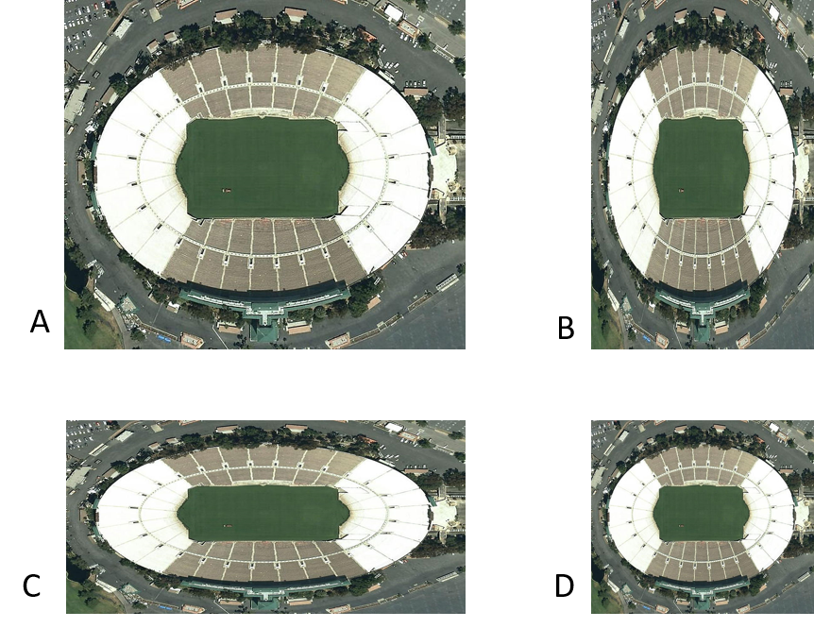
- Complete each equation with a number that makes it true.
  - $5⋅\text{______}=15$
  - $4⋅\text{______}=32$
  - $6⋅\text{______}=9$
  - $12⋅\text{______}=3$
© CC BY Open Up Resources. Adaptations CC BY IM.

