Lesson 11: Representing Ratios with Tables

11.1: How Is It Growing?
Look for a pattern in the figures.
- How many total tiles will be in:
  - the 4th figure?
  - the 5th figure?
  - the 10th figure?
- How do you see it growing?
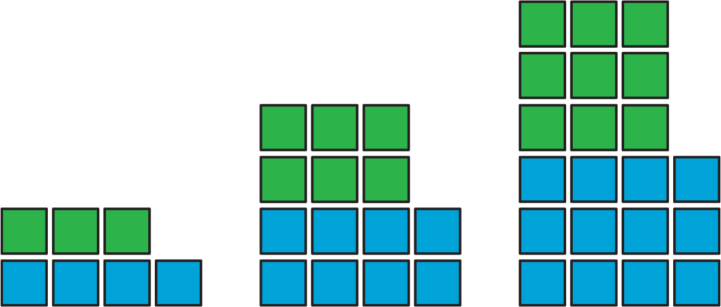

11.2: A Huge Amount of Sparkling Orange Juice
Noah’s recipe for one batch of sparkling orange juice uses 4 liters of orange juice and 5 liters of soda water.
- Use the double number line to show how many liters of each ingredient to use for different-sized batches of sparkling orange juice.
- If someone mixes 36 liters of orange juice and 45 liters of soda water, how many batches would they make?
- If someone uses 400 liters of orange juice, how much soda water would they need?
- If someone uses 455 liters of soda water, how much orange juice would they need?
- Explain the trouble with using a double number line diagram to answer the last two questions.

11.3: Batches of Trail Mix
A recipe for trail mix says: “Mix 7 ounces of almonds with 5 ounces of raisins.” Here is a table that has been started to show how many ounces of almonds and raisins would be in different-sized batches of this trail mix.
almonds (oz) | raisins (oz)
7 | 5
28
 | 10
3.5
 | 250
56
- Complete the table so that ratios represented by each row are equivalent.
- What methods did you use to fill in the table?
- How do you know that each row shows a ratio that is equivalent
to $7:5$? Explain your reasoning.

Are you ready for more?
You have created a best-selling recipe for chocolate chip cookies. The ratio of sugar to flour is $2:5$.
Create a table in which each entry represents amounts of sugar and flour that might be used at the same time in your recipe.
- One entry should have amounts where you have fewer than 25 cups of flour.
- One entry should have amounts where you have between 20–30 cups of sugar.
- One entry can have any amounts using more than 500 units of flour.

Lesson 11 Summary
A table is a way to organize information. Each horizontal set of entries is called a row, and each vertical set of entries is called a column. (The table shown has 2 columns and 5 rows.) A table can be used to represent a collection of equivalent ratios.
Here is a double number line diagram and a table that both represent the situation: “The price is $2 for every 3 mangos.”
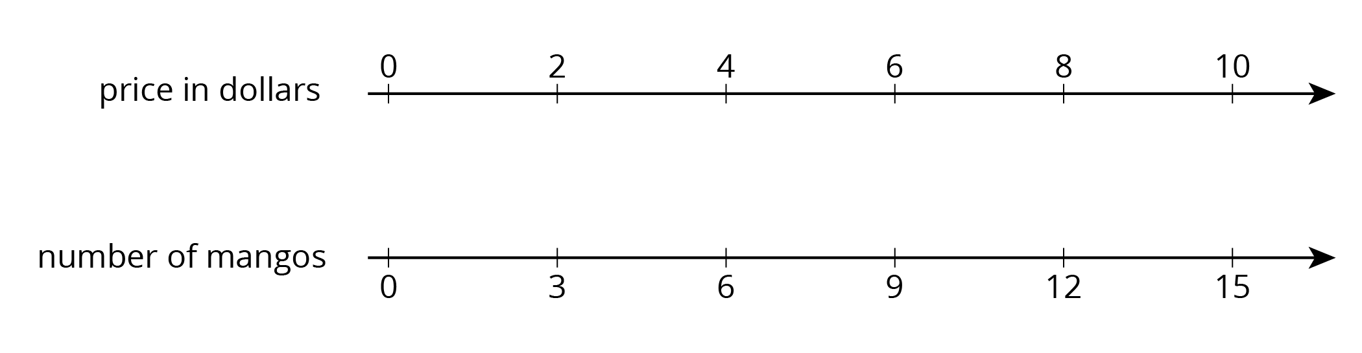
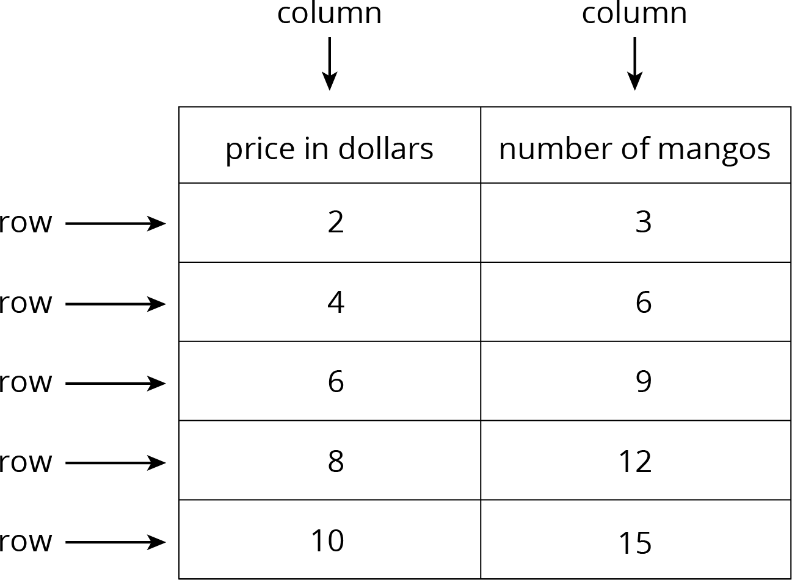
© CC BY Open Up Resources. Adaptations CC BY IM.

