Lesson 24 Practice Problems
- Two inequalities are graphed on the same coordinate plane.
- Which region represents the solution to the system of the two inequalities?
- Select all the pairs of $x$ and $y$ that are solutions to the system of inequalities: $\left\{\begin{matrix}y≤\text{-}2x+6 \\ x−y<6\end{matrix}\right.$
  - $x=0,y=0$
  - $x=\text{-}5,y=\text{-}15$
  - $x=4,y=\text{-}2$
  - $x=3,y=0$
  - $x=10,y=0$
- Jada has $200 to spend on flowers for a school celebration. She decides that the only flowers that she wants to buy are roses and carnations. Roses cost $1.45 each and carnations cost $0.65 each. Jada buys enough roses so that each of the 75 people attending the event can take home at least one rose.
  - Write an inequality to represent the constraint that every person takes home at least one rose.
  - Write an inequality to represent the cost constraint.
- Here are the graphs of the equations $3x+y=9$ and $3x−y=9$ on the same coordinate plane.
- 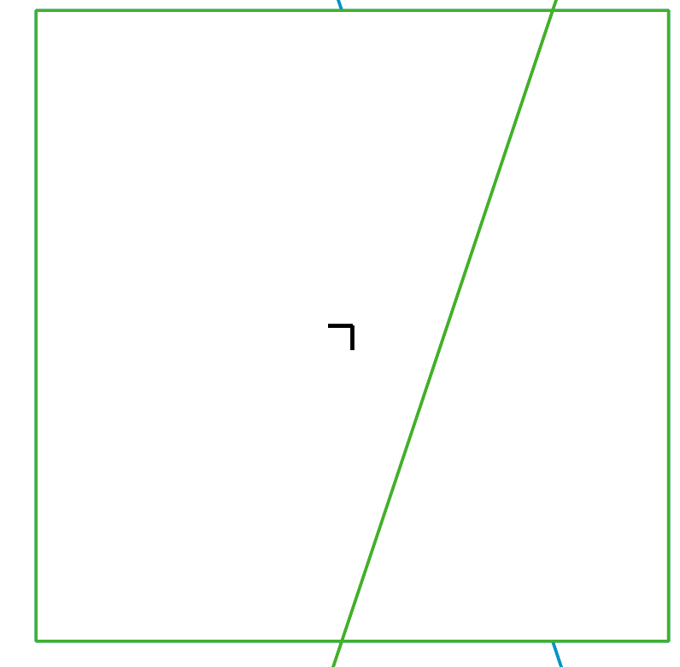
  - Label each graph with the equation it represents.
  - Identify the region that represents the solution set to $3x+y<9$. Is the boundary line a part of the solution? Use a colored pencil or cross-hatching to shade the region.
  - Identify the region that represents the solution set to $3x−y<9$. Is the boundary line a part of the solution? Use a different colored pencil or cross-hatching to shade the region.
  - Identify a point that is a solution to both $3x+y<9$ and $3x−y<9$.
- Which coordinate pair is a solution to the inequality $4x−2y<22$?
  - $(4,\text{-}3)$
  - $(4,3)$
  - $(8,\text{-}3)$
  - $(8,3)$
- (From Unit 2, Lesson 21.)
- Consider the linear equation $9x−3y=12$.
  - The pair $(3,5)$ is a solution to the equation. Find another pair $(x,y)$ that is a solution to the equation.
  - Are $(3,5)$ and $(2,\text{-}10)$ solutions to the inequality $9x−3y≤12$ ? Explain how you know.
- (From Unit 2, Lesson 21.)
- Elena is considering buying bracelets and necklaces as gifts for her friends. Bracelets cost $3, and necklaces cost $5. She can spend no more than $30 on the gifts.
  - Write an inequality to represent the number of bracelets, $b$, and the number of necklaces $n$, she could buy while sticking to her budget.
  - Graph the solutions to the inequality on the coordinate plane.
  - Explain how we could check if the boundary is included or excluded from the solution set.
- (From Unit 2, Lesson 22.)
- In physical education class, Mai takes 10 free throws and 10 jump shots. She earns 1 point for each free throw she makes and 2 points for each jump shot she makes. The greatest number of points that she can earn is 30.
  - Write an inequality to describe the constraints. Specify what each variable represents.
  - Name one solution to the inequality and explain what it represents in that situation.
- (From Unit 2, Lesson 23.)
- A rectangle with a width of $w$ and a length of $l$ has a perimeter greater than 100.
- Here is a graph that represents this situation.
  - Write an inequality that represents this situation.
  - Can the rectangle have width of 45 and a length of 10? Explain your reasoning.
  - Can the rectangle have a width of 30 and a length of 20? Explain your reasoning.
- (From Unit 2, Lesson 23.)
© CC BY 2019 by Illustrative Mathematics®

