Unit 2 Lesson 8: The Perpendicular Bisector Theorem

1 Which One Doesn’t Belong: Intersecting Lines (Warm up)

Student Task Statement
Which one doesn’t belong?

A
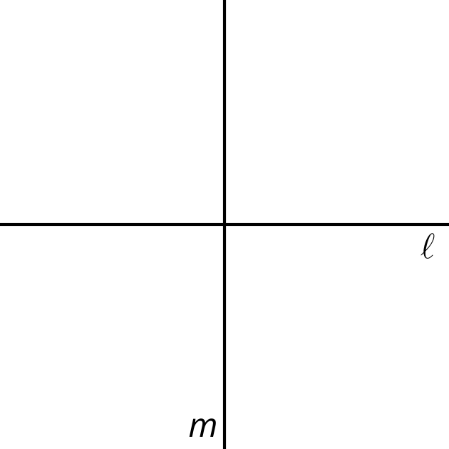

B
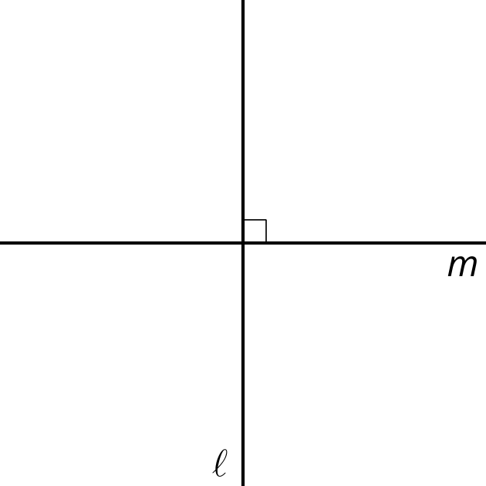

C
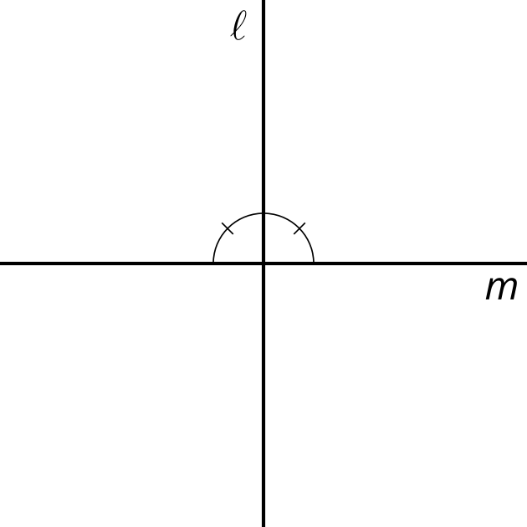

D
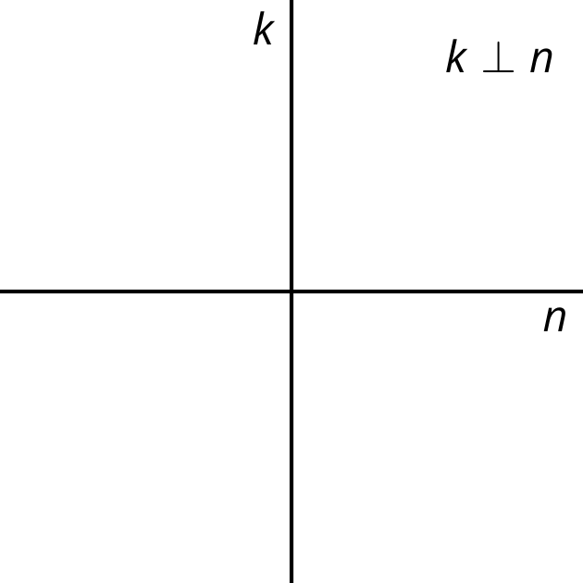

2 Lots of Lines

Images for Launch

$\overset{¯}{AP}≅\overset{¯}{BP}$
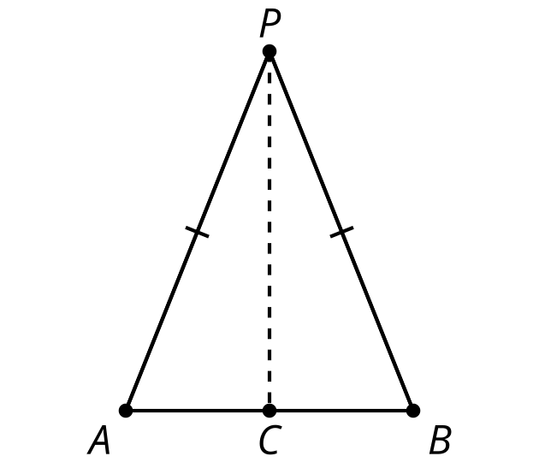

Student Task Statement
Diego, Jada, and Noah were given the following task:
Prove that if a point $C$ is the same distance from $A$ as it is from $B$, then $C$ must be on the perpendicular bisector of $AB$.
At first they were really stuck. Noah asked, “How do you prove a point is on a line?” Their teacher gave them the hint, “Another way to think about it is to draw a line that you know $C$ is on, and prove that line has to be the perpendicular bisector.”
They each drew a line and thought about their pictures. Here are their rough drafts.
Diego’s approach: “I drew a line through $C$ that was perpendicular to $AB$ and through the midpoint of $AB$. That line is the perpendicular bisector of $AB$ and $C$ is on it, so that proves $C$ is on the perpendicular bisector.”
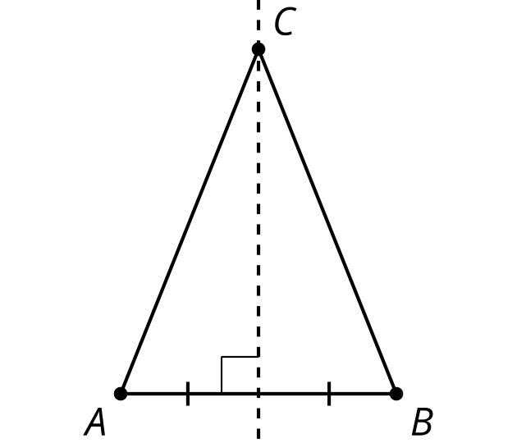
Jada’s approach: “I thought the line through $C$ would probably go through the midpoint of $AB$ so I drew that and labeled the midpoint $D$. Triangle $ACB$ is isosceles, so angles $A$ and $B$ are congruent, and $AC$ and $BC$ are congruent. And $AD$ and $DB$ are congruent because $D$ is a midpoint. That made two congruent triangles by the Side-Angle-Side Triangle Congruence Theorem. So I know angle $ADC$ and angle $BDC$ are congruent, but I still don’t know if $DC$ is the perpendicular bisector of $AB$.”
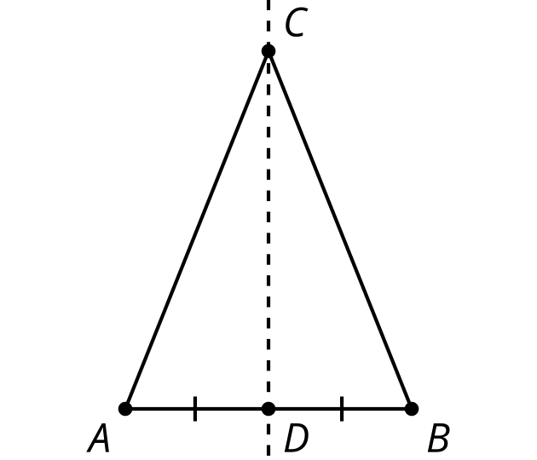
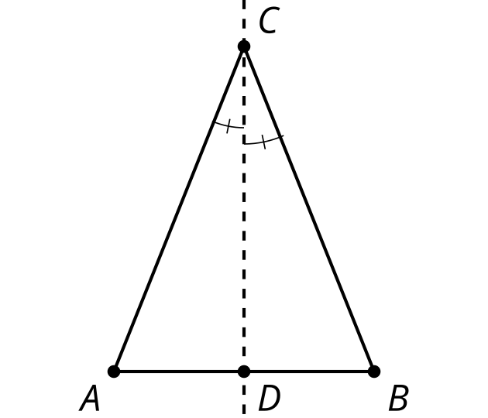
Noah’s approach: “In the Isosceles Triangle Theorem proof, Mai and Kiran drew an angle bisector in their isosceles triangle, so I’ll try that. I’ll draw the angle bisector of angle $ACB$. The point where the angle bisector hits $AB$ will be $D$. So triangles $ACD$ and $BCD$ are congruent, which means $AD$ and $BD$ are congruent, so $D$ is a midpoint and $CD$ is the perpendicular bisector.”
- With your partner, discuss each student’s approach.
  - What do you notice that this student understands about the problem?
  - What question would you ask them to help them move forward?
- Using the ideas you heard and the ways you think each student could make their explanation better, write your own explanation for why $C$ must be on the perpendicular bisector of $A$ and $B$.

Activity Synthesis

$\overset{¯}{AP}≅\overset{¯}{BP}$
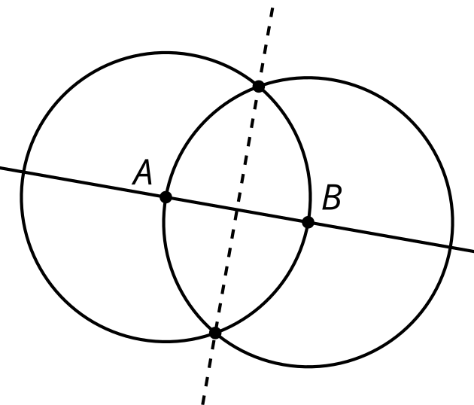

$\overset{¯}{AC}≅\overset{¯}{BC}$, so $C$ is on the line through midpoint $M$ perpendicular to $\overset{¯}{AB}$
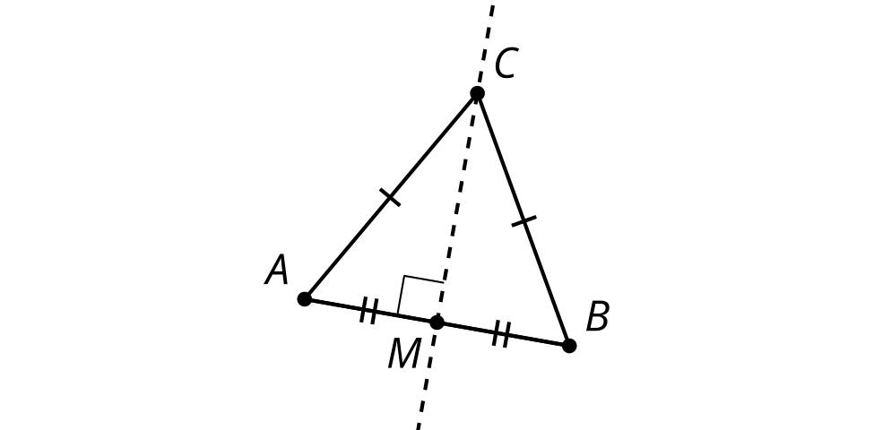

3 Not Too Close, Not Too Far

Student Task Statement
- Work on your own to make a diagram and write a rough draft of a proof for the statement:
- If $P$ is a point on the perpendicular bisector of $AB$, prove that the distance from $P$ to $A$ is the same as the distance from $P$ to $B$.
- With your partner, discuss each other’s drafts. Record your partner‘s feedback for your proof.
  - What do you notice that your partner understands about the problem?
  - What question would you ask them to help them move forward?

Images for Activity Synthesis
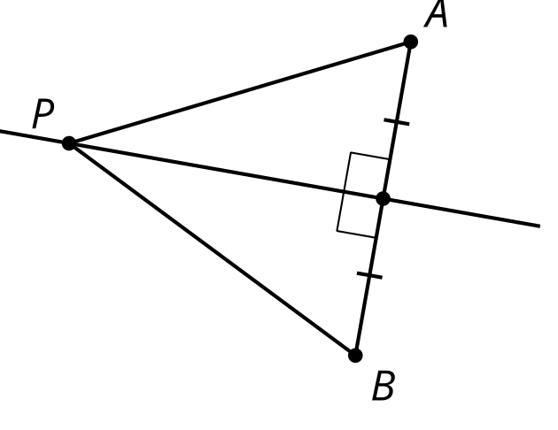

$\overset{¯}{AB}⊥\overset{¯}{CM},\overset{¯}{AM}≅\overset{¯}{BM},$ so $\overset{¯}{AC}≅\overset{¯}{BC}$
© CC BY 2019 by Illustrative Mathematics®

