Unit 6 Lesson 2: Powers of 10

WU How Many Do You See: Starburst (Warm up)

Student Task Statement
How many do you see? How do you see them?
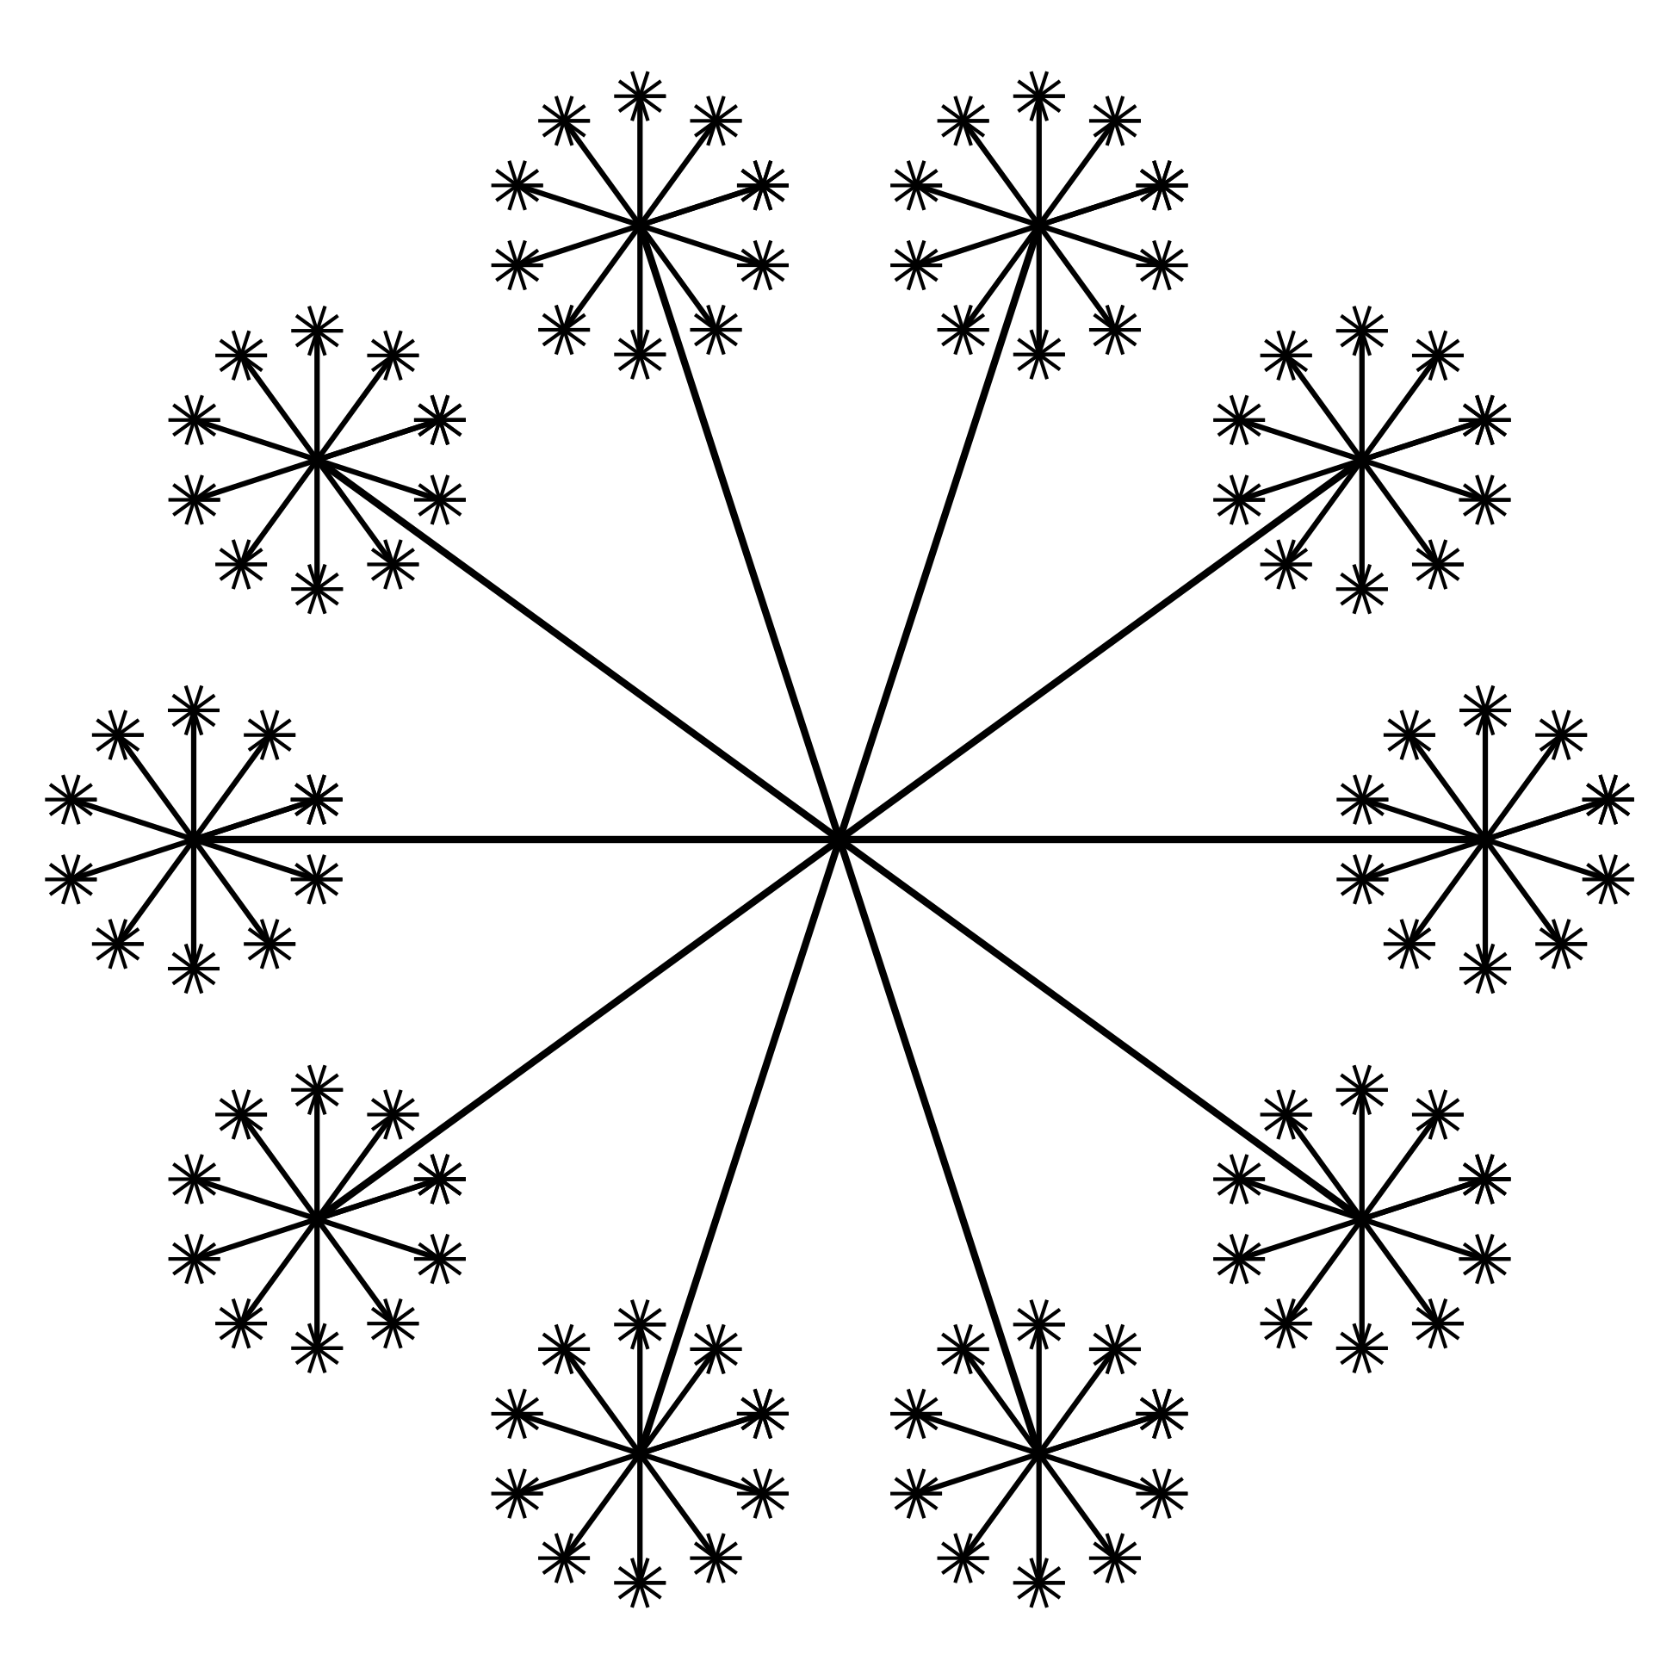

1 Population of Delaware and India

Student Task Statement
- About 1,000,000 people live in Delaware.
  - How do you say this number?
  - How many thousands is this? Explain or show your reasoning.
  - Write the number using powers of 10.
  - How many times would you need to extend the diagram from the warm-up to get 1,000,000 tiny segments? Explain or show your reasoning.
- In 1997, the population of India was about 1,000,000,000.
  - How would you say this number?
  - How many millions is this? How many thousands is it? Explain or show your reasoning.
  - Write the number using powers of 10.
  - How many times would you need to extend the diagram from the warm-up to get 1,000,000,000 tiny segments? Explain or show your reasoning.

2 Powers of 10

Student Task Statement
- Find the missing number that makes each equation true. Show your reasoning.
  - $2,​000=\underset{_}{}×20$
  - $20×10×\underset{_}{}=20,​000$
  - $\underset{_}{}×10=100,​000$
  - $1,​000×10,​000=\underset{_}{}$
- How were products of 10s useful in solving these problems?
- Write each power of 10 as a number.
  - ${10}^{3}$
  - ${10}^{4}$
  - ${10}^{7}$

3 Beyond a Billion (Optional)

Student Task Statement
- How would you say the number 1,000,000,000,000?
- How many billions is that? How many millions is it? Explain or show your reasoning.
- Write the number using powers of 10.
- Describe an example of something that there are 1,000,000,000,000 of in the world.
© CC BY 2021 Illustrative Mathematics®

