Lesson 2: Represent Unit Fraction Multiplication
- Let’s write expressions to represent multiplication of unit fractions.

Warm-up: Which One Doesn’t Belong: Diagrams
Which one doesn’t belong?
A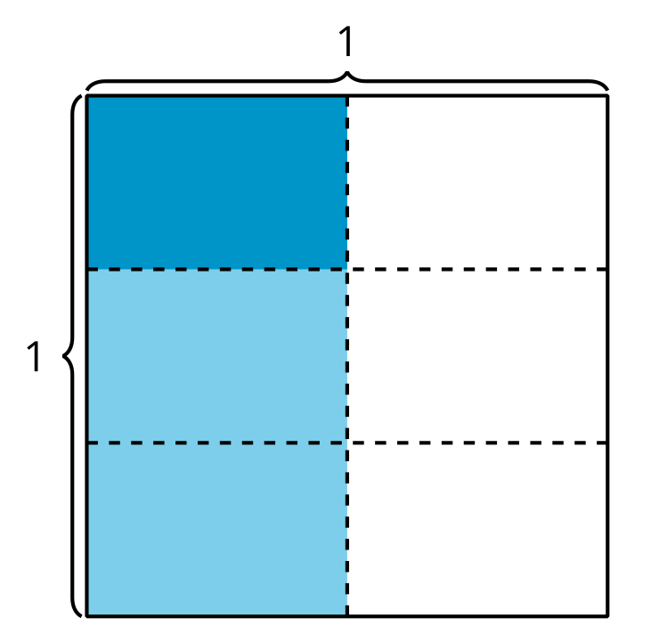
B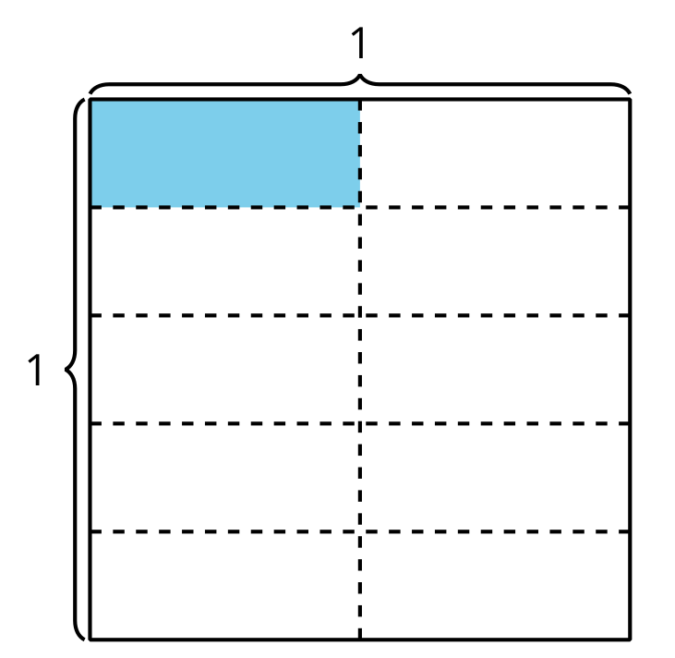
C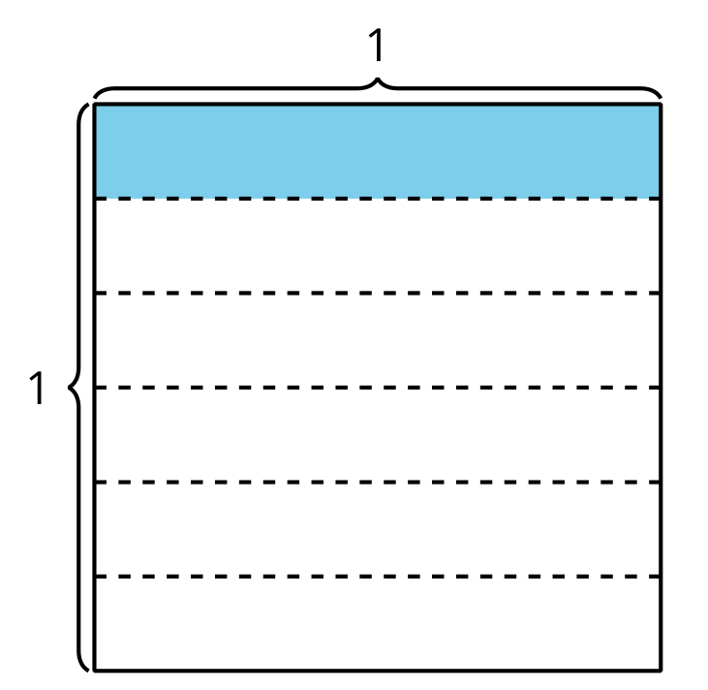
D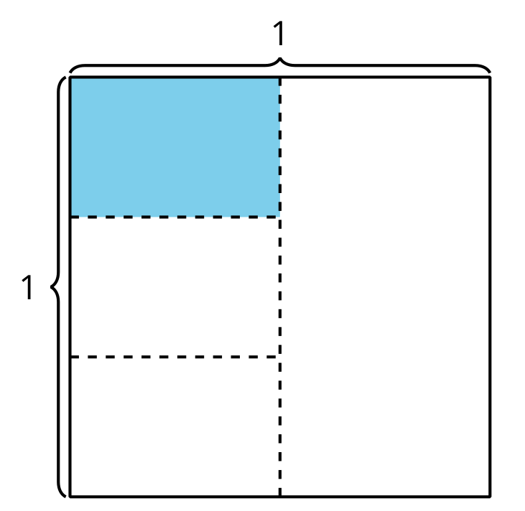

2.1: Interpret Diagrams
- Show $\frac{1}{3}$ of the square.
Shade $\frac{1}{4}$ of $\frac{1}{3}$ of the square.
How much of the whole square is shaded?
- Show $\frac{1}{4}$ of the square.
Shade $\frac{1}{3}$ of $\frac{1}{4}$ of the square.
How much of the whole square is shaded?
- How are the diagrams the same and how are they different?

2.2: Write an Expression
Priya shaded part of a square.
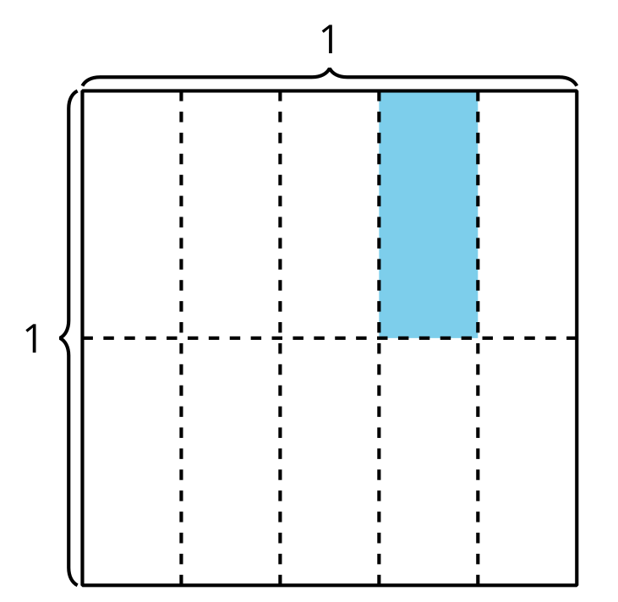
- Explain or show how the expression $\frac{1}{5}×\frac{1}{2}$ represents the area of the shaded piece.
- Explain or show how the expression $\frac{1}{2}×\frac{1}{5}$ represents the area of the shaded piece.
- Write a multiplication expression to represent the area of the shaded piece. Be prepared to explain your reasoning.
- 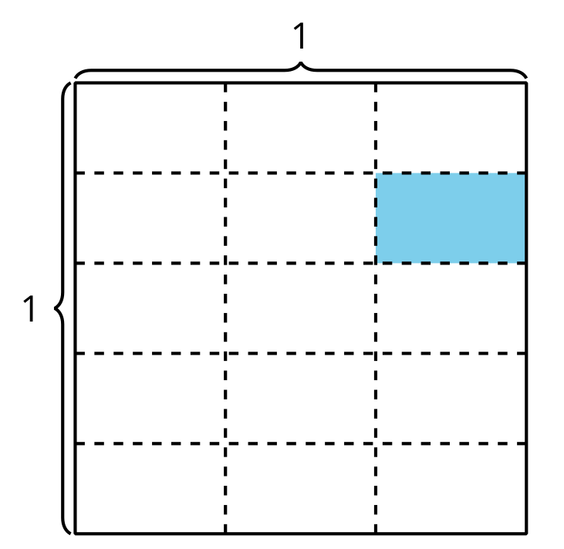
- How much of the whole square is shaded?
© CC BY 2021 Illustrative Mathematics®

