Lesson 12 Practice Problems
- Match each diagram showing a sector with the measure of its central angle in radians.
  - diagram A
  - diagram B
  - diagram C
  - diagram D
  - diagram E
  - diagram F
  - $\frac{3π}{2}$
  - $π$
  - $\frac{π}{3}$
  - $\frac{π}{2}$
  - $2π$
  - $\frac{2π}{3}$
- In the circle, sketch a central angle that measures $\frac{2π}{3}$ radians.
- Angle $AOC$ has a measure of $\frac{5π}{6}$ radians. The length of arc $AB$ is $2π$ units and the radius is 12 units. What is the area of sector $BOC$?

- Calculate the radian measure of a 30 degree angle. Use any method you like, including sketching in the circle diagram provided. Explain or show your reasoning.
- (From Unit 7, Lesson 11.)
- Lin thinks that the central angle in circle A is congruent to the central angle in circle B. Do you agree with Lin? Show or explain your reasoning.

- circle A
- 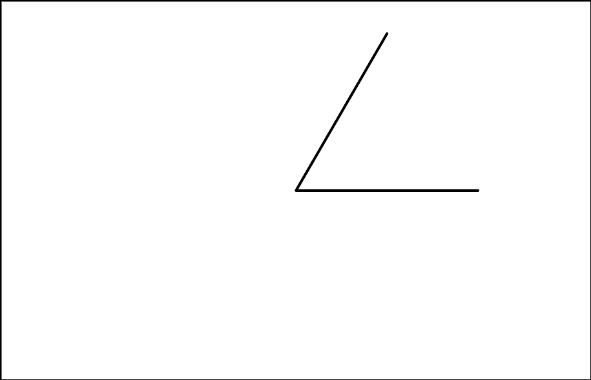

- circle B
- (From Unit 7, Lesson 11.)

- circle A

- circle B
- Select all true statements.
  - The sector in circle B has a larger area than the sector in circle A.
  - Not taking into account the sectors, circle A and circle B are similar.
  - The fraction of the circumference taken up by the arc outlining circle A’s sector is smaller than the fraction of the circumference taken up by the arc in circle B.
  - The ratio of the area of circle A’s sector to its total area is $\frac{1}{6}$.
  - The ratio of circle A’s area to circle B’s area is $\frac{5}{9}$.
- (From Unit 7, Lesson 10.)
- Match each arc length and radius with the measure of the central angle that defines the arc.
  - arc length $5π$ cm, radius 5 cm
  - arc length $4π$ cm, radius 10 cm
  - arc length $9π$ cm, radius 12 cm
  - arc length $3π$ cm, radius 18 cm
  - angle: 30 degrees
  - angle: 72 degrees
  - angle: 135 degrees
  - angle: 180 degrees
- (From Unit 7, Lesson 9.)
- Quadrilateral $ABCD$ is shown with the given angle measures. Select all true statements.
  - Angle $A$ measures 140 degrees.
  - The measures of angle $A$ and angle $D$ must add to 180 degrees.
  - Angle $A$ measures 55 degrees.
  - Angle $D$ measures 55 degrees.
  - Angle $D$ measures 40 degrees.
- (From Unit 7, Lesson 4.)
© CC BY 2019 by Illustrative Mathematics®

