Lesson 6: Changing Temperatures
Let's add signed numbers.

6.1: Which One Doesn’t Belong: Arrows
Which pair of arrows doesn't belong?

- 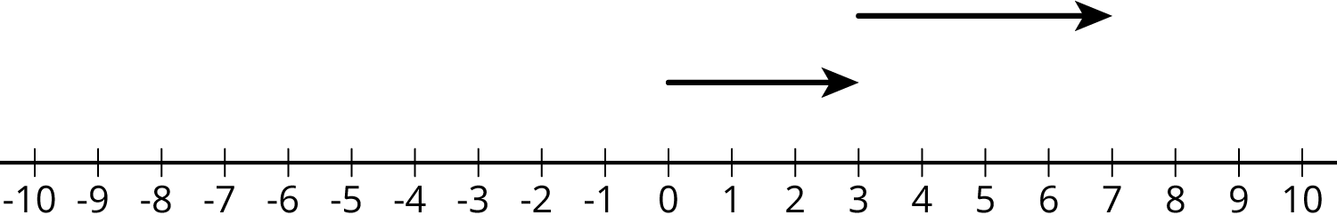

- 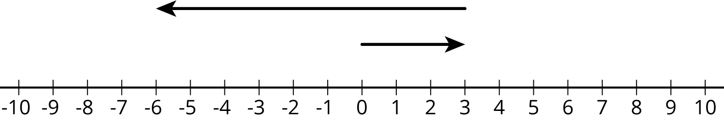

- 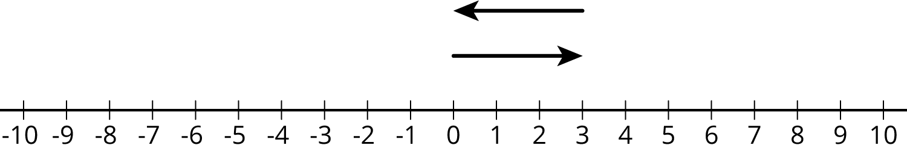

- 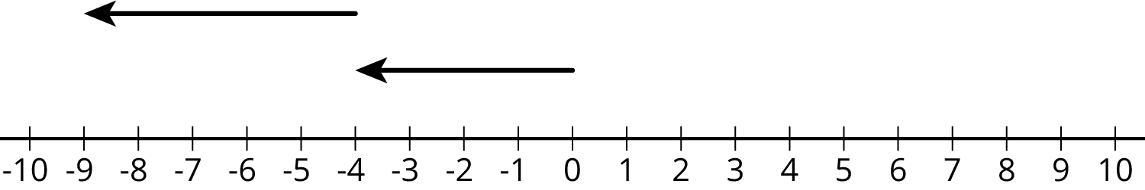

6.2: Warmer and Colder
- Complete the table and draw a number line diagram for each situation.
 | - start ($​^{∘}\text{C}$) | - change ($​^{∘}\text{C}$) | - final ($​^{∘}\text{C}$) | - addition equation
- a | - +40 | - 10 degrees warmer | - +50 | - $40+10=50$
- b | - +40 | - 5 degrees colder
- c | - +40 | - 30 degrees colder
- d | - +40 | - 40 degrees colder
- e | - +40 | - 50 degrees colder

- Complete the table and draw a number line diagram for each situation.
 | - start ($​^{∘}\text{C}$) | - change ($​^{∘}\text{C}$) | - final ($​^{∘}\text{C}$) | - addition equation
- a | - -20 | - 30 degrees warmer
- b | - -20 | - 35 degrees warmer
- c | - -20 | - 15 degrees warmer
- d | - -20 | - 15 degrees colder

Are you ready for more?
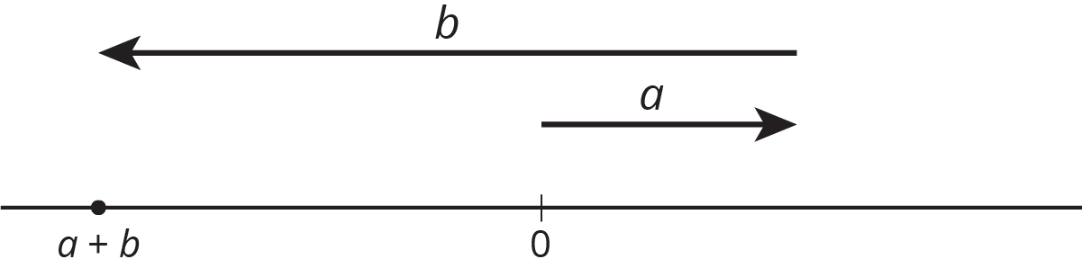
For the numbers $a$ and $b$ represented in the figure, which expression is equal to $\left|a+b\right|$?
$\left|a\right|+\left|b\right|$
$\left|a\right|−\left|b\right|$
$\left|b\right|−\left|a\right|$

6.3: Winter Temperatures
One winter day, the temperature in Houston is $8^{∘}$ Celsius. Find the temperatures in these other cities. Explain or show your reasoning.
- In Orlando, it is ${10}^{∘}$ warmer than it is in Houston.
- In Salt Lake City, it is $8^{∘}$ colder than it is in Houston.
- In Minneapolis, it is ${20}^{∘}$ colder than it is in Houston.
- In Fairbanks, it is ${10}^{∘}$ colder than it is in Minneapolis.
- Write an addition equation that represents the relationship between the temperature in Houston and the temperature in Fairbanks.

Lesson 6 Summary
If it is ${42}^{∘}$ outside and the temperature increases by $7^{∘}$, then we can add the initial temperature and the change in temperature to find the final temperature.
$42+7=49$
If the temperature decreases by $7^{∘}$, we can either subtract $42−7$ to find the final temperature, or we can think of the change as $\text{-}7^{∘}$. Again, we can add to find the final temperature.
$42+\left(\text{-}7\right)=35$
In general, we can represent a change in temperature with a positive number if it increases and a negative number if it decreases. Then we can find the final temperature by adding the initial temperature and the change. If it is $3^{∘}$ and the temperature decreases by $7^{∘}$, then we can add to find the final temperature.
$3+\left(\text{-}7\right)=\text{-}4$
We can represent signed numbers with arrows on a number line. We can represent positive numbers with arrows that start at 0 and point to the right. For example, this arrow represents +10 because it is 10 units long and it points to the right.
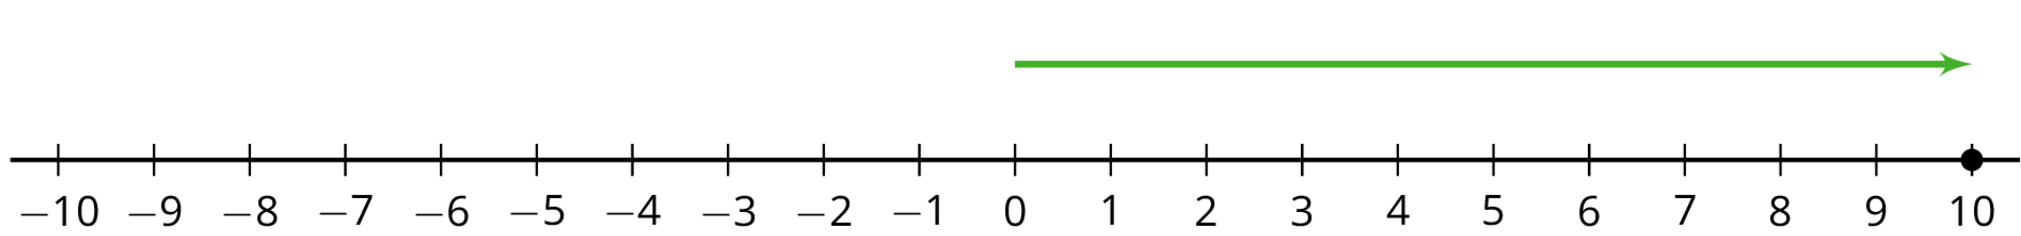
We can represent negative numbers with arrows that start at 0 and point to the left. For example, this arrow represents -4 because it is 4 units long and it points to the left.
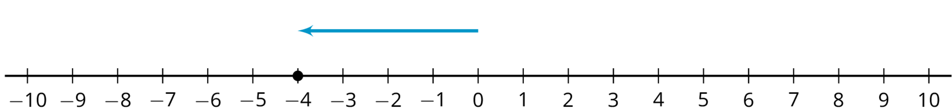
To represent addition, we put the arrows “tip to tail.” So this diagram represents $3+5$:
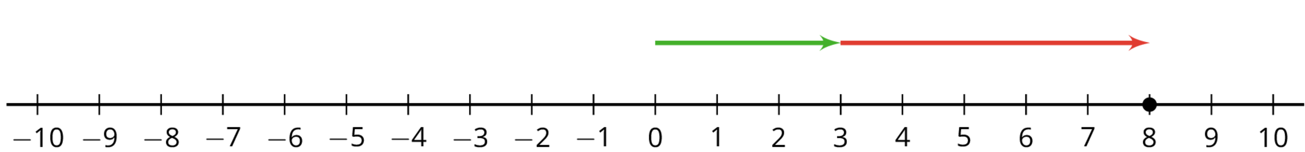
And this represents $3+\left(\text{-}5\right)$:
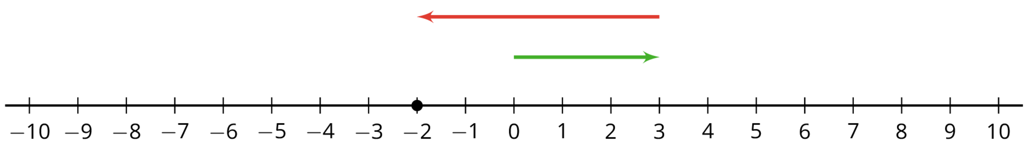
© CC BY Open Up Resources. Adaptations CC BY IM.

