Unit 1 Lesson 9: Create Picture Books

WU Act It Out: The Story Changes (Warm up)

Student Task Statement
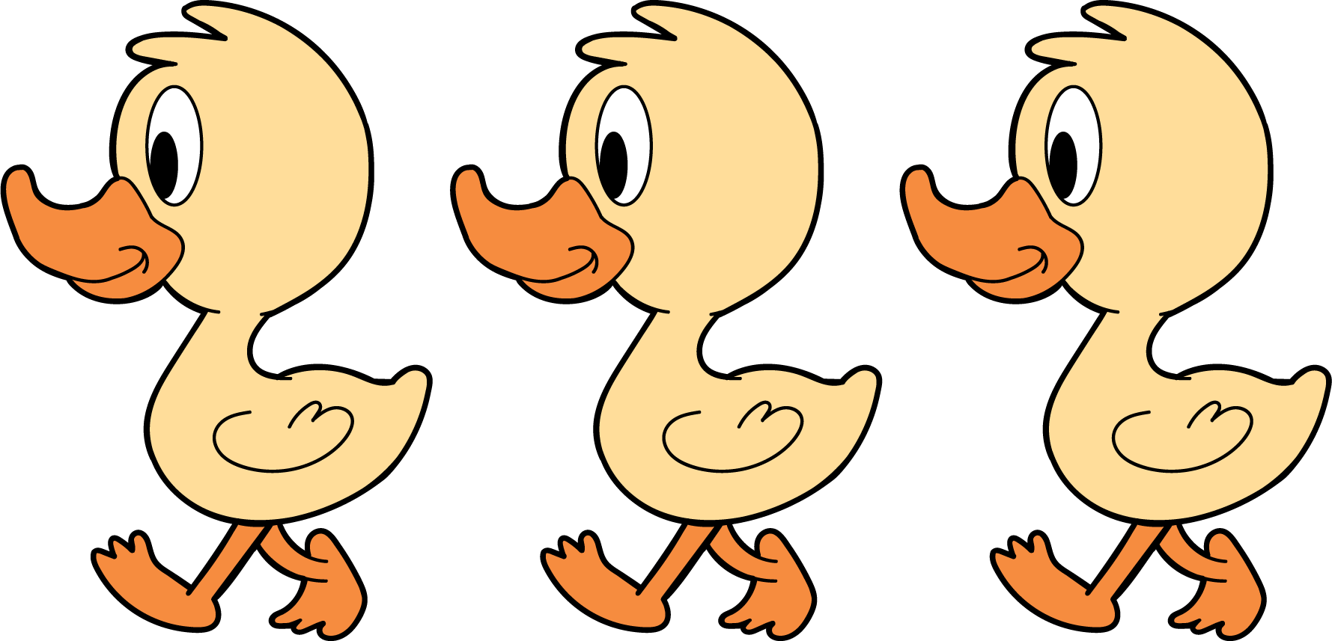
3 little ducks went out one day,
over the hill and far away.
Mother duck said, “Quack, quack, quack.”
Then 3 little ducks came back.
3 little ducks went out one day,
over the hill and far away.
Mother duck said, “Quack, quack, quack.”
Then 2 little ducks came back.

1 How Many Do You See: What Do You Notice?

Student Task Statement
How many do you see?
How do you see them?

2 Introduce Picture Books, Create

Student Task Statement
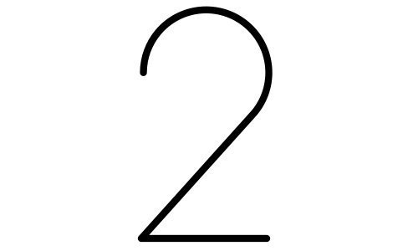

3 Centers: Choice Time

Student Task Statement
Choose a center.
Geoblocks
Connecting Cubes
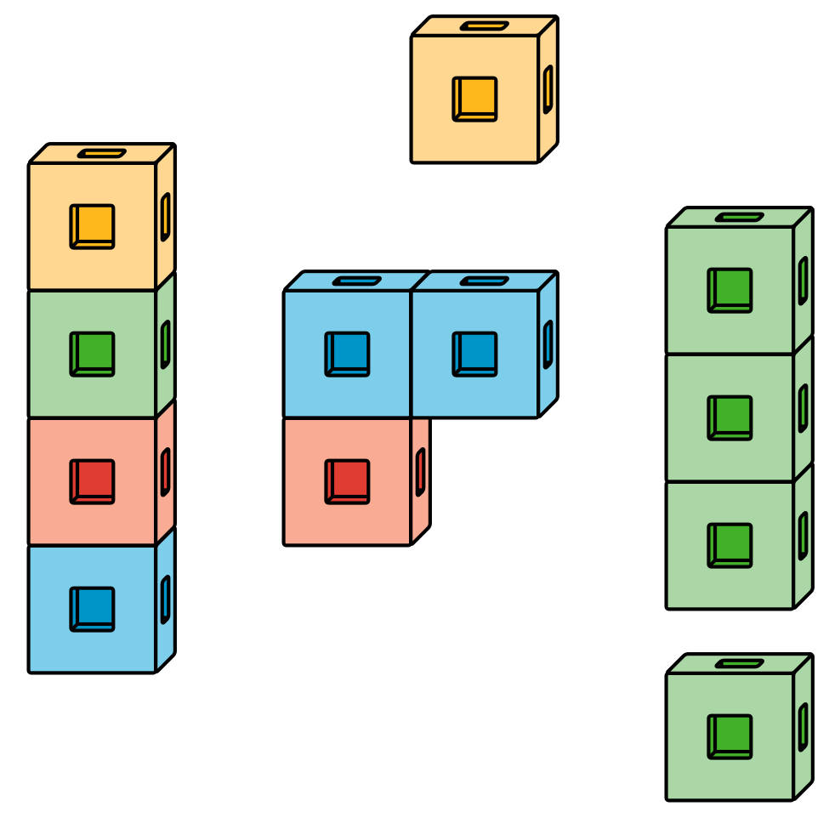
Pattern Blocks
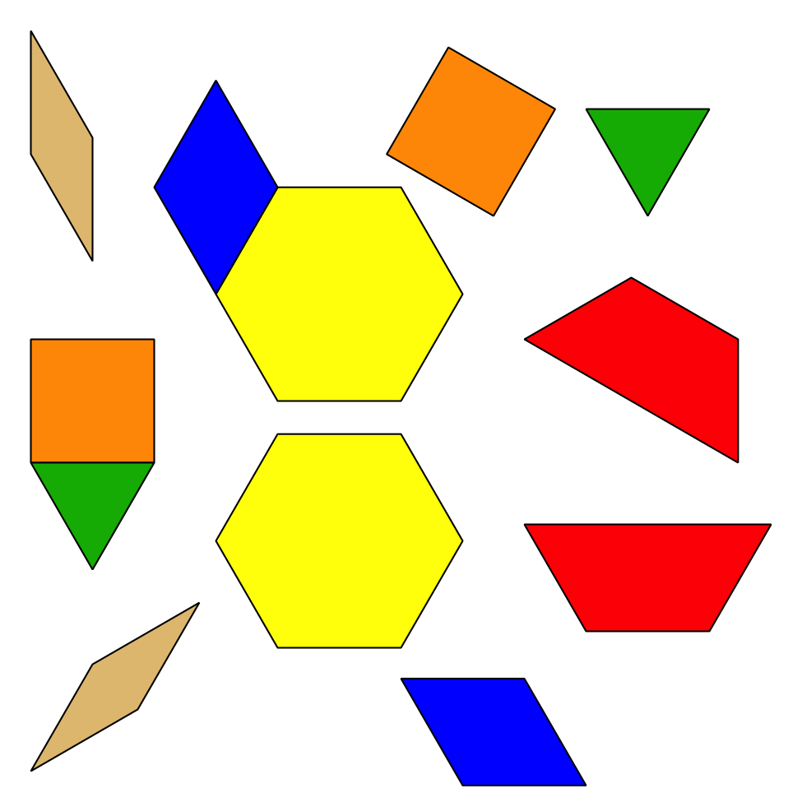
Picture Books
© CC BY 2021 Illustrative Mathematics®

