Lesson 7: Make Numbers with 10 and Some More (Part 1)
- Let’s make numbers with full 10-frames and some more.

7.2: Add More Counters
number
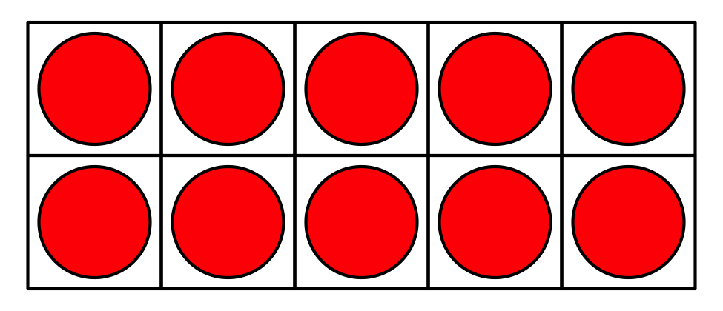
_______________
_______________
_______________
_______________
_______________

7.3: Centers: Choice Time
Choose a center.
Number Race
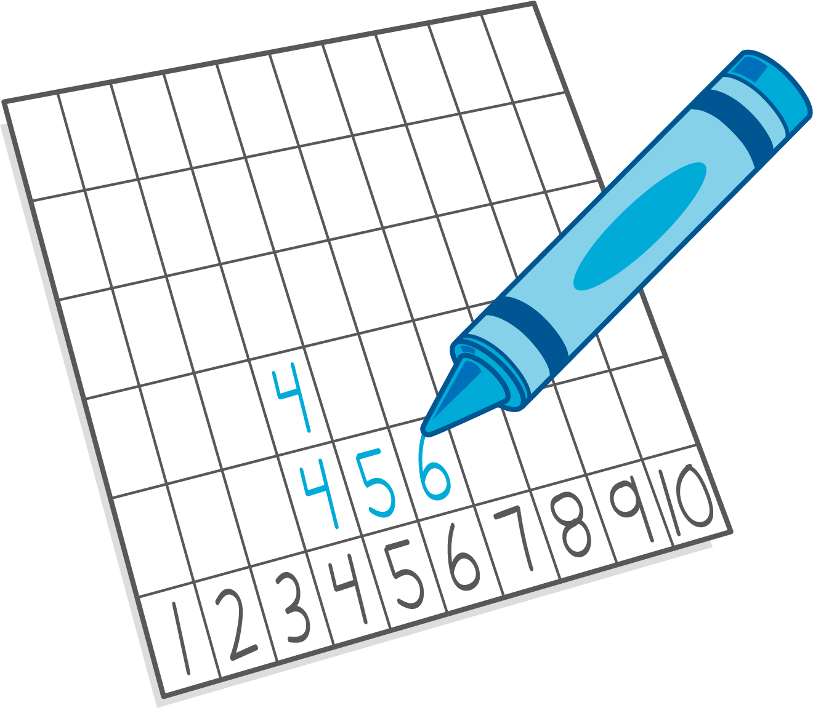
Grab and Count
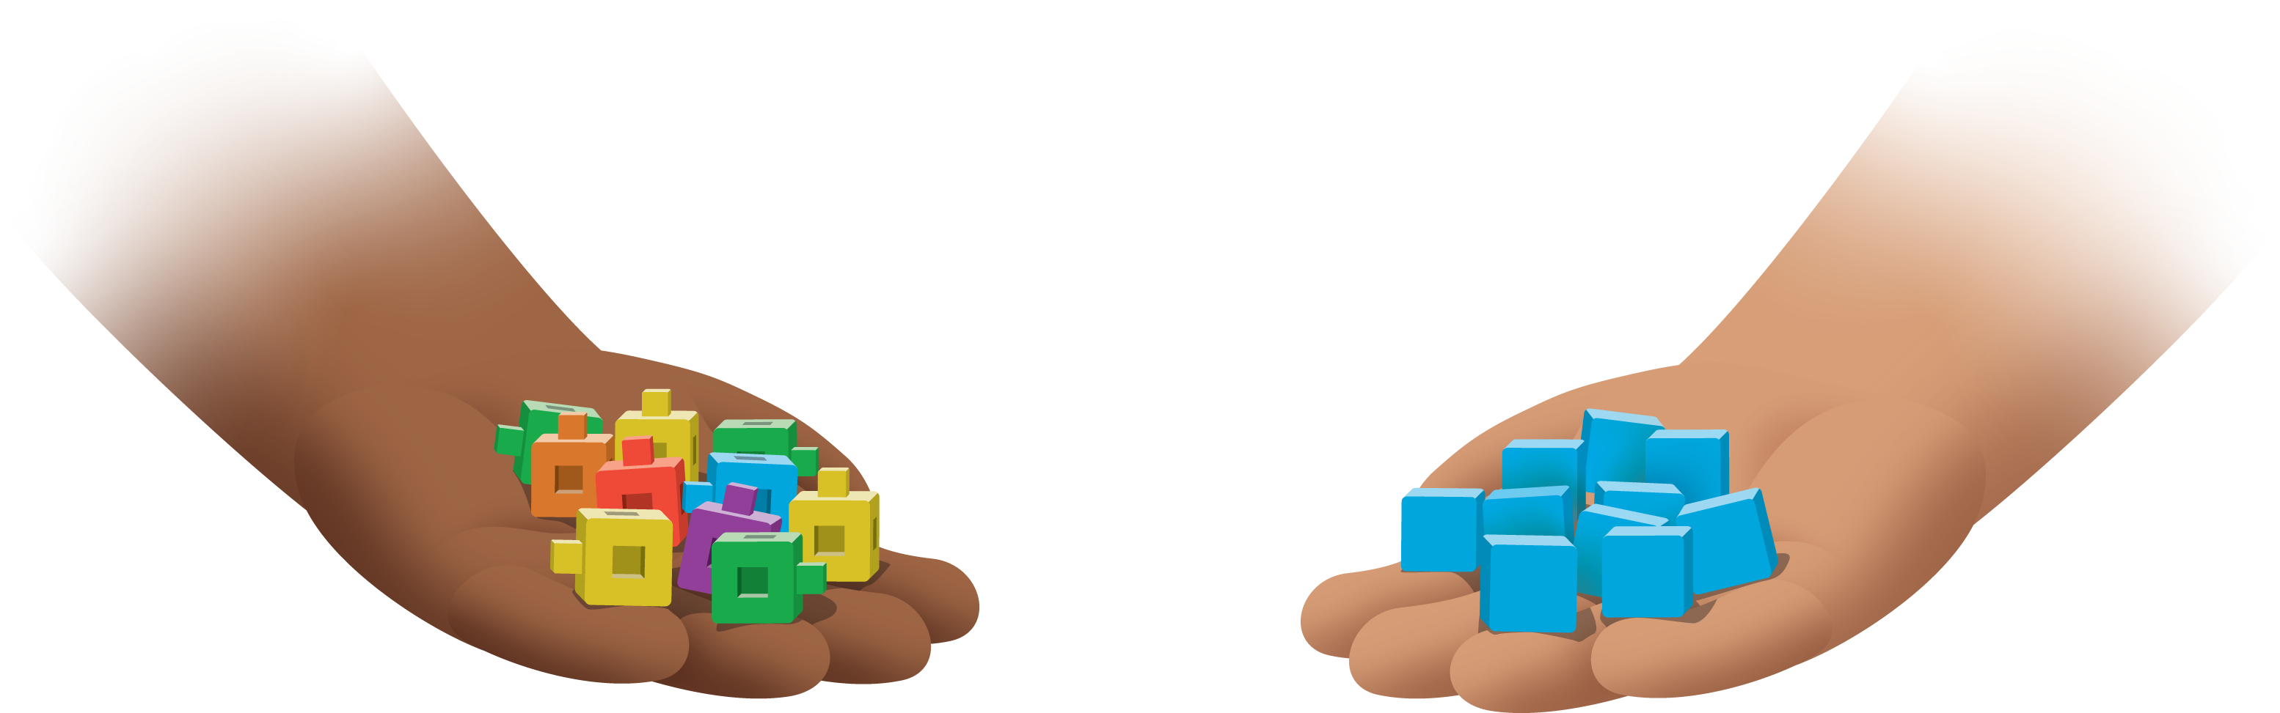
Find the Pair
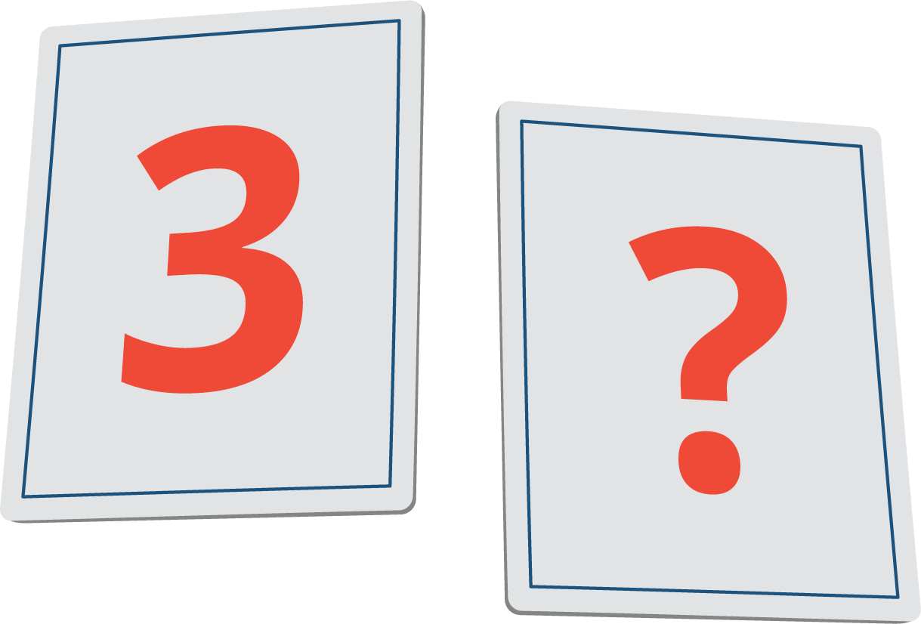
Tower Build
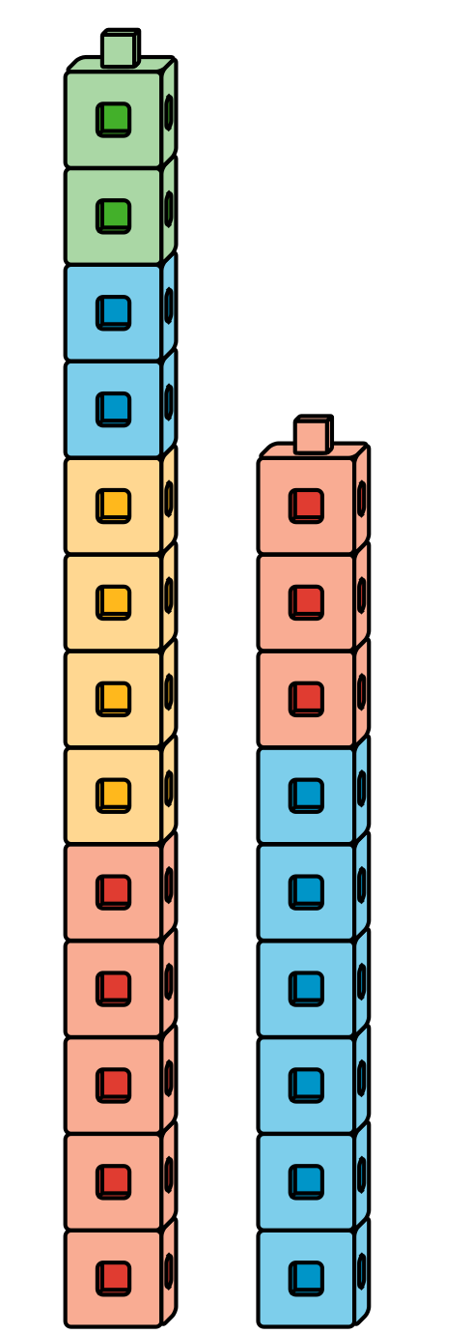
© CC BY 2021 Illustrative Mathematics®

