Lesson 12: Make Dot Images
- Let’s make our own groups of dots.

Warm-up: How Many Do You See: Dots in Different Colors
How many do you see?
How do you see them?
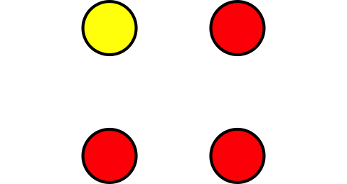
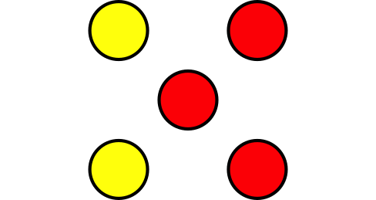

12.3: Centers: Choice Time
Choose a center.
5-frames
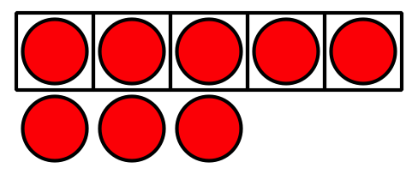
Roll and Add
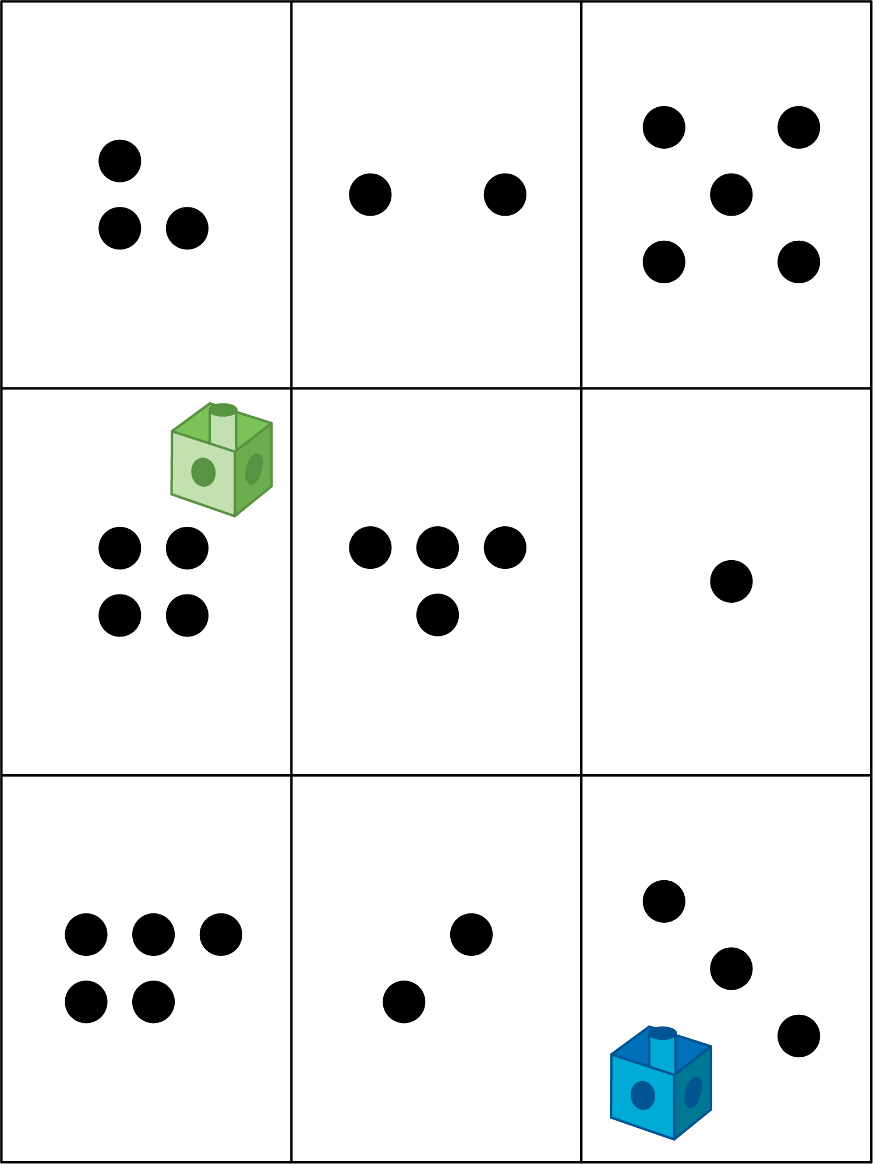
Bingo
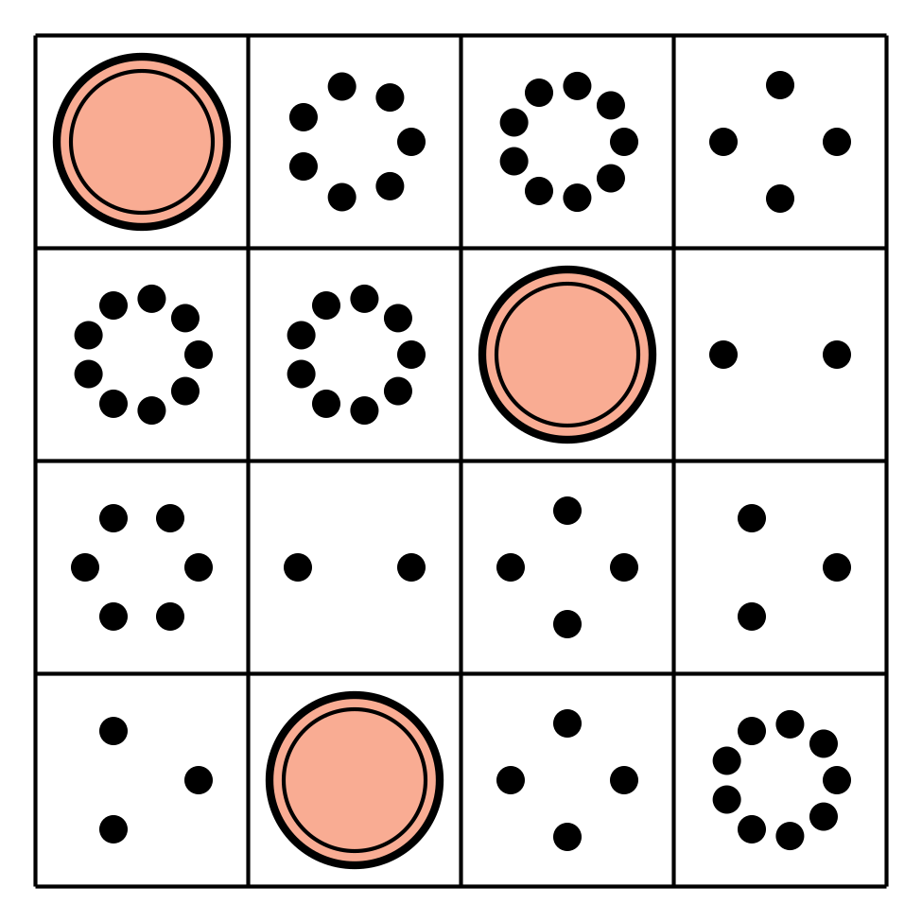
Geoblocks
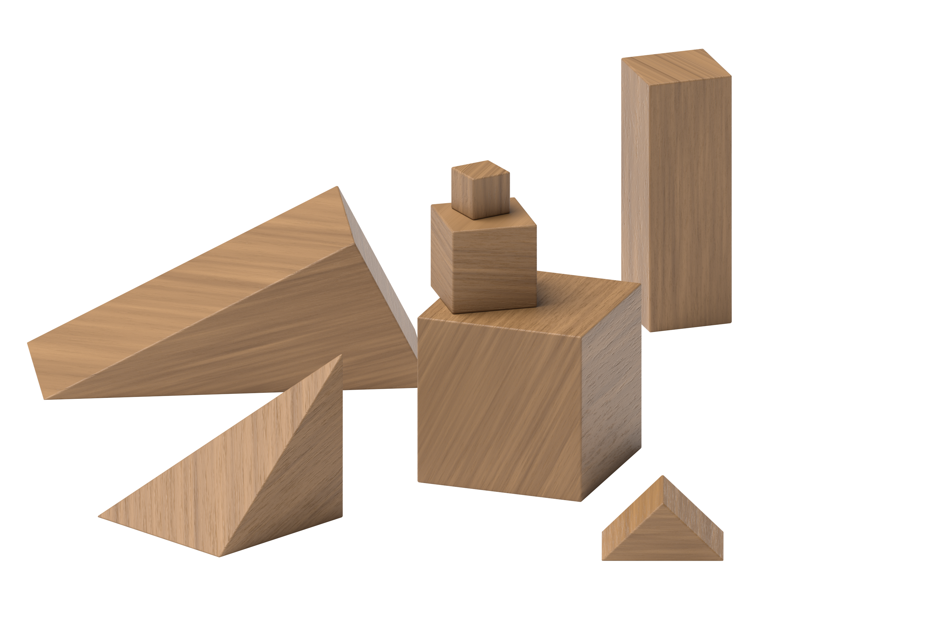
Find the Value of Expressions
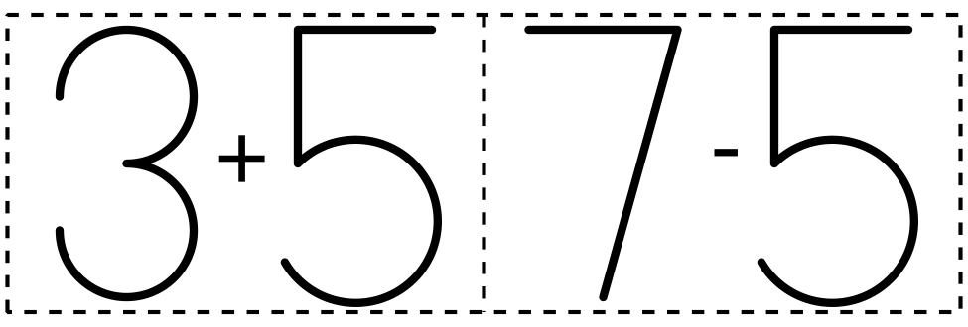
© CC BY 2021 Illustrative Mathematics®

