Lesson 10 Practice Problems
- Andre bought a new bag of cat food. The next day, he opened it to feed his cat. The graph shows how many ounces were left in the bag on the days after it was bought.
  - How many ounces of food were in the bag 12 days after Andre bought it?
  - How many days did it take for the bag to contain 16 ounces of food?
  - How much did the bag weigh before it was opened?
  - About how many days did it take for the bag to be empty?
- 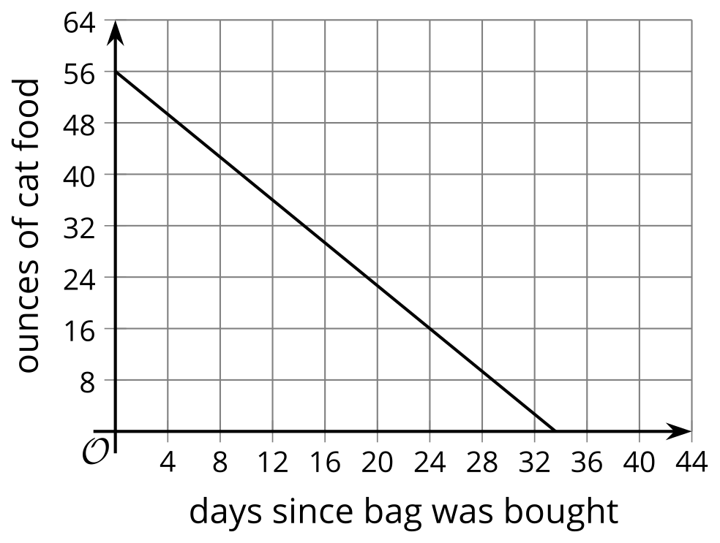
- A little league baseball team is ordering hats.
- 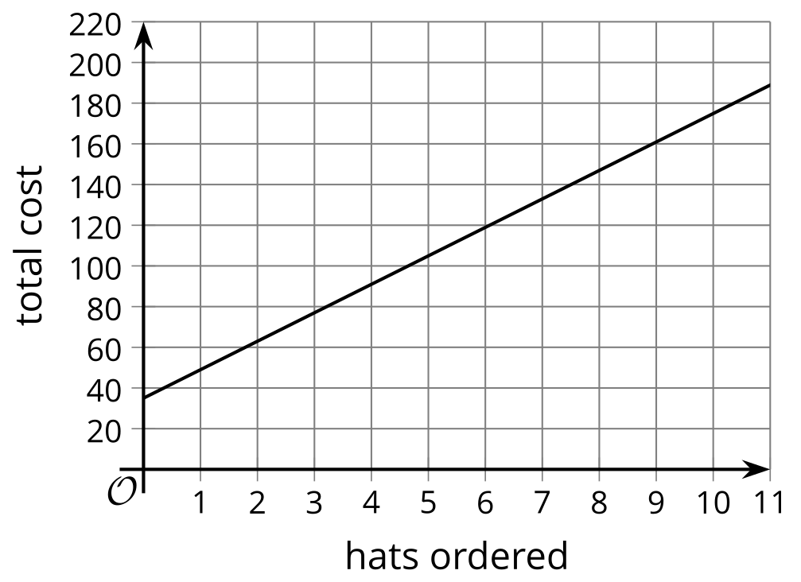
- The graph shows the relationship between the total cost, in dollars, and the number of hats ordered.
- What does the slope of the graph tell us in this situation?
  - It tells us that there is a fixed cost of approximately $35 for ordering hats.
  - It tells us the amount that the total cost increases for each additional hat ordered.
  - It tell us that when 9 hats are ordered, the total cost is approximately $160.
  - It tells us that when the number of hats ordered increases by 10, the total cost increases by approximately $175.
- A group of hikers is progressing steadily along an uphill trail. The graph shows their elevation (or height above sea level), in feet, at each distance from the start of the trail, in miles.
- 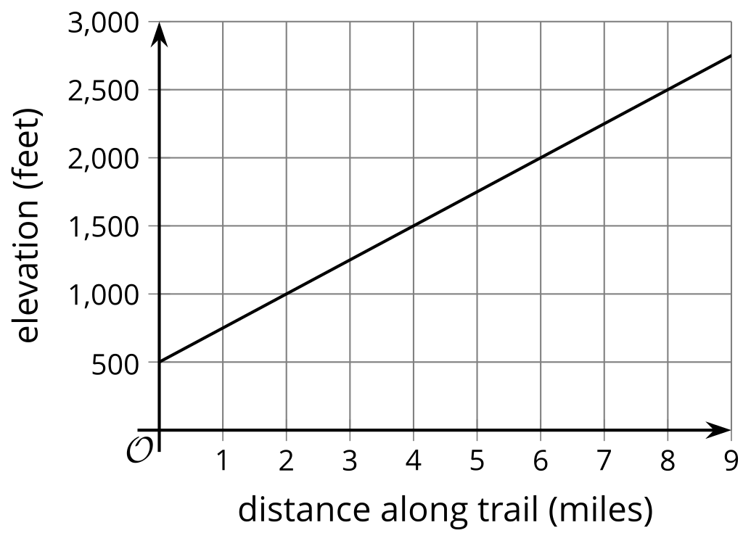
  - What is the slope of the graph? Show your reasoning.
  - What does the slope tell us about this situation?
  - Write an equation that represents the relationship between the hikers' distance from the start of the trail, $x$, and their elevation, $y$.
  - Does the equation $y−250x=500$ represent the same relationship between the distance from the start of trail and the elevation? Explain your reasoning.
- A kindergarten teacher bought $21 worth of stickers and cardstock for his class. The stickers cost $1.50 a sheet and the cardstock cost $3.50 per pack. The equation $1.5s+3.5c=21$ represents the relationship between sheets of stickers, $s$, packs of cardstocks, $c$, and the dollar amount a kindergarten teacher spent on these supplies.
  - Explain how we can tell that this graph represents the given equation.
  - 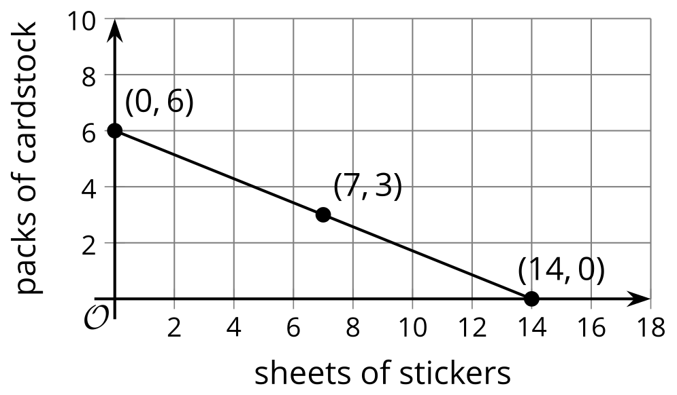

  - What do the vertical and horizontal intercepts, $\left(0,6\right)$ and $\left(14,0\right)$, mean in this situation?
- In physics, the equation $PV=nRT$ is called the ideal gas law. It is used to approximate the behavior of many gases under different conditions.
- $P$, $V$, and $T$ represent pressure, volume, and temperature, $n$ represents the number of moles of gas, and $R$ is a constant for the ideal gas.
- Which equation is solved for $T$?
  - $\frac{PV}{R}=nT$
  - $\frac{PV}{nR}=T$
  - $T=PV−nR$
  - $PVnR=T$
- (From Unit 2, Lesson 9.)
- To raise funds for uniforms and travel expenses, the soccer team is holding a car wash in a part of town with a lot of car and truck traffic. The team spent $90 on supplies like sponges and soap. They plan to charge $10 per car and $20 per truck. Their goal is to raise $460.
- How many cars do they have to wash if they washed the following numbers of trucks?
  - 4 trucks
  - 15 trucks
  - 21 trucks
  - 27 trucks
  - $t$ trucks
- (From Unit 2, Lesson 9.)
- During the Middle Ages, people often used grains, scruples, and drahms to measure the weights of different medicines.
- If 120 grains are equivalent to 6 scruples and 6 scruples are equivalent to 2 drahms, how many drahms are equivalent to 300 grains? Explain your reasoning. If you get stuck, try creating a table.
- (From Unit 2, Lesson 3.)
- Explain why the equation $2\left(3x−5\right)=6x+8$ has no solutions.
- (From Unit 2, Lesson 7.)
- Consider the equation $3a+0.1n=123$. If we solve this equation for $n$, which equation would result?
  - $0.1n=123−3a$
  - $n=123−3a−0.1$
  - $n=1,​230−30a$
  - $\frac{3a−123}{0.1}=n$
- (From Unit 2, Lesson 8.)
- Diego is buying shrimp and rice to make dinner. Shrimp costs $6.20 per pound and rice costs $1.25 per pound. Diego spent $10.55 buying shrimp and rice. The relationship between pounds of shrimp $s$, pounds of rice $r$, and the total cost is represented by the equation $6.20s+1.25r=10.55$.
- Write an equation that makes it easy to find the number of pounds of rice if we know the number of pounds of shrimp purchased.
- (From Unit 2, Lesson 8.)
© CC BY 2019 by Illustrative Mathematics®

