Lesson 12 Practice Problems
- Here are four graphs. Match each graph with a quadratic equation that it represents.

- Graph A
- 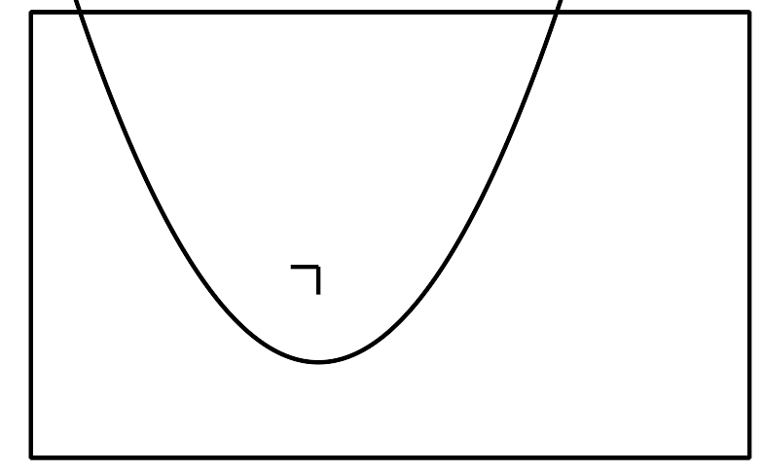

- Graph B
- 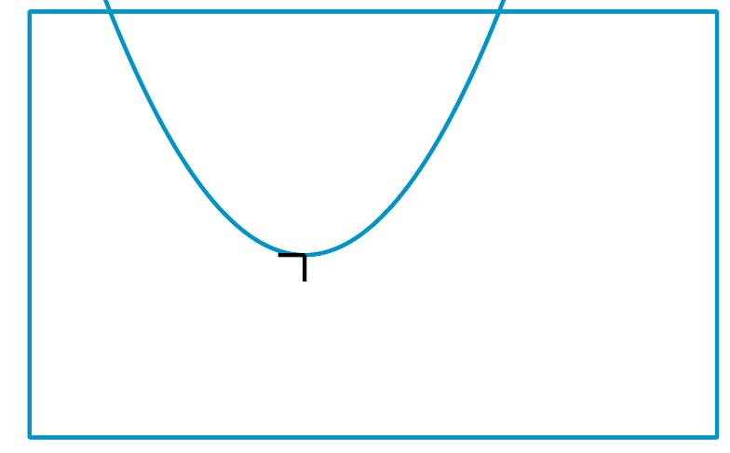

- Graph C
- 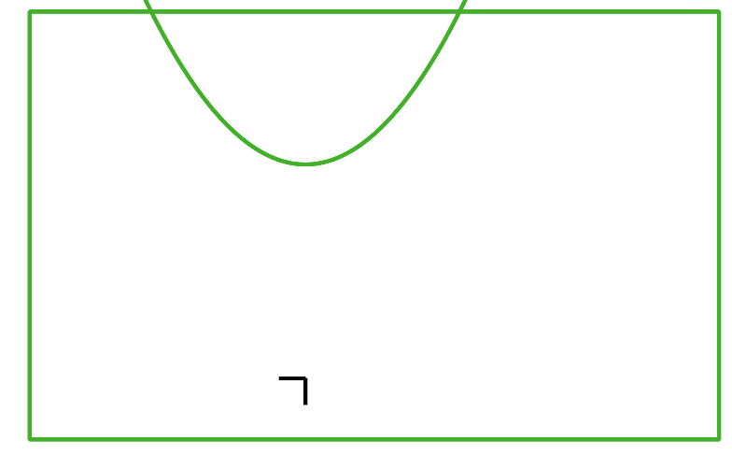

- Graph D
- 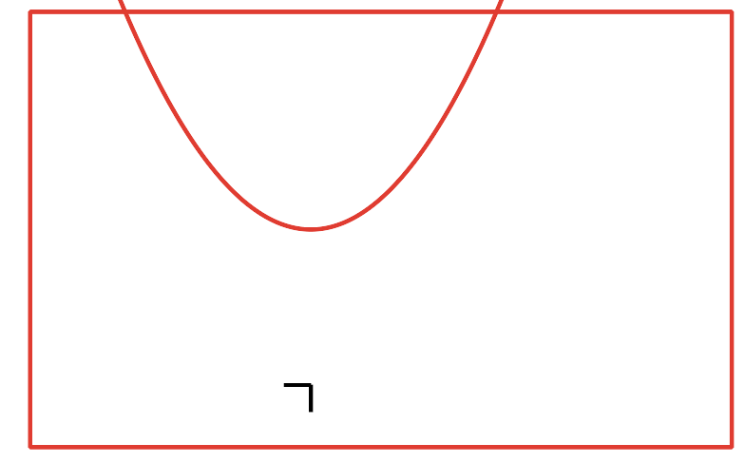
  - Graph A
  - Graph B
  - Graph C
  - Graph D
  - $y=x^{2}$
  - $y=x^{2}+5$
  - $y=x^{2}+7$
  - $y=x^{2}−3$
- The two equations $y=(x+2)(x+3)$ and $y=x^{2}+5x+6$ are equivalent.
  - Which equation helps find the $x$-intercepts most efficiently?
  - Which equation helps find the $y$-intercept most efficiently?
- Here is a graph that represents $y=x^{2}$.
- On the same coordinate plane, sketch and label the graph that represents each equation:
  - $y=x^{2}−4$
  - $y=\text{-}x^{2}+5$
- Select all equations whose graphs have a $y$-intercept with a positive $y$-coordinate.
  - $y=x^{2}+3x−2$
  - $y=x^{2}−10x$
  - $y=(x−1)^{2}$
  - $y=5x^{2}−3x−5$
  - $y=(x+1)(x+2)$
  - Describe how the graph of $A(x)=|x|$ has to be shifted to match the given graph.
  - Write an equation for the function represented by the graph.
- (From Unit 4, Lesson 14.)
- Here is a graph of the function $g$ given by $g(x)=a⋅b^{x}$.
- What can you say about the value of $b$? Explain how you know.
- 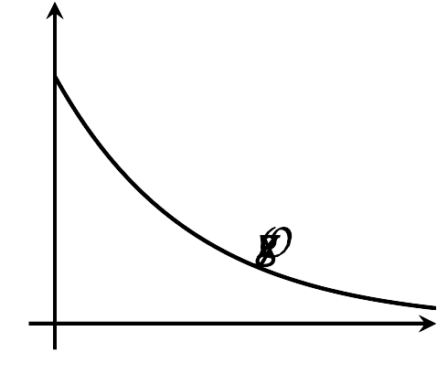
- (From Unit 5, Lesson 13.)
  - What are the $x$-intercepts of the graph that represents $y=(x+1)(x+5)$? Explain how you know.
  - What is the $x$-coordinate of the vertex of the graph that represents $y=(x+1)(x+5)$? Explain how you know.
  - Find the $y$-coordinate of the vertex. Show your reasoning.
  - Sketch a graph of $y=(x+1)(x+5)$.
- (From Unit 6, Lesson 11.)
- Determine the $x$-intercepts, the vertex, and the $y$-intercept of the graph of each equation.
- equation | - $x$-intercepts | - vertex | - $y$-intercept
- $y=(x−5)(x−3)$
- $y=2x(8−x)$
- (From Unit 6, Lesson 11.)
- Equal amounts of money were invested in stock A and stock B. In the first year, stock A increased in value by 20%, and stock B decreased by 20%. In the second year, stock A decreased in value by 20%, and stock B increased by 20%.
- Was one stock a better investment than the other? Explain your reasoning.
- (From Unit 5, Lesson 15.)
© CC BY 2019 by Illustrative Mathematics®

