Teacher Presentation Materials

Unit 5 Lesson 8: Scaling the Outputs

1 Notice and Wonder: Arch You Glad to See Me? (Warm up)

Student Task Statement
What do you notice? What do you wonder?
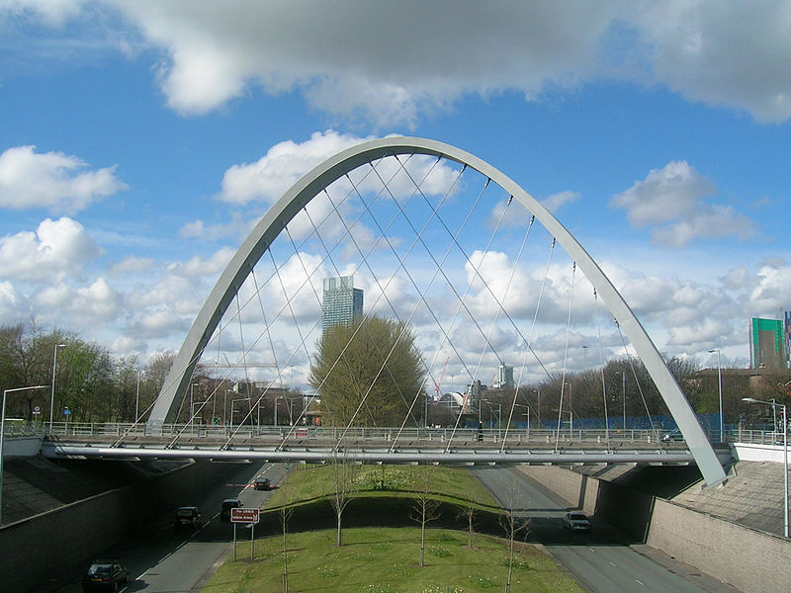

2 The Hulme Arch Bridge

Student Task Statement
The Hulme Arch Bridge in Manchester, England is shaped like a parabola. The ends of the arch are 52 meters apart, and it is 25 meters high.
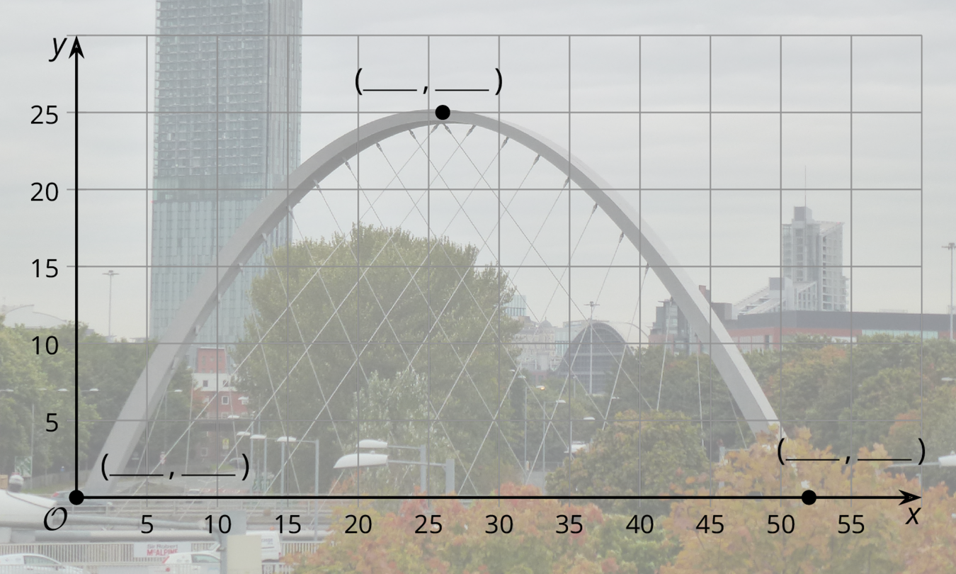
- Use the description to help you label the 3 coordinates on the graph.
- Han wants to model the shape of the arch with the graph of a function, and he chooses $H(x)=x(52−x)$, where $H(x)$ is the height in meters above a point $x$ meters along the base of the arch from the left end.
  - For the $x$-coordinates of the three points, what are the corresponding points on the graph of $H$?
  - What aspects of the shape does Han’s function model well, and what parts does it not model well?
  - Compare the height of Han’s graph with the height of the Hulme Arch Bridge. How can you change the outputs of $H$ to make it fit better? What would the revised version of $H(x)$ be?

3 Feed the Dog

Student Task Statement
A certain brand of dog food gives the minimum daily amount of food a dog needs depending on its weight. We want to model the relationship between the amount of food and the dog’s weight with a function $F$, where $F(w)$ is the amount of food, in grams, needed by a dog weighing $w$ pounds.
weight (pounds) | food (grams)
5 | 50
10 | 75
20 | 130
40 | 230
60 | 305
80 | 375
100 | 435
- Use graphing technology to find a linear function, $F(w)=mw+b$, that fits the data.
- What aspects of the data does your function model well and what aspects does it not model well?
- The graph of $f(w)=w^{\frac{2}{3}}$ has a general shape that fits the data. Use graphing technology to find a scale factor $k$ so that $F(w)=kf(w)$ fits the data.
© CC BY 2019 by Illustrative Mathematics

