Lesson 3: Multiply Unit Fractions
- Let’s solve equations.

Warm-up: Estimation Exploration: How Much is Shaded?
What is the area of the shaded region?
Record an estimate that is:
too low | about right | too high

3.1: Notice Patterns in Expressions
A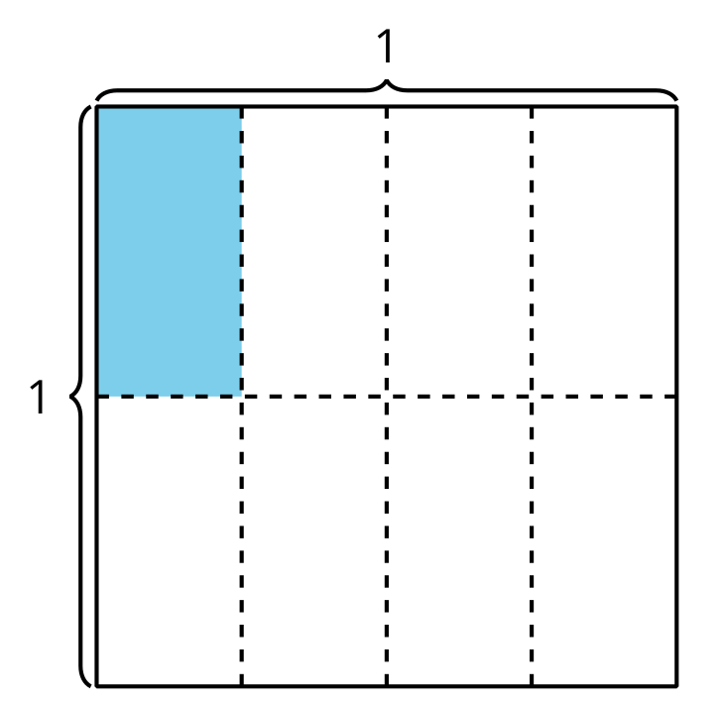
B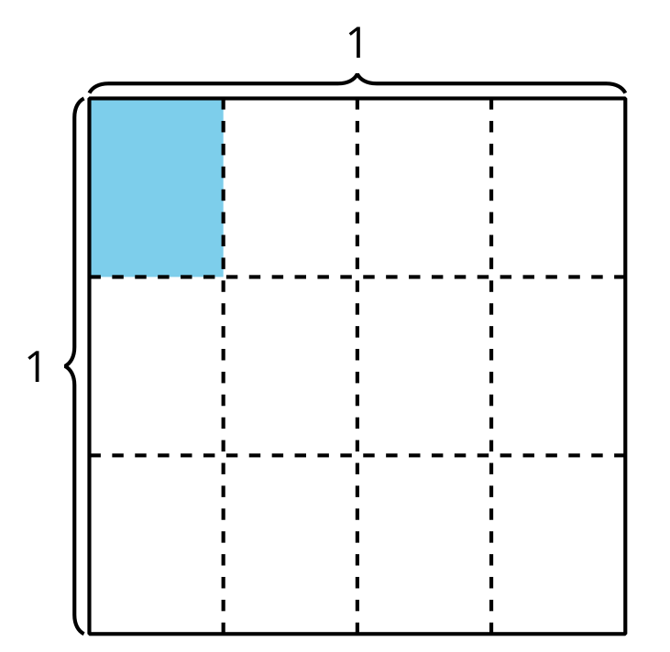
C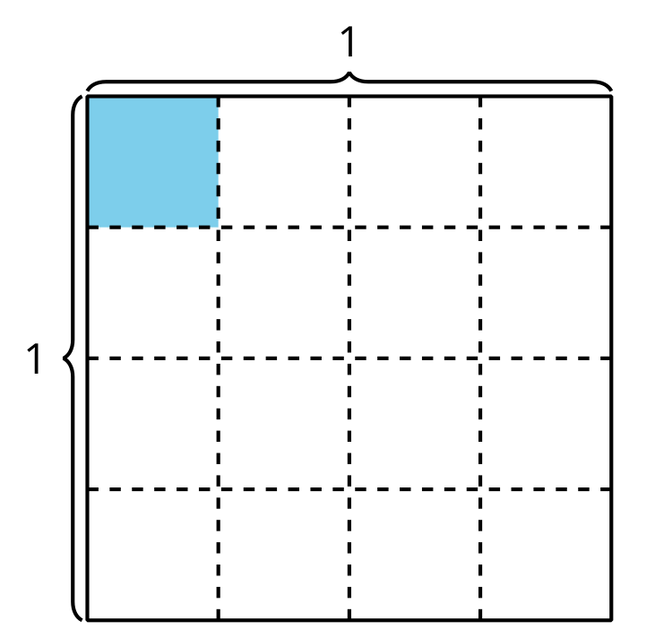
D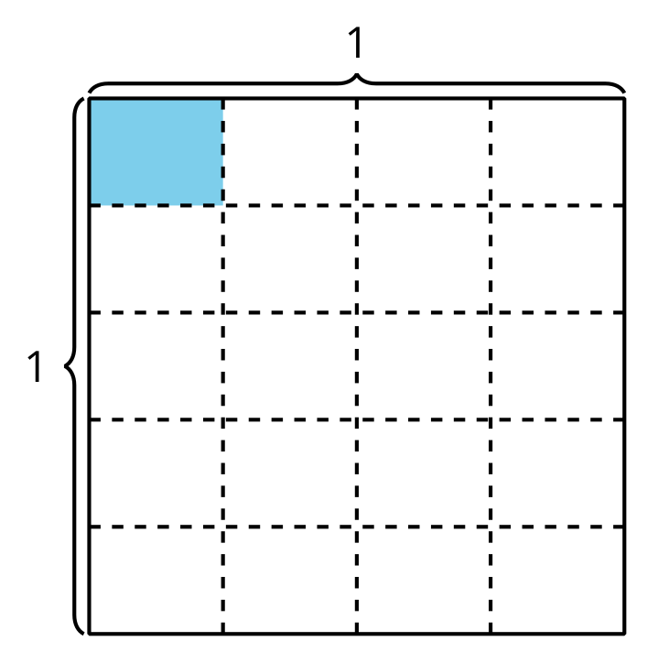
- Choose one of the diagrams and write a multiplication expression to represent the shaded region. How much of the whole square is shaded? Explain or show your thinking.
- If the pattern continues, draw what you think the next diagram will look like. Be prepared to explain your thinking.

3.2: Write a Multiplication Equation
- Write a multiplication equation to represent the area of the shaded piece.
- 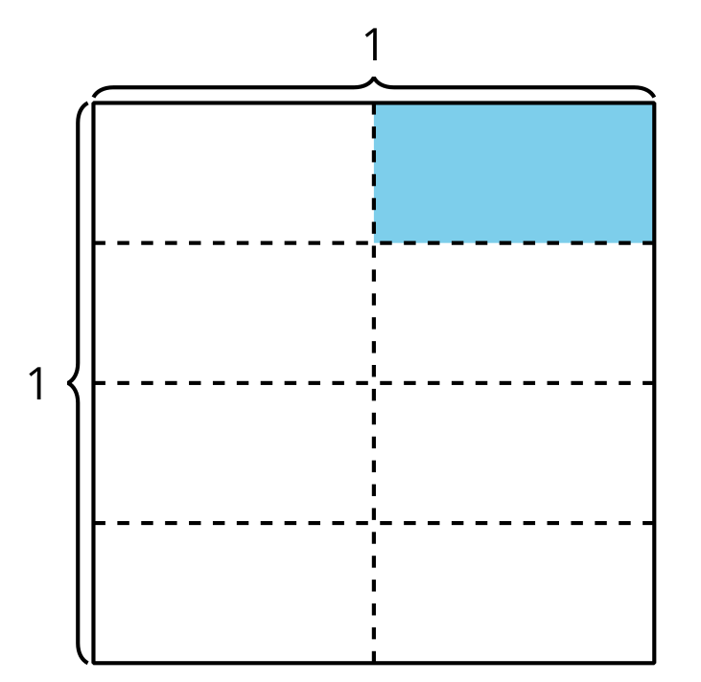
- Explain how the diagram represents the equation $\frac{1}{5}×\frac{1}{3}=\frac{1}{15}$.
- 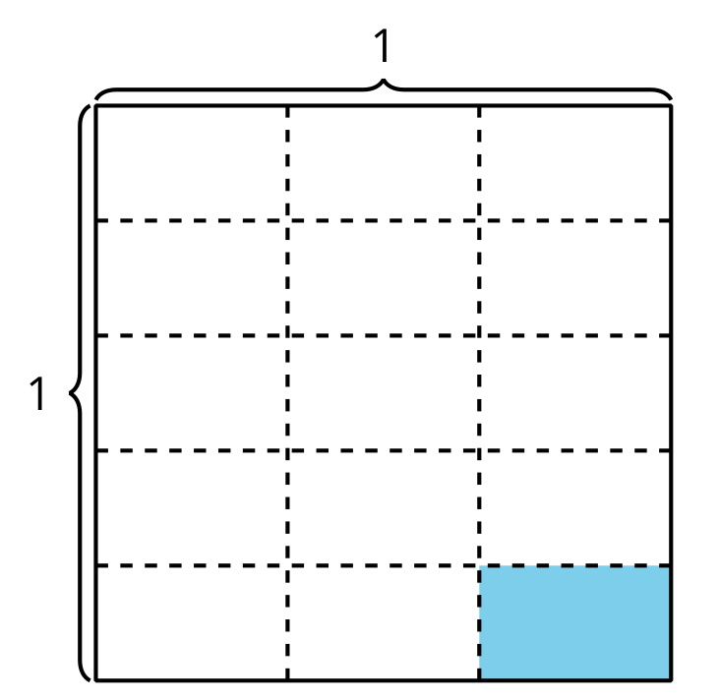
- Find the value that makes each equation true. Use a diagram, if it is helpful.
  - $\frac{1}{2}×\frac{1}{6}=?$
  - $\frac{1}{4}×\frac{1}{6}=?$
© CC BY 2021 Illustrative Mathematics®

