Unit 4 Lesson 15: Expressions and Drawings

WU Notice and Wonder: Shapes and Numbers (Warm up)

Student Task Statement
What do you notice?
What do you wonder?
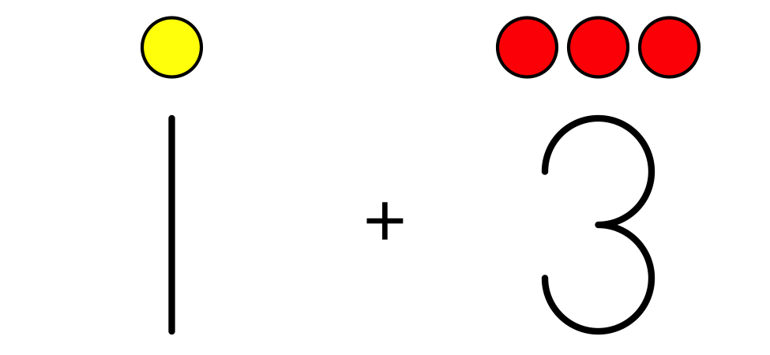

1 Match Drawings to Expressions

Student Task Statement
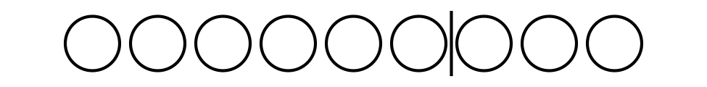
$9−2$
$6−3$
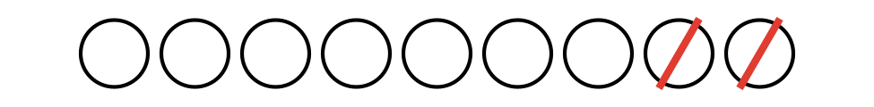
$4+2$
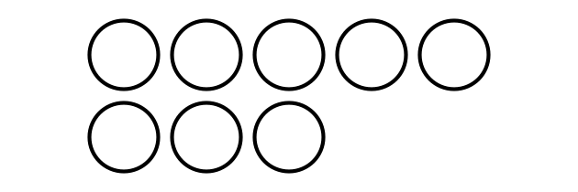
$6+3$
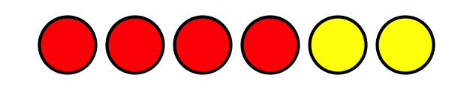
$5+3$
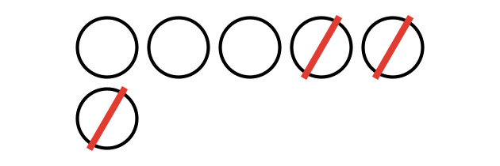
$7+0$

Activity Synthesis

2 Create Expressions and Drawings

Student Task Statement
Fill in the missing expressions and drawings.
$4+3$
$4−0$
$\underset{_}{}−\underset{_}{}$
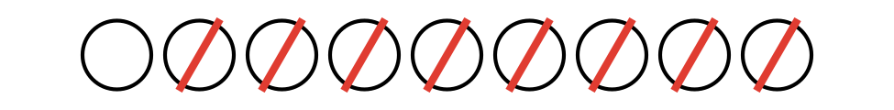
$5+3$
Fill in the missing expressions and drawings.
$8−2$
$\underset{_}{}+\underset{_}{}$
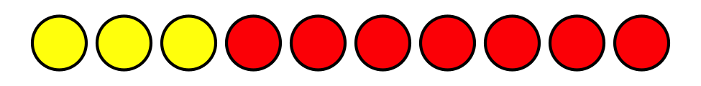
$1+6$
$\underset{_}{}−\underset{_}{}$

Activity Synthesis

3 Introduce Shake and Spill, Represent

Student Task Statement
Choose a center.
Shake and Spill
Number Race
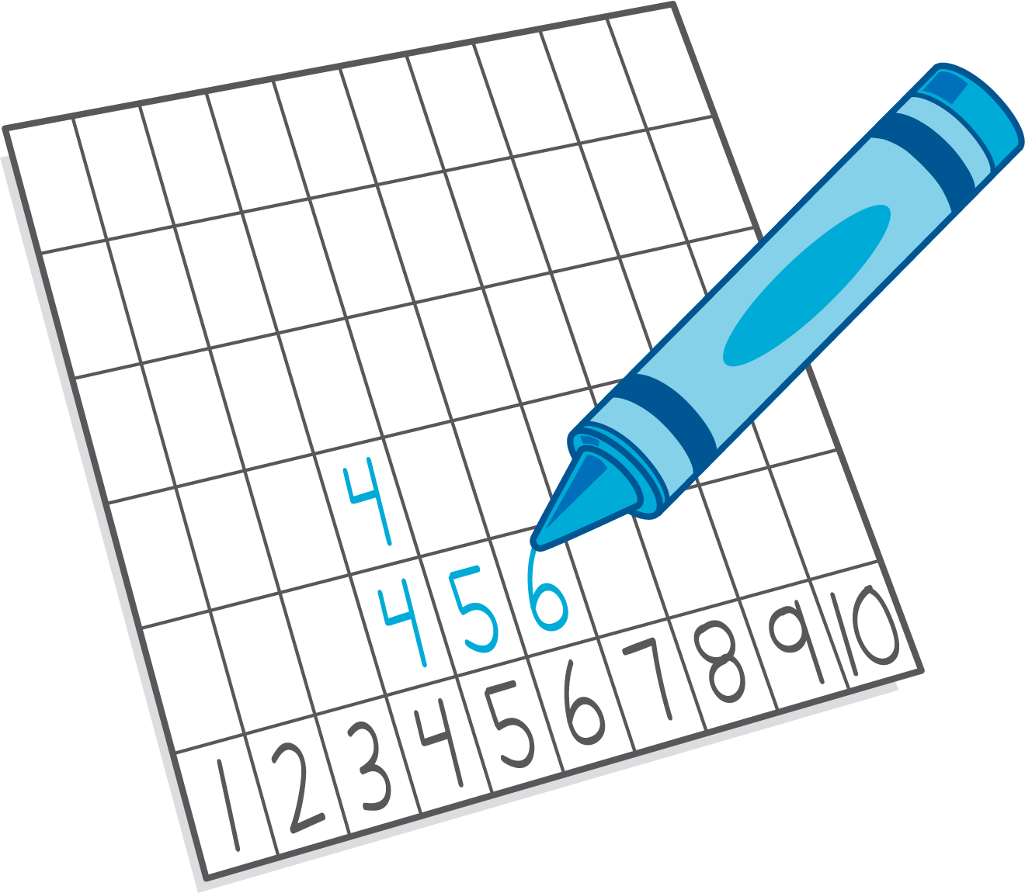
Math Stories
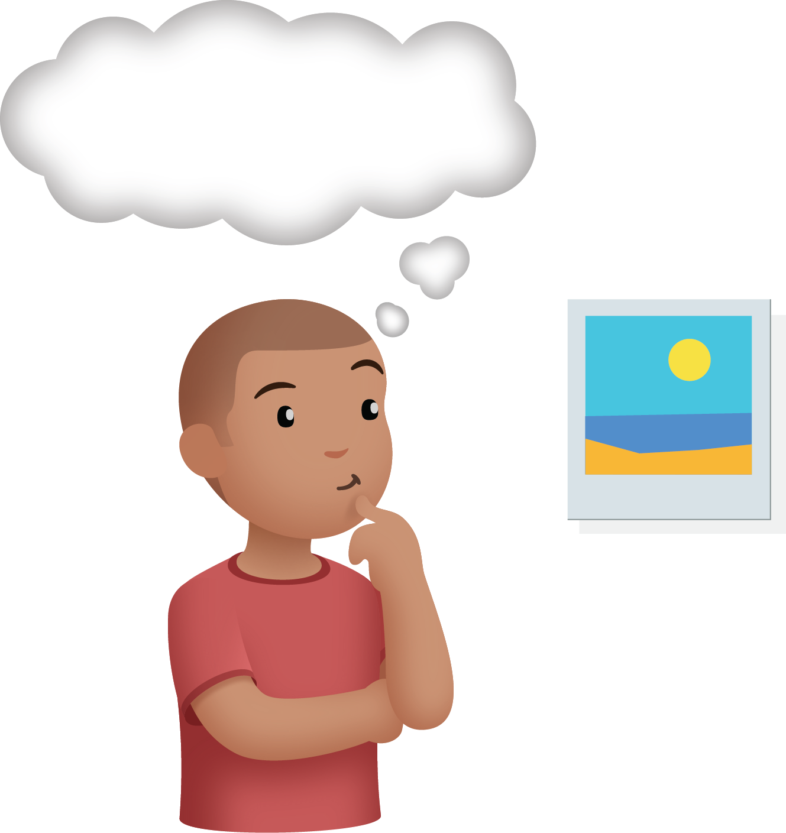

Images for Activity Synthesis
© CC BY 2021 Illustrative Mathematics®

