Lesson 9: Add Three-digit Numbers
- Let’s practice adding within 1,000.

Warm-up: Number Talk: Ten and Some More
Find the value of each expression mentally.
- $528+2$
- $528+7$
- $487+3$
- $487+8$

9.1: How Did You Add Three-digit Numbers?
Find the value of each expression. Show your thinking.
- $384+409$
- $757+152$
- $262+438$
- $575+166$

9.2: Analyze and Add
Noah and Kiran showed how they found the value of $267+338$.
Noah's work
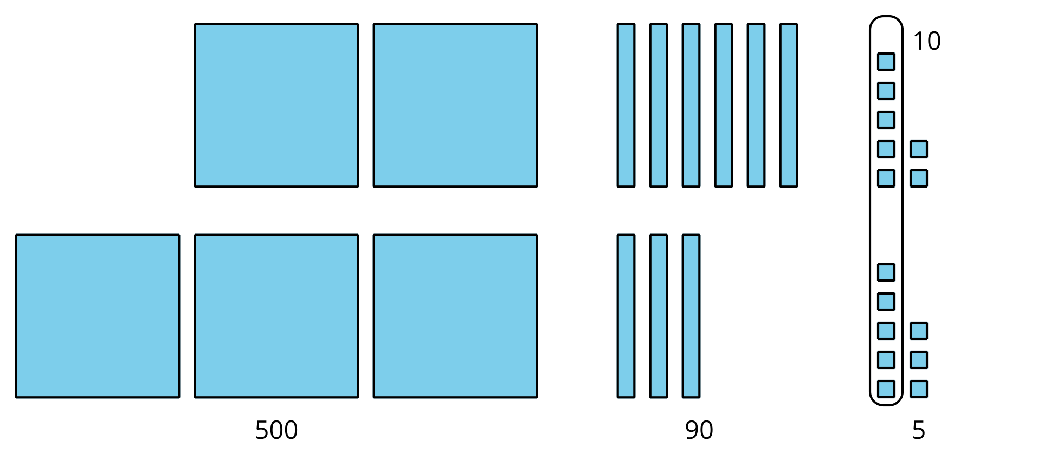
Kiran's work
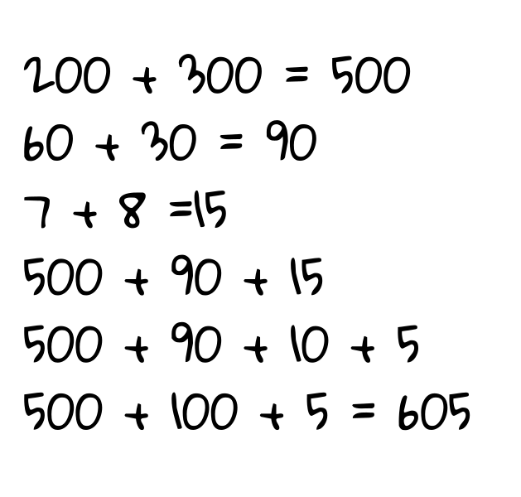
- How is Noah and Kiran’s work the same? How is it different?
- Which student found the correct value? Explain or show your thinking.
© CC BY 2021 Illustrative Mathematics®

