Unit 7 Lesson 15: Irrational Numbers

1 Finding a Home for Irrational Numbers (Warm up)

Student Task Statement
Use the number line to place these values in their approximate location.
- $\sqrt{5}$
- $\text{-}\sqrt{13}$
- $3+\sqrt{2}$
- $3−\sqrt{2}$

2 Solving for Missing Sides

Images for Launch
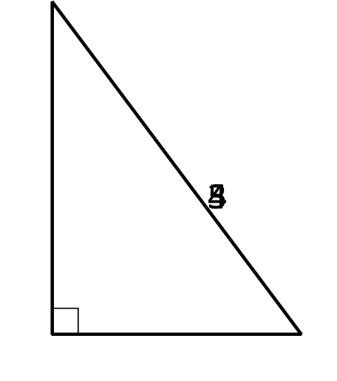
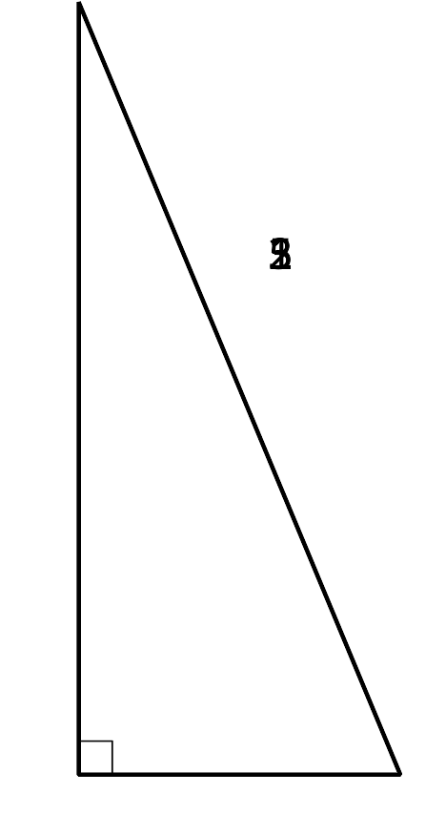
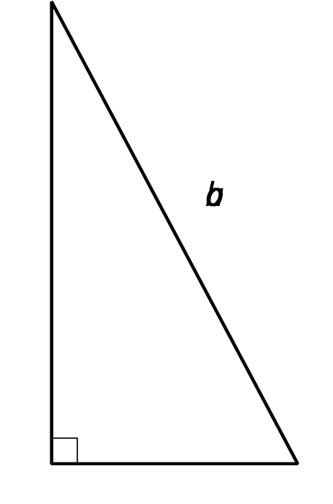

Student Task Statement
For each triangle, use the Pythagorean Theorem to find the length of the missing side.
- 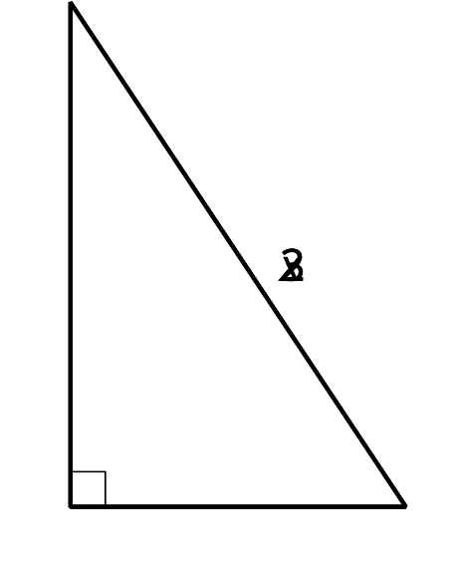
- 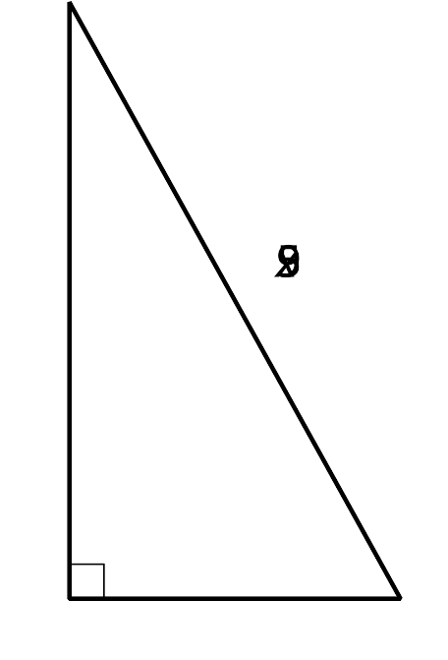
- 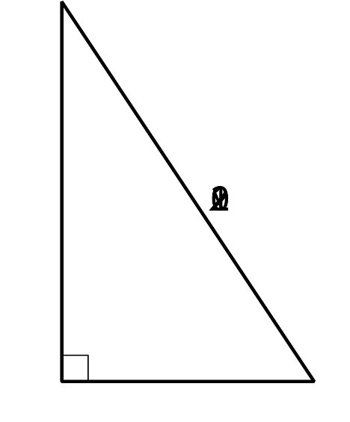
- 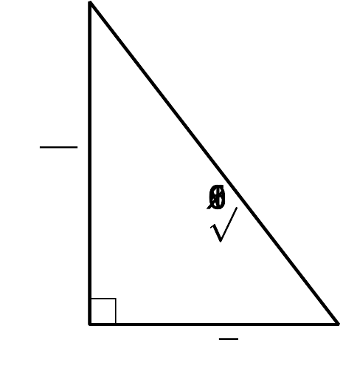
- 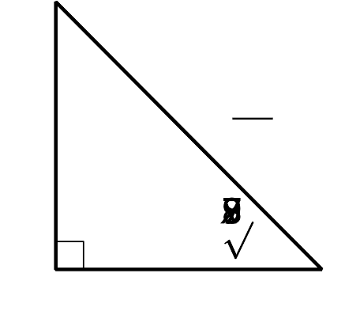

3 Solving with Square Roots

Student Task Statement
Solve each of these equations. Represent the solutions exactly. If the solution is not a whole number, what 2 whole numbers does each solution lie between? Be prepared to explain your reasoning.
- $(x+1)^{2}=64$
- $(x−3)^{2}−4=0$
- $x^{2}=10$
- $(x−2)^{2}=12$
- $(x+3)^{2}=24+4$

Activity Synthesis
© CC BY 2019 by Illustrative Mathematics®

