Lesson 2: Draw Shapes

Standards Alignments
Addressing | 2.G.A.1

Teacher-facing Learning Goals
- Recognize and draw triangles, quadrilaterals, pentagons, and hexagons.

Student-facing Learning Goals
- Let’s recognize and draw triangles, quadrilaterals, pentagons, and hexagons.

Lesson Purpose
The purpose of this lesson is for students to recognize and draw shapes that have a specified number of sides or corners.
In previous lessons, students sorted and identified two-dimensional shapes based on their sides and corners. In previous grades, students built and drew squares, circles, triangles, rectangles, and hexagons.
In this lesson, students recognize and draw shapes based on a given number of sides or corners. Students continue to practice shape vocabulary (quadrilateral, pentagon, hexagon) and describe shapes based on their defining attributes (MP6).

Access for:

Students with Disabilities
- Representation (Activity 2)

English Learners
- MLR2 (Activity 2)

Instructional Routines
Which One Doesn’t Belong? (Warm-up)

Lesson Timeline
Warm-up | 10 min
Activity 1 | 15 min
Activity 2 | 20 min
Lesson Synthesis | 10 min
Cool-down | 5 min

Teacher Reflection Question
As students identified and drew shapes with given attributes, what evidence did you see that they are building an understanding of the defining attributes of quadrilaterals, pentagons, and hexagons?

Cool-down
(to be completed at the end of the lesson) 5min
Name and Draw Shapes

Standards Alignments
Addressing | 2.G.A.1

Student-facing Task Statement
- What is the name of this shape?
- ________________________________
- 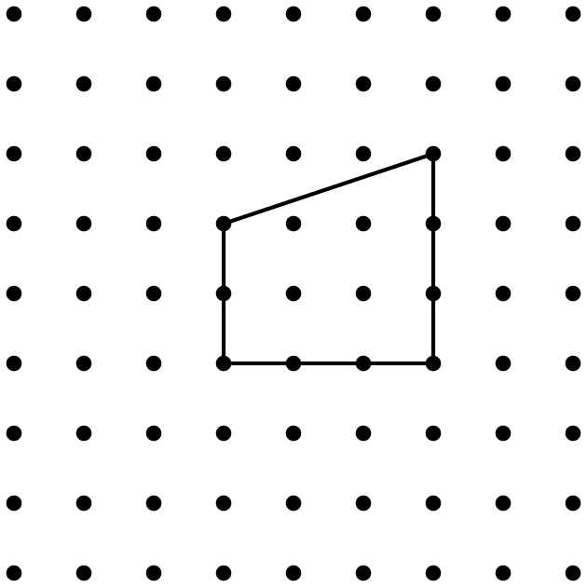
- Draw a shape with 5 sides and 5 corners.
- What is the name of the shape you drew?
- ________________________________

Student Responses
- quadrilateral
- pentagon
- Sample response:
- 