Unit 4 Lesson 14: Ways to Represent Multiplication of Teen Numbers

WU Notice and Wonder: Seeing Groups (Warm up)

Student Task Statement
What do you notice? What do you wonder?
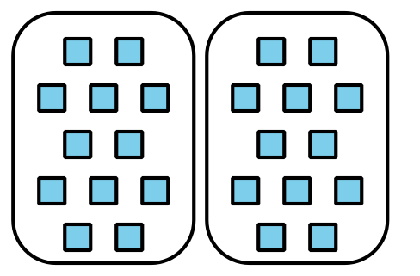
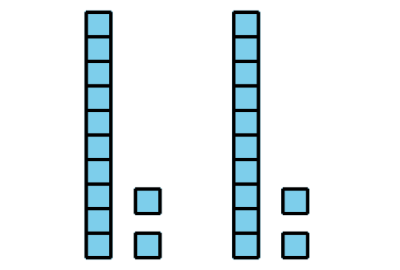
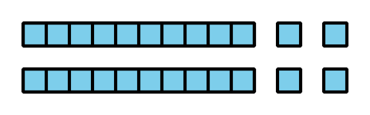

1 A Factor Greater than Ten

Student Task Statement
- Tyler says he can use base-ten blocks to find the value of $7×13$ because he knows $7×10$ and $7×3$. He says this diagram proves his thinking.
- Do you agree or disagree? Explain your reasoning.
- 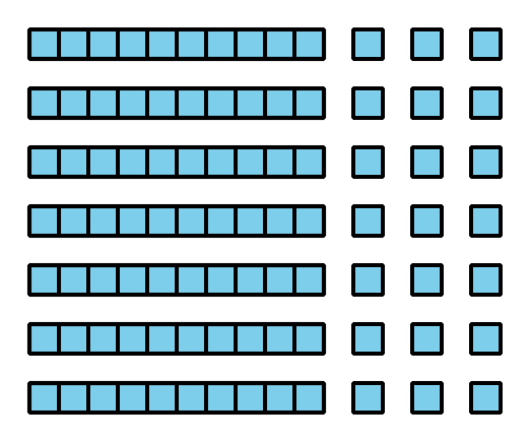
- Use Tyler’s method to find the value of $3×14$. Explain or show your reasoning.

2 Ways to Represent

Student Task Statement
Andre, Clare, and Diego represented the same expression. Their representations are shown below.
Andre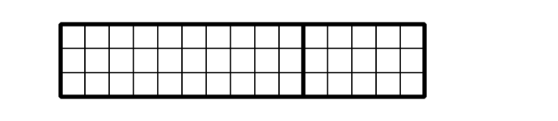
Clare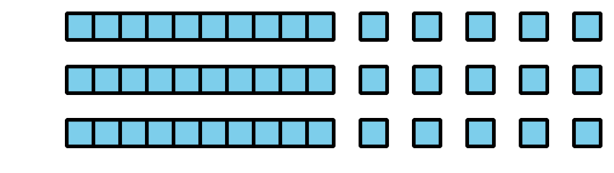
Diego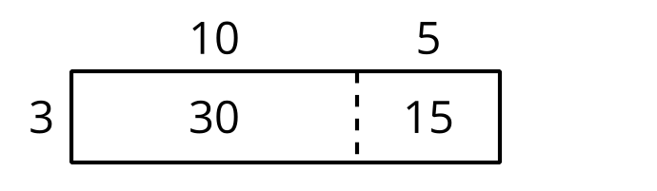
- Where do you see the factors in each diagram?
- Where do you see the product in each diagram?
© CC BY 2021 Illustrative Mathematics®

