Unit 4 Lesson 16: Find the Value of Expressions

WU What Do You Know About $3+2$? (Warm up)

Student Task Statement
What do you know about $3+2$?

1 Introduce Roll and Add, Addition Expressions

Student Task Statement

2 Find the Value of Expressions

Student Task Statement
$3+1$
$6−3$
$5−4$
$7+2$
$5+0$
$9−4$

3 Centers: Choice Time

Student Task Statement
Choose a center.
Roll and Add
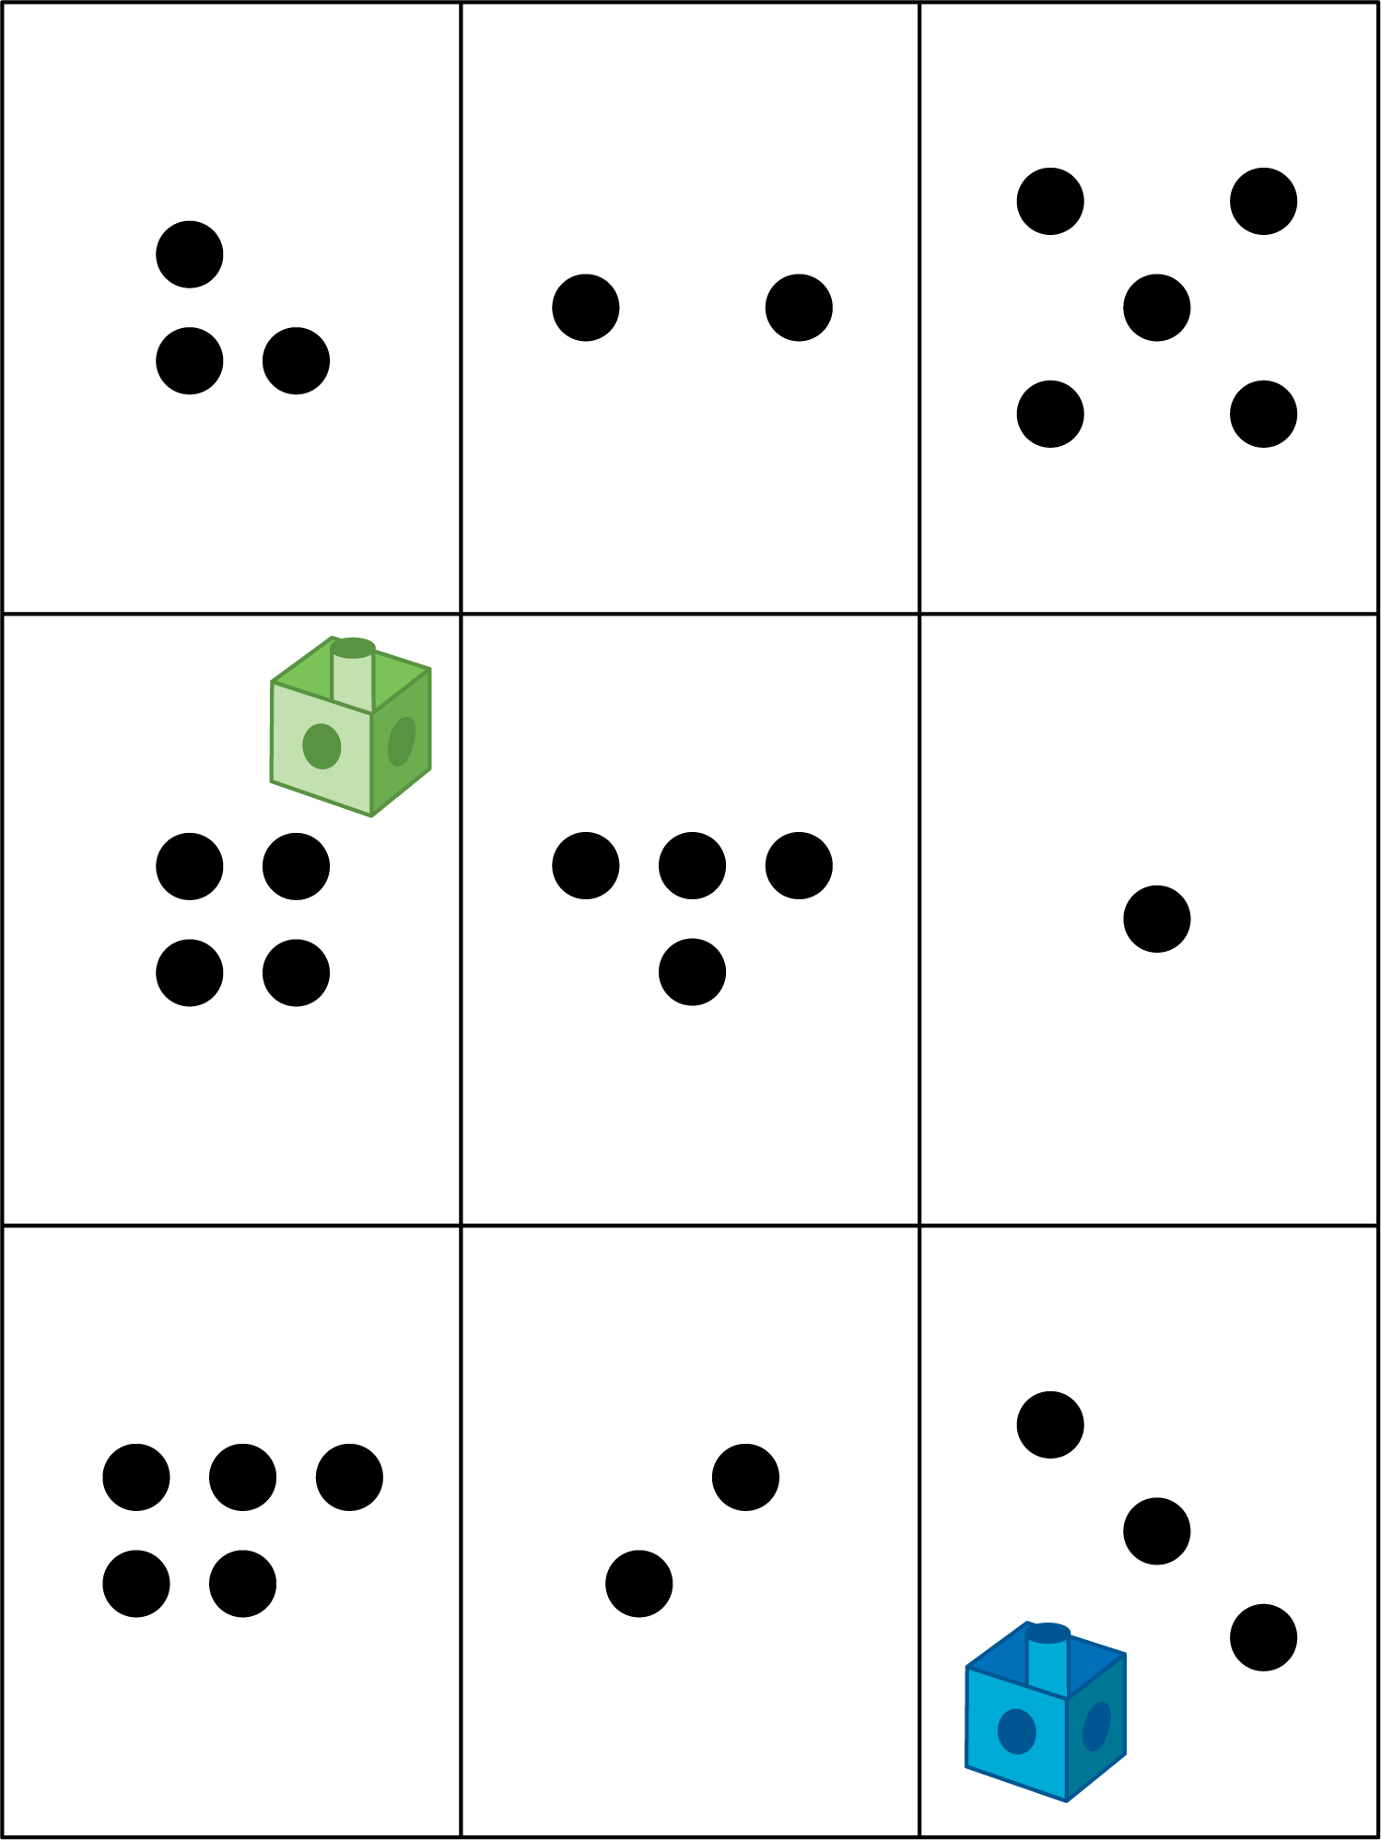
Shake and Spill
Number Race
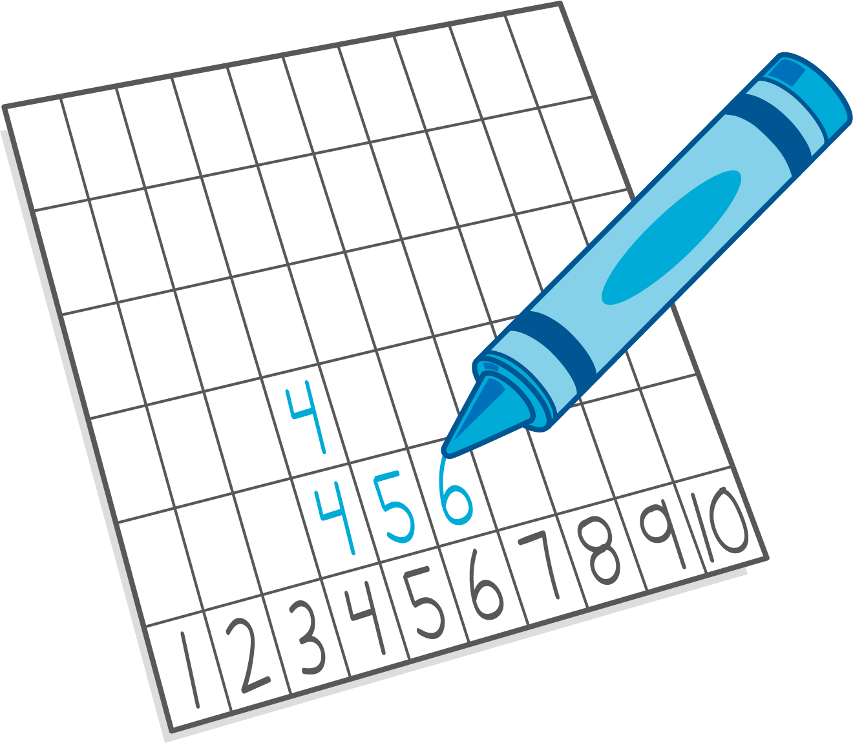
Math Stories
© CC BY 2021 Illustrative Mathematics®

