Lesson 10: Add within 1,000
- Let’s find sums within 1,000 and explain our strategies.

Warm-up: Number Talk: Use Sums to Find Sums
Find the value of each expression mentally.
- $199+23$
- $198+24$
- $297+25$
- $395+27$

10.1: Card Sort: Three-digit Sums
- Sort the cards into 2 groups with your partner.
  - Make a group of expressions that you agree the value is less challenging to find.
  - Make another group of expressions that you agree the value is more challenging to find.
  - Keep any expressions together that you and your partner disagree on.
- Choose an expression that you feel is less challenging.
- Find the value of the sum. Show your thinking.
- Choose an expression that you feel is more challenging.
- Find the value of the sum. Show your thinking.
- Discuss one card you and your partner disagreed on. If you felt the expression was more challenging, explain why. If you felt the expression was less challenging, explain your method.
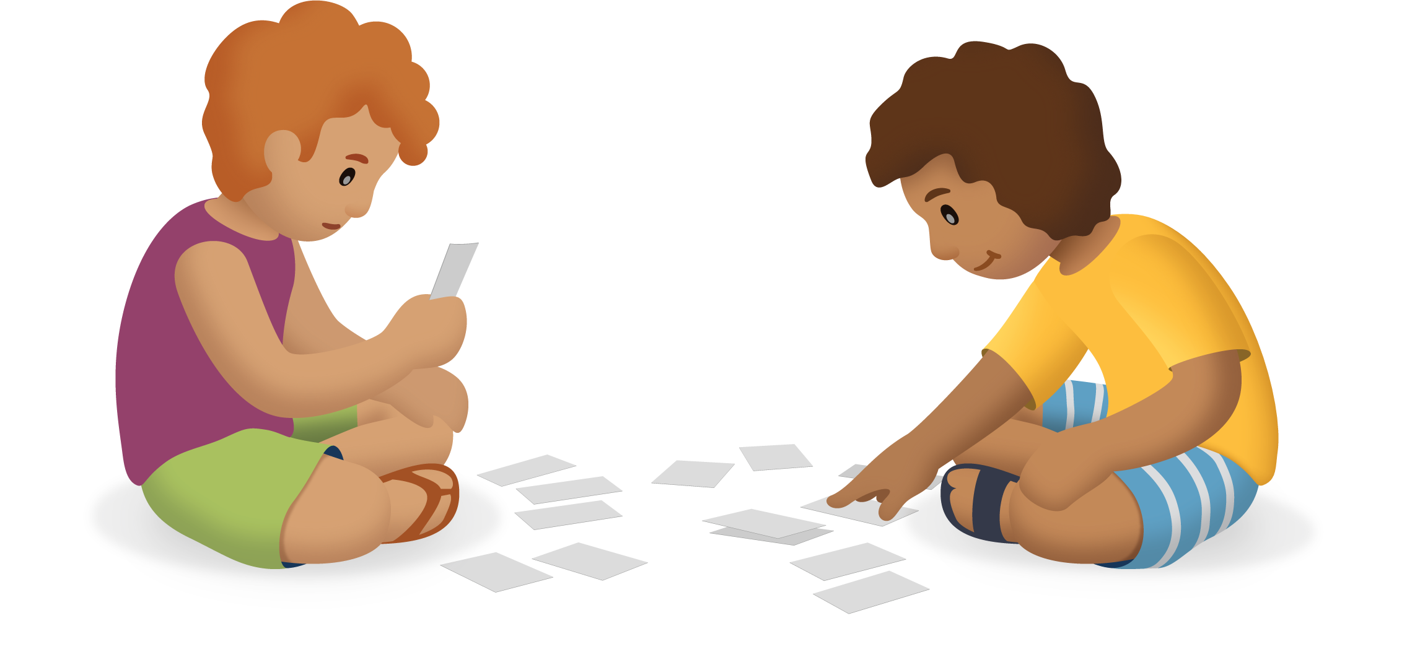

10.2: Find the Unknown Value
Oh no! Diego spilled paint on his paper and now he can’t see all the digits in each of his equations.
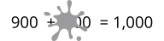
- What three-digit number makes the equation true? Show your thinking.
- What three-digit number makes the equation true? Show your thinking.

Section Summary
Section Summary
In this section of the unit, we learned many different ways to add three-digit numbers using what we know about place value. We used base-ten blocks, diagrams, and equations to show adding hundreds to hundreds, tens to tens, and ones to ones. We learned that when you add by place, you may need to compose a ten, a hundred, or both.
Base-ten Diagram
$358+67$
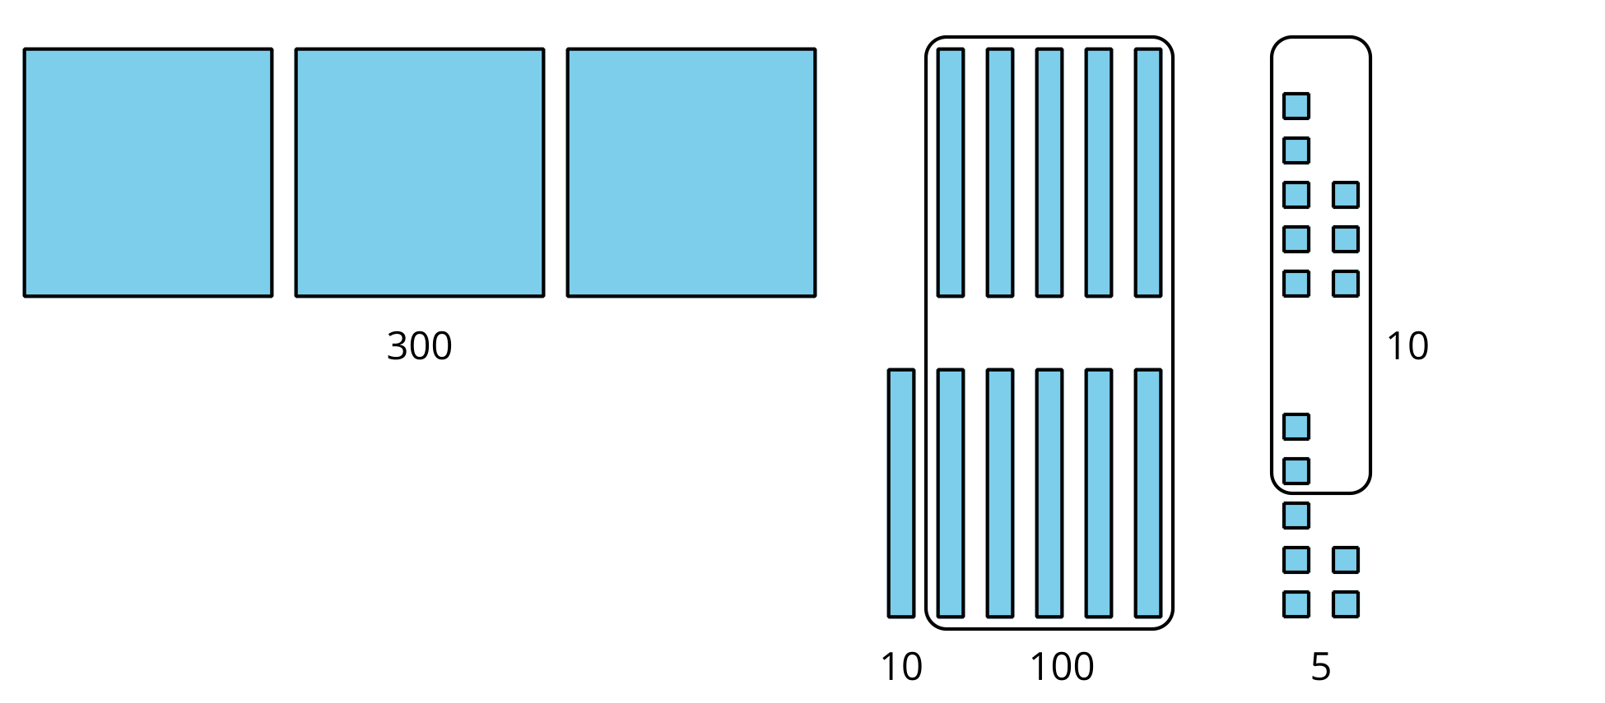
Unit Form and Equations
$358+67$
3 hundreds + 11 tens + 15 ones
11 tens = 110
15 ones = 15
$300+110+15=425$
Adding by Place
$267+338$
$200+300=500$
$60+30=90$
$7+8=15$
$500+90+15$
$500+90+10+5$
$500+100+5=605$
© CC BY 2021 Illustrative Mathematics®

