Unit 4 Lesson 2: Equivalent Decimals

WU True or False: Equivalent Fractions (Warm up)

Student Task Statement
Decide whether each statement is true or false. Be prepared to explain your reasoning.
- $\frac{50}{100}=\frac{5}{10}$
- $\frac{20}{10}=\frac{20}{100}$
- $2=1+\frac{90}{100}$
- $3\frac{1}{10}=\frac{31}{10}$

1 Card Sort: Diagrams of Fractions and Decimals

Student Task Statement
Your teacher will give you a set of cards. Each large square on the cards represents 1.
- Sort the cards into groups so that the representations in each group have the same value. Record your sorting decisions. Be prepared to explain your reasoning.
- One of the diagrams has no matching fraction or decimal. What fraction and decimal does it represent?
- Are 0.20 and 0.2 equivalent? Use fractions and a diagram to explain your reasoning.
- 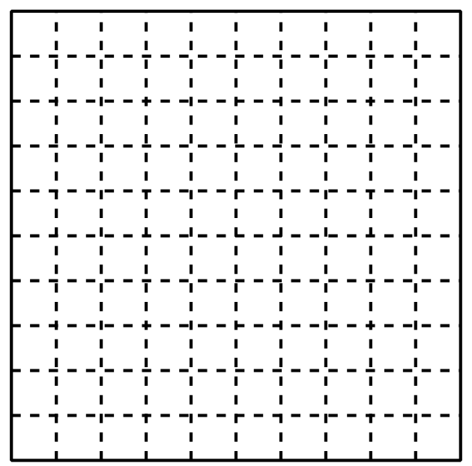

2 True or Not True?

Student Task Statement
- Decide whether each statement is true or false. For each statement that is false, replace one of the numbers to make it true. (The numbers on the two sides of the equal sign should not be identical.) Be prepared to share your thinking.
  - $\frac{50}{100}=0.50$
  - $0.05=0.5$
  - $0.3=\frac{3}{10}$
  - $0.3=\frac{30}{100}$
  - $0.3=0.30$
  - $1.1=1.10$
  - $3.06=3.60$
  - $2.70=0.27$
- Jada says that if we locate the numbers 0.05, 0.5, and 0.50 on the number line, we would end up with only two points. Do you agree? Explain or show your reasoning.

Images for Activity Synthesis
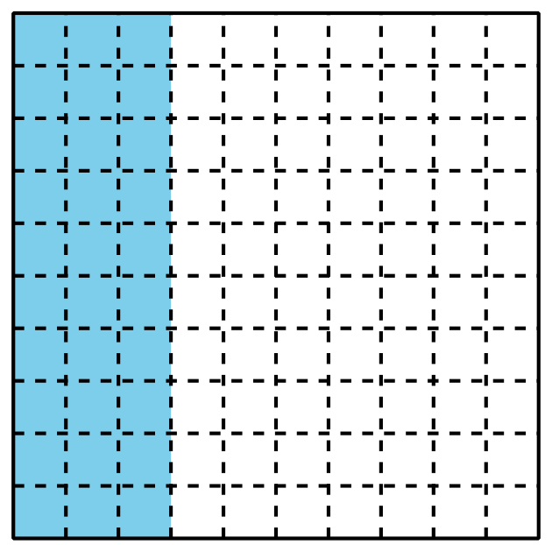
© CC BY 2021 Illustrative Mathematics®

