Unit 4 Lesson 8: Expanding and Factoring

1 Number Talk: Parentheses (Warm up)

Student Task Statement
Find the value of each expression mentally.
$2+3⋅4$
$(2+3)(4)$
$2−3⋅4$
$2−(3+4)$

2 Factoring and Expanding with Negative Numbers

Student Task Statement
In each row, write the equivalent expression. If you get stuck, use a diagram to organize your work. The first row is provided as an example. Diagrams are provided for the first three rows.
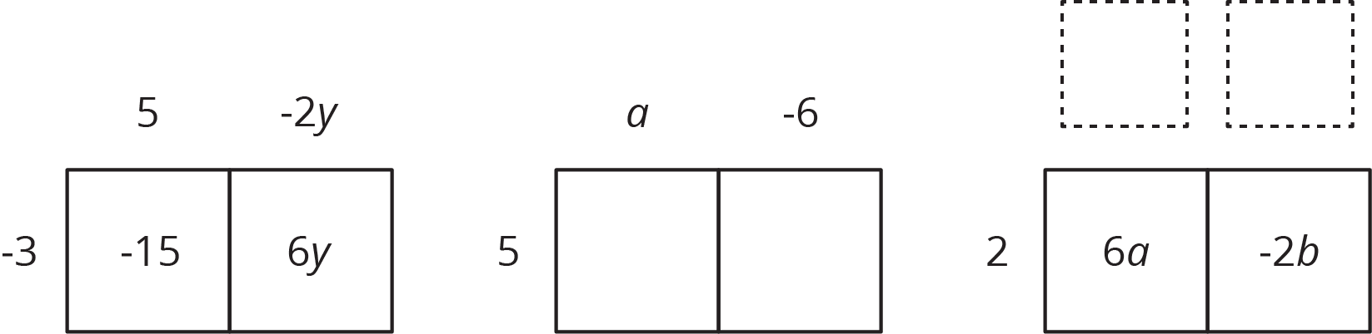
factored | expanded
$\text{-}3(5−2y)$ | $\text{-}15+6y$
$5(a−6)$
 | $6a−2b$
$\text{-}4(2w−5z)$
$\text{-}(2x−3y)$
 | $20x−10y+15z$
$k(4−17)$
 | $10a−13a$
$\text{-}2x(3y−z)$
 | $ab−bc−3bd$
$\text{-}x(3y−z+4w)$

© CC BY Open Up Resources. Adaptations CC BY IM.

