Lesson 8: Money and Debts
Let's apply what we know about signed numbers to money.

8.1: Concert Tickets
Priya wants to buy three tickets for a concert. She has earned $135 and each ticket costs $50. She borrows the rest of the money she needs from a bank and buys the tickets.
- How can you represent the amount of money that Priya has after buying the tickets?
- How much more money will Priya need to earn to pay back the money she borrowed from the bank?
- How much money will she have after she pays back the money she borrowed from the bank?

8.2: Cafeteria Food Debt
At the beginning of the month Kiran had $24 in his school cafeteria account. Use a variable to represent the unknown quantity in each transaction below and write an equation to represent it. Then, represent each transaction on a number line. What is the unknown quantity in each case?
- In the first week he spent $16 on lunches. How much was in his account then?
- Then he deposited some more money and his account balance was $28. How much did he deposit?
- Then he spent $34 on lunches the next week. How much was in his account then?
- Then he deposited enough money to pay off his debt to the cafeteria. How much did he deposit?
- Explain why it makes sense to use a negative number to represent Kiran's account balance when he owes money.

8.3: Bank Statement
Here is a bank statement.
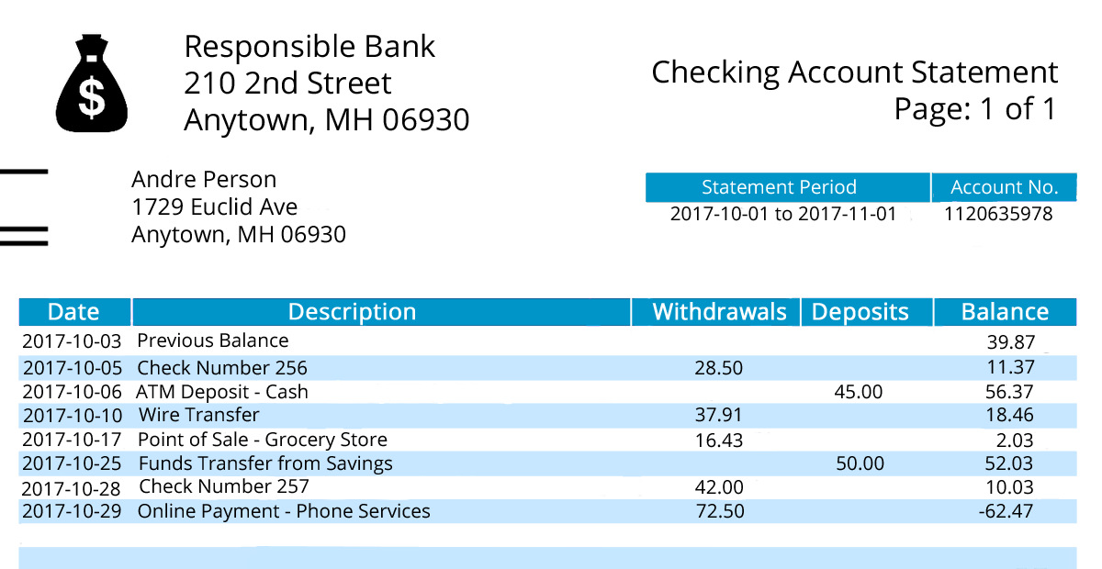
- If we put withdrawals and deposits in the same column, how can they be represented?
- Andre withdraws $40 to buy a music player. What is his new balance?
- If Andre deposits $100 in this account, will he still be in debt? How do you know?

Are you ready for more?
The national debt of a country is the total amount of money the government of that country owes. Imagine everyone in the United States was asked to help pay off the national debt. How much would each person have to pay?

Lesson 8 Summary
Banks use positive numbers to represent money that gets put into an account and negative numbers to represent money that gets taken out of an account. When you put money into an account, it is called a deposit. When you take money out of an account, it is called a withdrawal.
People also use negative numbers to represent debt. If you take out more money from your account than you put in, then you owe the bank money, and your account balance will be a negative number to represent that debt. For example, if you have $200 in your bank account, and then you write a check for $300, you will owe the bank $100 and your account balance will be -$100.
starting balance | deposits and withdrawals | new balance
0 | 50 | $0+50$
50 | 150 | $50+150$
200 | -300 | $200+\left(\text{-}300\right)$
-100
In general, you can find a new account balance by adding the value of the deposit or withdrawal to it. You can also tell quickly how much money is needed to repay a debt using the fact that to get to zero from a negative value you need to add its opposite.
© CC BY Open Up Resources. Adaptations CC BY IM.

