Unit 8 Lesson 12 Cumulative Practice Problems
- Elena and Han are discussing how to write the repeating decimal $x=0.13\overline{7}$ as a fraction. Han says that $0.13\overline{7}$ equals $\frac{13764}{99900}$. “I calculated $1000x=137.77\overline{7}$ because the decimal begins repeating after 3 digits. Then I subtracted to get $999x=137.64$. Then I multiplied by $100$ to get rid of the decimal: $99900x=13764$. And finally I divided to get $x=\frac{13764}{99900}$.” Elena says that $0.13\overline{7}$ equals $\frac{124}{900}$. “I calculated $10x=1.37\overline{7}$ because one digit repeats. Then I subtracted to get $9x=1.24$. Then I did what Han did to get $900x=124$ and $x=\frac{124}{900}$.”
- Do you agree with either of them? Explain your reasoning.
- How are the numbers $0.444$ and $0.\overline{4}$ the same? How are they different?
  - Write each fraction as a decimal.
    - $\frac{2}{3}$
    - $\frac{126}{37}$
  - Write each decimal as a fraction.
    - $0.\overline{75}$
    - $0.\overline{3}$
- Write each fraction as a decimal.
  - $\frac{5}{9}$
  - $\frac{5}{4}$
  - $\frac{48}{99}$
  - $\frac{5}{99}$
  - $\frac{7}{100}$
  - $\frac{53}{90}$
- Write each decimal as a fraction.
  - $0.\overline{7}$
  - $0.\overline{2}$
  - $0.1\overline{3}$
  - $0.\overline{14}$
  - $0.\overline{03}$
  - $0.6\overline{38}$
  - $0.52\overline{4}$
  - $0.1\overline{5}$
- ${2.2}^{2}=4.84$ and ${2.3}^{2}=5.29$. This gives some information about $\sqrt{5}$.
- Without directly calculating the square root, plot $\sqrt{5}$ on all three number lines using successive approximation.
- 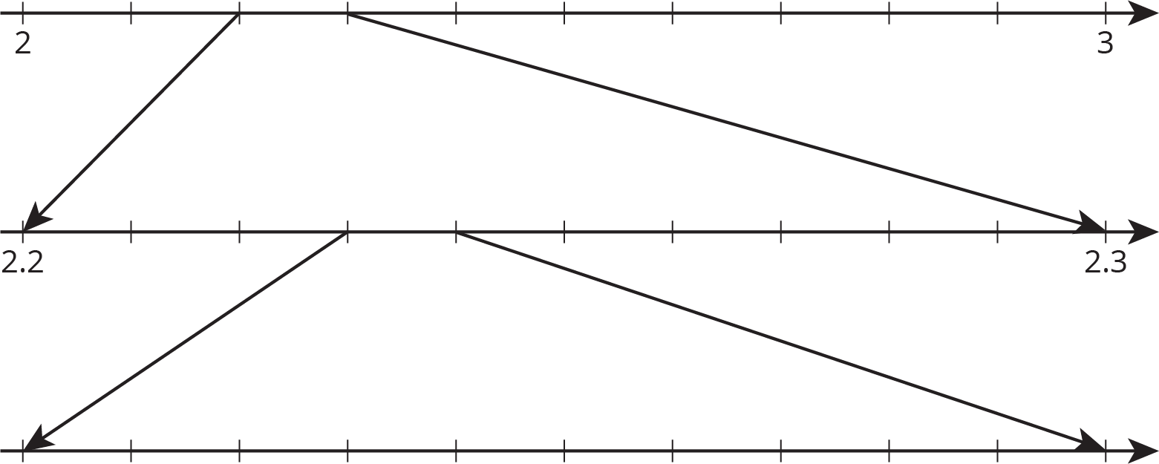
© CC BY Open Up Resources. Adaptations CC BY IM.

