Lesson 9 Practice Problems
- Each small square represents 1 square centimeter.
  - Sketch and label the solid formed by rotating this two-dimensional figure around the horizontal axis shown.
  - What is the volume of this solid?
- Match each two-dimensional figure with the solid formed from rotating it using the bold axis shown.

  - Image 1

  - Image 2
  - 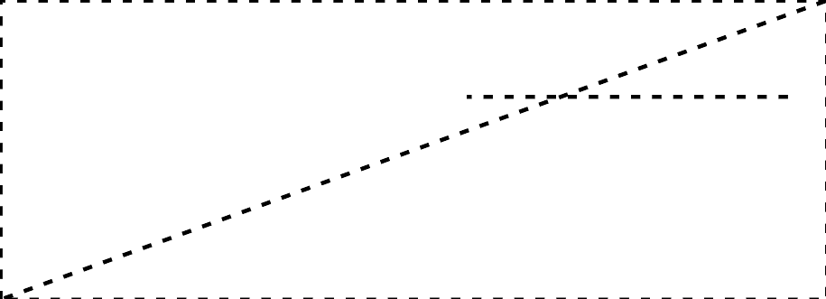

  - Image 3

  - Image 4
  - 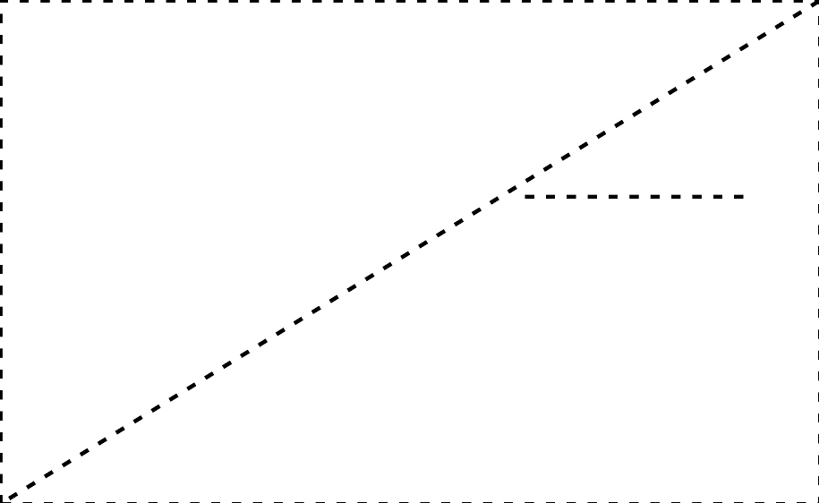
- Find the volume of each solid.
  - a cylinder with radius 4 inches and height 3 inches
  - a cylinder with radius 3 inches and height 4 inches
  - a hexagonal prism whose base has area 30.5 square centimeters and whose height is 6.5 centimeters
  - a prism 5 feet tall whose base is a right triangle with leg lengths 6 feet and 7 feet
- Technology required. A bagel shop makes bagels that serve 1 person each. For a party, the baker is asked to make a large bagel in the same shape that will serve 25 people.
  - By what scale factor will the bagel need to be dilated? Round your answer to the nearest tenth.
  - The bagels are topped with a thin layer of cream cheese. Assume the thickness of the cream cheese is the same on both bagels. How many times more cream cheese will be required for the dilated bagel as for the original? Round your answer to the nearest tenth.
- (From Unit 5, Lesson 8.)
- A toothpaste manufacturer wraps its boxes in plastic. Its most popular toothpaste comes in a box that’s 8 centimeters tall and uses 1,224 square centimeters of plastic wrap. The company sells a travel version of the toothpaste in a box that’s a dilation of the original box. The travel version uses 306 square centimeters of plastic wrap. How tall is the travel version’s box?
  - $\frac{1}{2}$ centimeters
  - 2 centimeters
  - 4 centimeters
  - 5 centimeters
- (From Unit 5, Lesson 8.)
- A solid with volume 32 cubic units is dilated by a scale factor of $k$ to obtain a solid with volume $4$ cubic units. Find the value of $k$.
  - 8
  - $\frac{1}{8}$
  - $\frac{1}{4}$
  - $\frac{1}{2}$
- (From Unit 5, Lesson 7.)
- A cube has edge length 4 inches.
  - Find the surface area and volume of the cube.
  - The cube is dilated by a scale factor of 0.25. Find the surface area and volume of the image.
- (From Unit 5, Lesson 6.)
© CC BY 2019 by Illustrative Mathematics®

