Unit 1 Lesson 11: Get Enough

WU How Many Do You See: In a Flash (Warm up)

Student Task Statement
How many do you see?
How do you see them?

1 Act It Out: Four Little Speckled Frogs (Part 2)

Student Task Statement
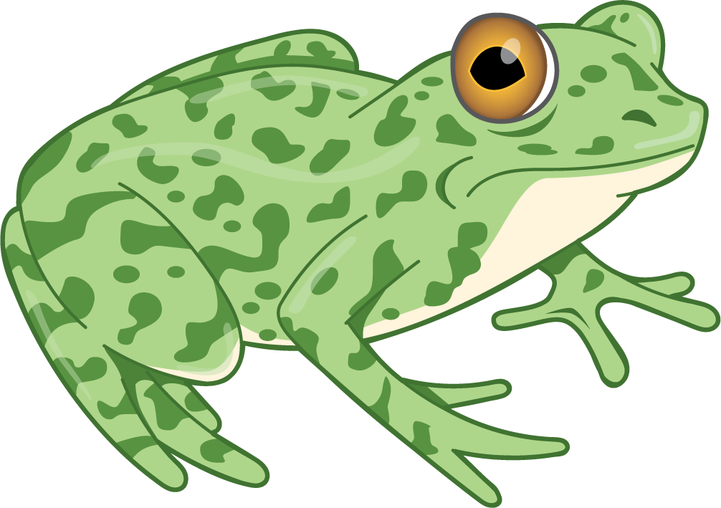
4 little speckled frogs sat on a speckled log,
eating the most delicious bugs. Yum! Yum!
1 jumped into the pool, where it was nice and cool.
Now there are 3 green speckled frogs. Glub! Glub!

2 Get Enough

Student Task Statement

3 Centers: Choice Time

Student Task Statement
Choose a center.
Geoblocks
Connecting Cubes
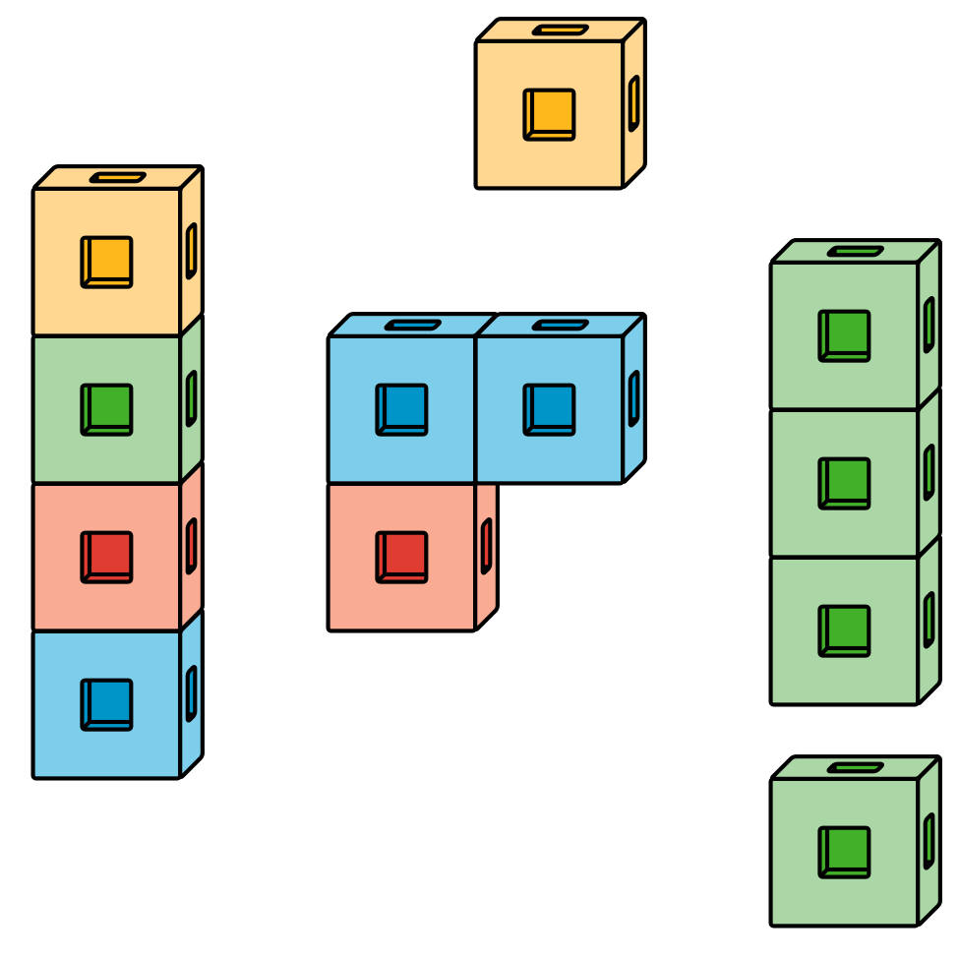
Pattern Blocks
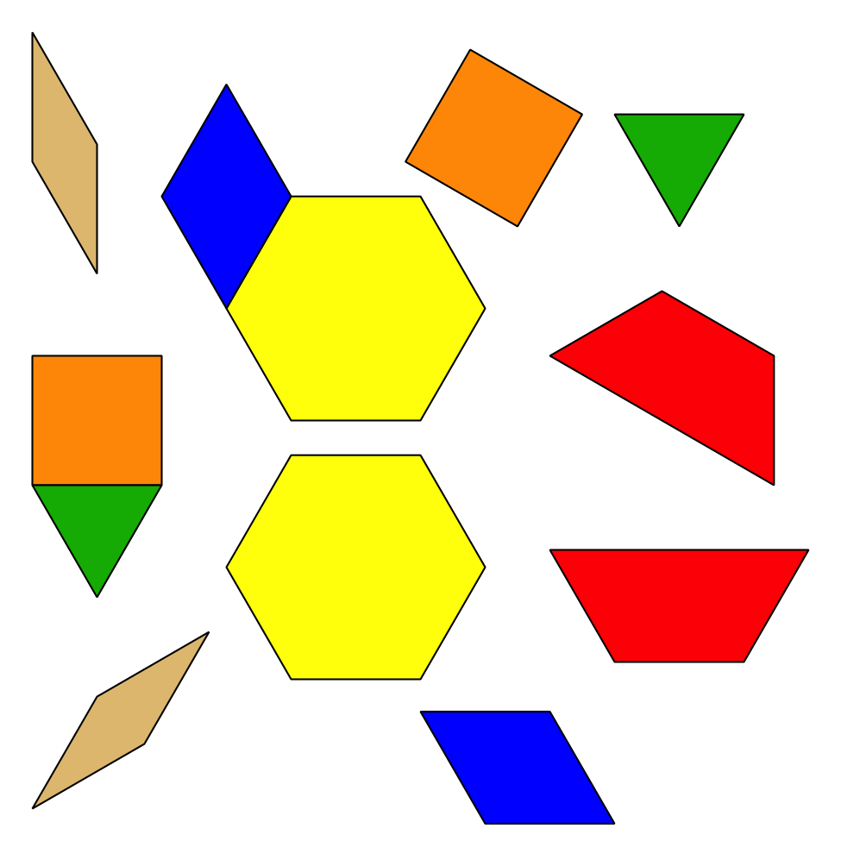
Picture Books
© CC BY 2021 Illustrative Mathematics®

